[](Journal%20logo)[Artificial Intelligence in Agriculture 2 (2019) 38–84](https://doi.org/10.1016/j.aiia.2019.06.003)

Contents lists available at [ScienceDirect](http://www.sciencedirect.com/science/journal/25897217)

Artificial Intelligence in Agriculture

journal homepage: [http://www.keaipublishing.com/en/j ournals/artificial- intelligence-in-agriculture/](http://www.keaipublishing.com/en/journals/artificial-intelligence-in-agriculture/)

[](http://crossmark.crossref.org/dialog/?doi=10.1016/j.aiia.2019.06.003&domain=pdf)Reliable execution of a robust soft computing workplace found on multiple neuro-fuzzy inference systems coupled with multiple nonlinear equations for exhaustive perception of tractor-implement performance in plowing process

S.M. Shafaei, M. Loghavi, S. Kamgar ⁎

*Department of Biosystems Engineering, School of Agriculture, Shiraz University, Shiraz 71441-65186, Iran*

a r t i c l e i n f o

*Article history:*

Received 7 May 2019

Received in revised form 21 June 2019

Accepted 21 June 2019

Available online 16 July 2019

*Keywords:*

Draft force Wheel slip

Fuel consumption Neuro-fuzzy strategies Intelligent simulation

a b s t r a c t

Tendency towards computer simulations linked to agricultural machinery has enormously increased in recent years. In this regard, the principal contribution of current research was to develop soft computing simulation workplaces for performance prognostication of tractor-implement system in plowing process. Two neuro- fuzzy strategies based on multiple adaptive neuro-fuzzy inference systems (MANFIS) scenario and the MANFIS coupled with multiple nonlinear equations (MNE) scenario were executed in the workplace. Additionally, neural strategy based on artificial neural network (ANN) scenario was also fulfilled in the workplace. Operational vari- ables of plowing depth (10–30 cm), forward speed (2–6 km/h), and tillage implement type (moldboard, disk, and chisel plow) were considered as the workplace inputs and ten performance parameters were taken as the work- place outputs. According to the obtained prognostication accuracy, simulation time, and user-friendly configura- tion of three scenarios (ANN, MANFIS, and MANFIS+MNE), the MANFIS+MNE was recognized as the prominent simulation scenario. According to the MANFIS+MNE workplace results, for each tillage implement, the com- pound effect of plowing depth and forward speed on some performance parameters (required draft force of im- plement, tractor rear wheel slip, fuel consumption per working hour, specific volumetric fuel consumption, tractor drawbar power, energy requirement for tillage implement, overall energy efficiency, and tractor tractive efficiency) was nonlinearly synergetic. However, it was nonlinearly antagonism in case of specific draft force and fuel consumption per tilled area. The MANFIS+MNE workplace simulation results provide opportunity for tech- nical farmer associations involved in the decision-making of agricultural machinery management in order to gain exhaustive fundamental insights into the compound effect of plowing depth and forward speed on performance of tractor-implement systems in plowing process.

© 2019 The Authors. Production and hosting by Elsevier B.V. on behalf of KeAi Communications Co., Ltd. This is an open access article under the CC BY-NC-ND license (<http://creativecommons.org/licenses/by-nc-nd/4.0/>).

1. Introduction

Studying performance of tractor-implement system in plowing pro- cess could be advantageous to gain accurate view about how the system performs in the process. The performance realization provides the pos- sibility of upgrading the system mechanisms without performing re-

*Abbreviations:* ANFIS, adaptive neuro-fuzzy inference system; ANN, artificial neural network; ASABE, American Society of Agricultural and Biological Engineers; FIS, fuzzy in- ference system; MANFIS, multiple adaptive neuro-fuzzy inference systems; MRDM, mean relative deviation modulus; MAVSRE, mean of absolute values of simulation residual errors; MANOVA, multivariate analysis of variance; MFWD, mechanical front wheel drive; MLR, multiple linear regression; MNE, multiple nonlinear equation; MNR, multiple nonlin- ear regression; RMSE, root mean square error; RNAM, Regional Network for Agricultural Machinery; SD, standard deviation; CV, coefficient of variation; CNU, coefficient of non- uniformity; SLR, simple linear regression; 2WD, two-wheel drive; 4WD, four-wheel drive; R2, coefficient of determination.

* Corresponding author at: Department of Biosystems Engineering, School of Agriculture, Shiraz University, Shiraz, Iran.

*E-mail address:* [kamgar@shirazu.ac.ir](mailto:kamgar@shirazu.ac.ir) (S. Kamgar).

fabrication process. Moreover, the obtained view would be assistive to devise proper management strategies for inventory of tillage systems and thereby, it could remarkably reduce total cost of crop production systems, repair, maintenance, fuel, ownership, and other involved oper- ational issues. On the other hand, performance results of tractor- implement system in plowing process could be applied to develop ex- haustive information bank for multivariate analysis through partitioned graphical descriptions.

In this realm, modeling strategies help to comprehend performance of tractor-implement system in plowing process on the basis of exten- sion of discrete operational results towards integral interpretable re- sults. The discrete operational data are gained by performing limited experiments. The integral interpretable results provide an opportunity to ascertain general trend of variations of dependent performance pa- rameters when independent operational variables change. These deter- minations lead to presentation of physical meaning of phenomena occurring in the process and showing what happens along different working states of the process. Therefore, it can be indicated that a

<https://doi.org/10.1016/j.aiia.2019.06.003>

2589-7217/© 2019 The Authors. Production and hosting by Elsevier B.V. on behalf of KeAi Communications Co., Ltd. This is an open access article under the CC BY-NC-ND license ([http://](http://creativecommons.org/licenses/by-nc-nd/4.0/) [creativecommons.org/licenses/by-nc-nd/4.0/](http://creativecommons.org/licenses/by-nc-nd/4.0/)).

Nomenclature

CNU coefficient of non-uniformity (%) CV coefficient of variation (%)

Ef implement field efficiency (%)

ERTI energy requirement for tillage implement (MJ/ha) FCTA fuel consumption per tilled area (L/ha)

FS forward speed (km/h) GTF gross traction force (kN) h working hour (h)

IFC implement field capacity (ha/h) M mean of used data

MAVSRE mean of absolute values of simulation residual errors MRDM mean relative deviation modulus (%)

N number of used data NTF net traction force (kN)

OEE overall energy efficiency (%) PD plowing depth (m)

PPi ith performance parameter

PPmax maximum value of performance parameter PPmin minimum value of performance parameter PPobtave average of obtained performance parameter

PPobt,i PPsim,i R2 RMSE S

SD SDF SVFC TDP TFC TTE

Vf Vd

w X Y

ith obtained performance parameter ith simulated performance parameter coefficient of determination

root mean square error driving wheel slip (%) standard deviation

specific draft force (kN/m2)

specific volumetric fuel consumption (L/kW h) tractor drawbar power (kW)

tractor fuel consumption (L) tractor tractive efficiency (%)

forward speed of outer radius of the fifth wheel (km/h) forward speed of outer radius of rear driving wheel of the tractor (km/h)

implement working width (m)

dry weight of stubble per unit surface area (Lb/acre) percentage of stubble cover (%)

well-developed model is able to guarantee presentation of exhaustive perception of the phenomena in a wide ranges of conditions. Hence, a well-developed model is a supportive tool for researchers, engineers, and managements in solving problems associated with performance of tractor-implement system and thereby, optimization of the mecha- nized plowing process can be performed without conducting expensive and time-consuming field tests.

The modeling strategies frequently employed by the researchers can be classified into two main branches of mathematical and soft comput- ing models. In general term, mathematical models (SLR, MLR, one vari- able nonlinear regression, MNR, dimensional analysis, etc.) are linear or nonlinear equations with specific constants and coefficients. However, soft computing models (ANN, FIS, ANFIS, support vector machines, etc.) are computer simulation workplaces which are originally worked through predetermined consecutive calculations.

Among soft computing models, the ANN performs regarding intelli- gent computational scenario with self-learning algorithm. The FIS works on the basis of predetermined linguistic transparency in form of IF and THEN rules. The ANFIS includes advantages of both the ANN and the FIS. Therefore, the ANN and ANFIS soft computing scenarios are generally known as intelligent powerful modeling tools for dynamic, uncertain, and multidimensional and highly nonlinear interrelations, especially when physical relationships between input and output data are not fully understood.

The main body of this paper is organized in four parts. The first part is review and analysis of literature for relevant published attempts pre- viously completed in domain of model development for prognostication of performance parameters of tractor-implement system in plowing process. In this part, existing deficits of several sequential attempts doc- umented by earlier researchers are discussed and ultimately, aims and questions of the research are described. The second part is dedicated to execute simulation workplaces based on intelligent soft computing scenarios. The third part is devoted to extensively validate outstanding simulation workplace. The forth part presents exhaustive perception of performance parameters of tractor-implement system in plowing process on the basis of remarkable results obtained from prominent simulation workplace.

* 1. *Review and analysis of literature*

Modeling performance parameters of tractor-implement system in plowing process have been of great interest to researchers over the past five decades in stationery tests and field operations. The stationery tests have been commonly performed in indoor soil bin facility or as- phalt test track with load car. Meanwhile, field operations have been generally accomplished utilizing tillage implements in farm conditions. Table 1 presents tendency of the researchers to apply mathematical models for prognostication of the performance parameters. As it can be seen in the Table 1, the SLR, MLR, ASABE equations, MNR, one variable nonlinear regression, and dimensional analysis methodologies have been frequently employed by the researchers to model variations in some performance parameters based on some input variables of plowing depth, forward speed, static load, tractor engine speed, and im- plement type in conditions of field operations or stationery tests. For each case, results of these attempts have led to fit several equations to desired performance parameters which are applicable for a specific con- dition. Although some equations have been satisfactorily fitted to actual data, constants and coefficients of the equations varied as tested condi- tions changed. Moreover, inherent drawback of these parametric models confines them to prognosticate one output variable. Therefore, to prognosticate whole tractor performance parameters, there is a need to develop several equations with different constants, coefficients, and assumptions. This fact prevents the widest applicability of accept- able prognostications for set of input and output variables within tested ranges. Hence, the researchers focused their efforts to apply another methodology with taking multiple input and output variables into ac- count. This scheme motivated the researchers to release user-friendly software and programs with multiple objects. The software and pro- grams are great outreach potential tools for prognostication of some performance parameters on the basis of several input variables. Table 2 summarizes details of the software and programs. According to the information manifested in the Table 2, it can be pointed out that the software and programs suffer from wide range applications owing to dependency to equations defined based on the mathematical relationships documented in the ASABE standards or classical soil me- chanics theory. Therefore, these software and programs, similar to mathematical models, could be only applied for certain conditions of

stationery tests or field operations.

Recent progressive advancements in applications of soft computing models in engineering based simulation practices extend range of pos- sibilities in prognostication of some performance parameters of tractor-implement system in plowing process based on multiple opera- tional input variables. In this context, much interest has been focused on the ANN, FIS, and ANFIS soft computing scenarios by some researchers, in case of field operations and stationery tests. The overall descriptions concerning these employments are briefed in Table 3. Reviewing the re- sults of cited papers in the Table 3 demonstrated that these soft comput- ing scenarios are adaptable computer simulation environments. It means that model structure established based on these soft computing scenarios is trained with inventory data sets and it can be possible to be

Table 1

Mathematical models applied for prognostication of performance parameters of tractor-implement systems in plowing process.

Experimental conditions

Field

operations

Performance parameter Modeling strategy Authors

Draft force, drawbar power SLR Harrison and Reed (1962) Draft force Dimensional analysis Gee-Clough et al. (1978)

Draft force MNR Upadhyaya et al. (1984)

Draft force One variable nonlinear

regression

Summers et al. (1986)

Specific draft force, fuel consumption per tilled area ASABE equation, SLR Cullum et al. (1989) Specific draft force MLR Bashford et al. (1991)

Draft force, fuel consumption per working hour ASABE equation, SLR Ismail and Burkhardt (1993)

Draft force, specific draft force One variable nonlinear regression

Smith (1993)

Draft force MNR Glancey and Upadhyaya

(1995)

Draft force ASABE equation Harrigan and Rotz (1995)

Draft force Dimensional analysis Glancey et al. (1996)

Draft force MNR Grisso et al. (1996)

Specific draft force MNR Al-Janobi and Al-Suhaibani (1998)

Draft force, tractor rear wheel slip, fuel consumption per working hour SLR Manian and Kathirvel

(2001)

Draft force, tractor rear wheel slip, specific volumetric fuel consumption MNR Thomas and Singh (2002) Specific draft force, fuel consumption per working hour, specific volumetric fuel consumption ASABE equation, MNR Kheiralla et al. (2004)

Draft force, fuel consumption per working hour, specific volumetric fuel consumption SLR, MNR Serrano et al. (2007) Fuel consumption per working hour, specific volumetric fuel consumption ASABE equation, SLR, MNR Tafesse et al. (2007)

Fuel consumption per working hour, fuel consumption per tilled area, draft force, drawbar power

ASABE equation Grisso et al. (2007)

Draft force One variable nonlinear

regression

Godwin et al. (2007)

Tractor tractive efficiency Dimensional analysis Fakhraei and Karparvarfard (2008)

Draft force, fuel consumption per working hour, tractor rear wheel slip One variable nonlinear

regression

Energy requirement for tillage implement SLR, one variable nonlinear regression

Juostas and Janulevicius (2008)

Khadr (2008)

Specific draft force SLR Serrano and Peca (2008)

Draft force One variable nonlinear

regression

Sahay et al. (2009)

Fuel consumption per working hour SLR Fathollahzadeh et al. (2009)

Fuel consumption per tilled area SLR Fathollahzadeh et al. (2010)

Specific draft force MNR Al-Suhaibani et al. (2010) Fuel consumption per working hour MNR Udompetaikul et al. (2011)

Fuel consumption per tilled area SLR, MNR Ajav and Adewoyin (2012) Draft force Dimensional analysis Nkakini and Akor (2012)

Fuel consumption per tilled area SLR, MNR Adewoyin (2013)

Fuel consumption per tilled area SLR, MNR Adewoyin and Ajav (2013) Draft force ASABE equation Askari and

Khalifahamzehghasem (2013)

Draft force MNR Ranjbar et al. (2013)

Fuel consumption per working hour, fuel consumption per tilled area SLR, one variable nonlinear

regression

Moitzi et al. (2014)

Specific volumetric fuel consumption, draft force ASABE equations Pitla et al. (2014) Draft force Dimensional analysis Moeenifar et al. (2014)

Specific volumetric fuel consumption Dimensional analysis, ASABE equation

Karparvarfard and Rahmanian-Koushkaki (2015)

Draft force Dimensional analysis Nkakini (2015a)

Draft force SLR Nkakini (2015b)

Draft force MLR Al-Suhaibani et al. (2015)

Draft force ASABE equation Askari et al. (2016)

Fuel consumption per working hour, fuel consumption per tilled area, specific volumetric fuel consumption

MNR Almaliki et al. (2016a)

Specific draft force SLR Ndisya et al. (2016)

Draft force, specific draft force, drawbar power ASABE equation, classical soil mechanics based equations

Draft force, specific draft force, drawbar power Classical soil mechanics based equations

Draft force, drawbar power ASABE equation, classical soil mechanics based equations

Ahmadi (2016a) Ahmadi (2016b) Ahmadi (2016c)

Draft force, fuel consumption per working hour, fuel consumption per tilled area, tractor rear wheel slip, drawbar power, overall energy efficiency, tractor tractive efficiency

ASABE equation, SLR Ranjbarian et al. (2017)

Draft force SLR Askari et al. (2017)

Drawbar power Classical soil mechanics based Ahmadi (2017a)

Table 1 (*continued*)

Experimental conditions

Performance parameter Modeling strategy Authors

equations

Draft force, drawbar power Classical soil mechanics based equations

Draft force Classical soil mechanics based

equations

Draft force, drawbar power One variable nonlinear regression, MNR

Ahmadi (2017b) Ahmadi (2018) Okoko et al. (2018)

Tractor tractive efficiency Dimensional analysis Moinfar and Shahgholi (2018)

Drawbar power SLR, one variable nonlinear

regression

Alele et al. (2018)

Stationary tests

Fuel consumption per working hour MNR Hansson et al. (2003) Fuel consumption per working hour, specific volumetric fuel consumption ASABE equation, SLR Grisso et al. (2004)

Draft force MNR Mamman and Oni (2005)

Draft force MNR Sahu and Raheman (2006) Fuel consumption per working hour, specific volumetric fuel consumption MNR Grisso et al. (2008) Fuel consumption per working hour, specific volumetric fuel consumption MNR Coffman et al. (2010)

Fuel consumption per working hour SLR, MNR Kim et al. (2011) Draft force Dimensional analysis Moeenifar et al. (2013)

Draft force MNR Machindra and Raheman

(2017)

Fuel consumption per working hour MLR Kocher et al. (2017)

Specific draft force MNR, ASABE equation Upadhyay and Raheman (2019b)

extended with the same structure for other future conditions. This em- inent ability encourages the investigators to follow the previous re- searches in order to complement the knowledge in this realm.

Careful inspection of available literature which are chronologically reported in the Table 3 indicated that, although some partial attempts

have been accomplished by the investigators to apply soft computing scenarios for individual or component prognostication of some perfor- mance parameters of tractor-implement system in field operations, de- ficiency of an exhaustive attempt to simulate whole performance parameters is tedious.

Table 2

Software and program developed for prognostication of performance parameters of tractor-implement systems in plowing process.

Experimental conditions

Performance parameter Modeling strategy Authors

Field operations Fuel consumption per tilled area ASABE equations based program Colvin et al. (1989) Fuel consumption per working hour, tractor rear wheel slip ASABE equations based program Alimardani et al.

(1989)

Tractor rear wheel slip, draft force, tractor tractive efficiency ASABE equations based program AI-Hamed et al.

(1994)

Tractor tractive efficiency, tractor rear wheel slip, draft force, drawbar power ASABE equations based software Al-Hamed and

Al-Janobi (2001)

Draft force, tractor rear wheel slip ASABE equations based software Sahu and Raheman (2008)

Draft force, fuel consumption per working hour ASABE equations based software Pranav and Pandey

(2008)

Draft force, tractor rear wheel slip, fuel consumption per working hour, drawbar power ASABE equations based software Kumar and Pandey

(2009)

Drawbar power, draft force ASABE equations based software Ishola et al. (2010) Drawbar power, tractor tractive efficiency ASABE equations based software Al-Hamed et al.

(2010)

Draft force, tractor tractive efficiency, tractor rear wheel slip, specific volumetric fuel consumption, fuel consumption per tilled area

Classical tractor mechanics based program

Kolator and Bialobrzewski (2011)

Drawbar power ASABE equations based software Mehta et al. (2011)

Draft force, tractor tractive efficiency, tractor rear wheel slip, fuel consumption per working hour

ASABE equations based software Pranav et al. (2012)

Fuel consumption per working hour, specific volumetric fuel consumption, draft force, tractor rear wheel slip

ASABE equations and nonlinear regression based software

Kumar and Pandey (2015)

Fuel consumption per working hour, drawbar power ASABE equations based program Dahab et al. (2016)

Fuel consumption per working hour, fuel consumption per tilled area, specific volumetric fuel consumption

Draft force, tractor rear wheel slip, tractor tractive efficiency, fuel consumption per working hour

MLR, ASABE equations based program Lee et al. (2016) ASABE equations based software Kumar et al. (2017a)

Draft force ASABE equations based program Battiato and Diserens (2017)

Stationary tests Tractor rear wheel slip ASABE equations based software Catalan et al. (2008)

Tractor tractive efficiency ASABE equations based software Santos and Queiroz (2016)

Table 3

Soft computing scenarios employed for prognostication of performance parameters of tractor-implement systems in plowing process.

|  |  |  |  |  |
| --- | --- | --- | --- | --- |
| Experimental conditions | Performance parameter |  | Soft computing scenario and modeling strategy | Authors |
| Field |  | Specific draft force | ANN | Al-Janobi et al. (2001) |

operations Draft force ANN Aboukarima and Saad (2006)

Draft force ANN, one variable nonlinear

regression

Aboukarima (2007)

Draft force ANN Alimardani et al. (2009) Fuel consumption per tilled area ANN Al-Janobi et al. (2010)

Draft force, specific draft force ANN Al-Hamed et al. (2013) Draft force ANN Saleh and Aly (2013)

Fuel consumption per working hour, fuel consumption per tilled area, specific volumetric fuel consumption, drawbar power, tractor tractive efficiency

ANN Almaliki et al. (2016b)

Draft force ANFIS, ASABE equation Shafaei et al. (2017a)

Fuel consumption per working hour, fuel consumption per tilled area, specific volumetric fuel consumption

ANN, ANFIS Shafaei et al. (2018a)

Draft force ANN, MLR, ASABE equation Shafaei et al. (2018b) Draft force, specific draft force ANFIS, ASABE equation Shafaei et al. (2018c)

Energy requirement for tillage implement, overall energy efficiency ANN, ANFIS Shafaei et al. (2019c) Tractor tractive efficiency ANN, ANFIS Shafaei et al. (2018d)

Tractor rear wheel slip ANN, ANFIS Shafaei et al. (2019e)

Stationary tests Draft force ANN Choi et al. (2000)

Draft force ANN Roul et al. (2009)

Specific draft force FIS Marakoglu and Carman (2010)

Fuel consumption per working hour ANN, MLR Rahimi-Ajdadi and Abbaspour-Gilandeh (2011)

Draft force FIS Mohammadi et al. (2012)

Draft force ANN Akbarnia et al. (2014)

In a remarkable attempt, some performance parameters (fuel con- sumption per working hour, fuel consumption per tilled area, specific volumetric fuel consumption, tractor drawbar power, tractor tractive ef- ficiency) in plowing process with moldboard implement were intelli- gently simulated by means of the ANN scenario (Almaliki et al., 2016b). The ANN simulation workplace was trained well in accordance with input operational data sets of plowing depth and forward speed. However, the effects of plowing depth and forward speed on required draft force of the implement, tractor rear wheel slip, specific draft force, energy requirement for tillage implement, and overall energy ef- ficiency were not simulated in the research. Additionally, further inter- pretations for presentation of clear physical perceptions of the effect of the operational variables on the desired performance parameters have not been expressed by the researchers. Hence, it is still indispensable to take drastic efforts for extension of the ANN simulation workplace and employment of another intelligent simulation workplace (ANFIS) of soft computing scenario for exhaustive prognostication of whole per- formance parameters of tractor-implement system in plowing process.

* 1. *Hypotheses and problematic challenge of research*

The ANFIS soft computing scenario includes unique properties inte- grating advantages of the ANN and FIS soft computing scenarios. The FIS provide a strong mechanism for knowledge representation when expert knowledge is available. However, it does not possess the capabilities for automated learning. The ANN do not possess knowledge representation capability, but it has powerful mechanism of learning from sample data when expert knowledge is limited. The ANFIS overcomes the limitations of both soft computing scenarios of the ANN and FIS. It means that the ANFIS offers particularly strong simulation workplace with identifica- tion techniques when relationship between input and output data is not trivial. Therefore, it is understandable that the ANFIS is able to build a fuzzy rule based on the structure of the FIS (IF and THEN) and tune the parameters of the FIS membership functions from a given set of input/output data by training itself, like the ANN. Hence, between two intelligent soft computing scenarios of the ANN and ANFIS, it is an- ticipated that the ANFIS better performs than the ANN in simulation

Table 4

Key technical specifications of 4WD tractor used in the research.

|  |  |  |
| --- | --- | --- |
| Specification | Value | Unit |
| Manufacture | ITM-Iran | – |
| Model | MF-399 | – |
| Front tires | 37.85–60.96 | cm |
| Rear tires | 46.74/38.10–86.36 | cm |
| Wheel base | 264 | cm |
| Total weight | 39.34 | kN |
| Drawbar height | 43.3 | cm |
| Rear axle width | 151.8–242.8 | cm |
| Front axle width | 172.6–209.4 | cm |
| Weight of rear axle | 24.52 | kN |
| Weight of front axle | 14.82 | kN |
| Maximum power at 2200 rpm | 81 | kW |
| Inflation pressure of front tire | 204 | kPa |
| Inflation pressure of rear tire | 136 | kPa |

Table 5

Major technical characteristics of the transducers used in the digital instrumentation system.

|  |  |  |  |  |  |
| --- | --- | --- | --- | --- | --- |
| Transducer | Model | Manufacture | Country | Specification | Accuracy |
| Rotary shaft encoders | E50S8-500-3-T-24 | Autonics | Korea | 500 (pulse/revolution) | 1 (pulse) |
| Flow meters | FS300A G3/4 | Meinte | China | 0–60 (L/min) | 0.2 (L) |
| Load cell | NS4-5t | Mavin | China | 0–50 (kN) | 2.5 (N) |

practices. This hypotheses was approved by the authors in their previ- ous researches, especially in case of the component effect of nominal and numeral variables on desired target (Shafaei et al., 2015; Shafaei et al., 2018d; Shafaei et al., 2019b; Shafaei et al., 2019e). Accordingly, it is desired to validate the hypotheses in case of simulation of the com- ponent effect of plowing depth, forward speed, and tillage implement type on whole performance parameters (required draft force of imple- ment, tractor rear wheel slip, fuel consumption per working hour, spe- cific volumetric fuel consumption, tractor drawbar power, energy requirement for tillage implement, overall energy efficiency, tractor tractive efficiency, specific draft force, and fuel consumption per tilled area). To accomplish this, there is need to develop the ANFIS computer simulation workplace with three input variables and ten output param- eters. In this regard, a challenging problem exists in the ANFIS computer simulation workplace, when the number of output parameters is more than one. Practically, in the ANFIS computer simulation workplace, to link several input and output data, definition of fuzzy rules based on the structure of IF and THEN is very complex and impossible. Thus, to avoid this problem, the overall ANFIS structure has been established based on consideration of one output parameter in accordance with several input variables.

Literature review concerning application of the ANFIS computer simulation workplace for prognostication of several output parameters indicated that the investigators completed desired simulations by means of development of a simulation workplace including several ANFIS sub-environments, each for one output parameter, based on the same multiple input variables (Shafaei et al., 2016a; Shafaei et al., 2018a; Shafaei et al., 2018c; Shafaei et al., 2019c). Although, this simu- lation scenario obviated inherent drawback of structure of the ANFIS

computer simulation workplace for prognostication of several output parameters, more simulation time required to develop several sub- environments were reported by the investigators. Besides, user- friendly configuration of the simulation workplace was diminished with development of several sub-environments.

* 1. *New simulation scenario*

According to aggregation of outcome results of some previous pub- lished papers of the same authors (Shafaei et al., 2018a; Shafaei et al., 2018c; Shafaei et al., 2018d; Shafaei et al., 2019c), it was found that mas- ter performance parameters of tractor-implement system in plowing process are required draft force of implement, tractor rear wheel slip, and fuel consumption per working hour. Other seven slave performance parameters (specific draft force, fuel consumption per tilled area, spe- cific volumetric fuel consumption, tractor drawbar power, tractor trac- tive efficiency, energy requirement for tillage implement, and overall energy efficiency) can be mathematically obtained utilizing the three master performance parameters. Hence, to achieve higher prognostica- tion accuracy and user-friendly configuration of the workplace as well as lower simulation time, a new simulation scenario is presented in this research for the first time. The scenario is based on developing sim- ulation workplace for stepwise prognostication of ten performance pa- rameters with respect to three input variables of plowing depth, forward speed, and tillage implement type. The simulation procedure is performed in two main stages. In the first stage, the MANFIS configu- ration consisting of the ANFIS environments is developed to prognosti- cate three master performance parameters. In the second stage, the obtained simulation values of three master performance parameters

[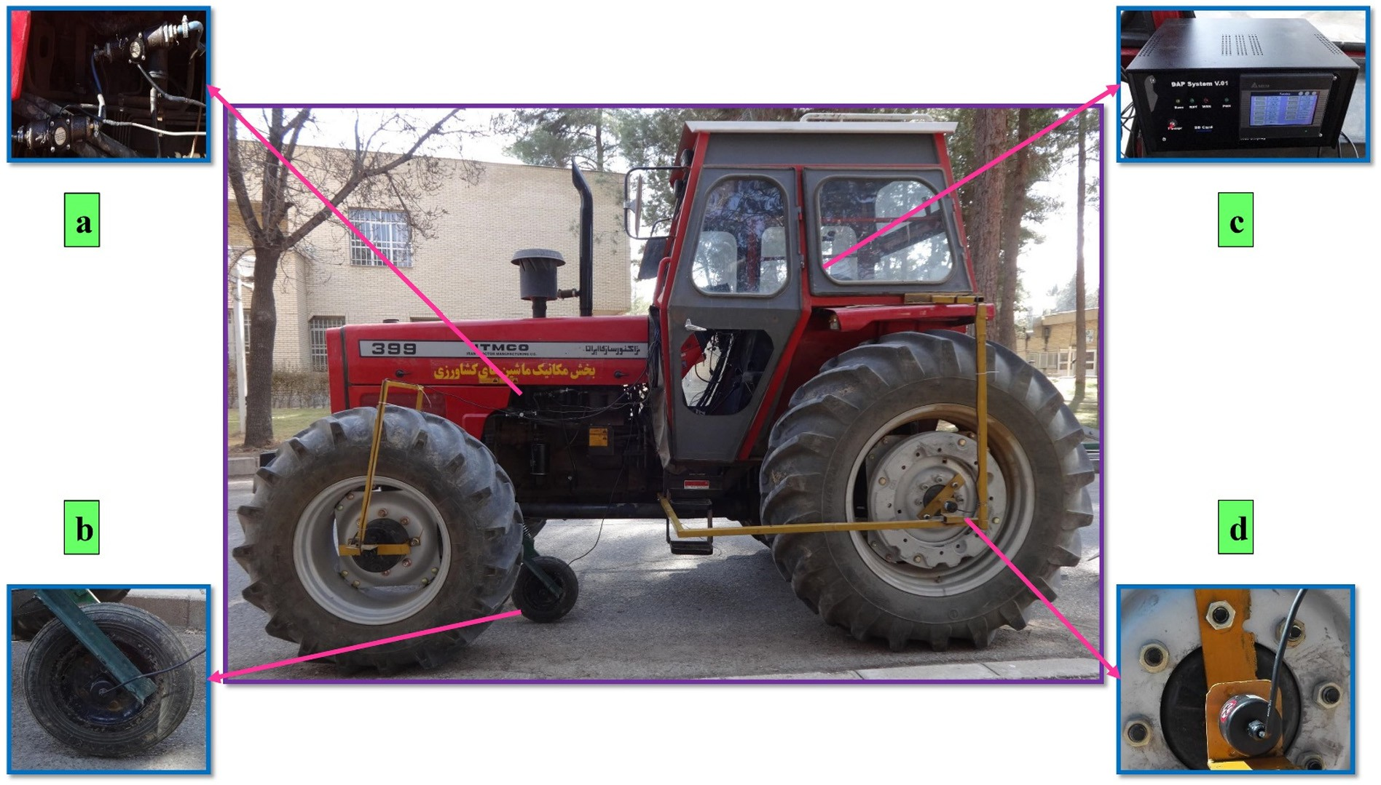](Image%20of%20Fig.%201)

Fig. 1. An instrumented tractor at base station, a) flow meters, b) rotary shaft encoder mounted on non-driving fifth wheel, c) data acquisition unit, and d) rotary shaft encoder mounted on driving rear wheel.

Table 6

Principal technical specifications of the mounted implements used in the research.

|  |  |  |  |  |  |
| --- | --- | --- | --- | --- | --- |
| Implement | Model | Manufacture | Country | Main components | Working width (cm) |
| Chisel plow | CPP | Rau | Germany | Nine spring curved shanks | 225 |
| Disk plow | TAKA 165 | TAKA | Iran | Three disk bottoms | 120 |
| Moldboard plow | 3000IP65 | Moradi | Iran | Three bottoms | 90 |

are employed for stepwise prognostication of the other seven slave per- formance parameters. This task is performed by utilization of two MNE configurations. Therefore, it can be deduced that new simulation sce- nario is established based on development of the MANFIS coupled with the MNE. However, efficiency of new simulation scenario (MANFIS+MNE) is ascertainable in comparison with the two known simulation scenarios (ANN and MANFIS).

* 1. *Aims and questions of research*

The systematic literature survey concludes that there is an inevitable demand to obviate the aforementioned problematic challenge and in- vestigate the hypothesis through development of robust soft computing workplace operated based on the new introduced simulation scenario (MANFIS+MNE) for exhaustive prognostication of whole performance parameters (required draft force of implement, tractor rear wheel slip, fuel consumption per working hour, specific draft force, fuel consump- tion per tilled area, specific volumetric fuel consumption, tractor draw- bar power, tractor tractive efficiency, energy requirement for tillage implement, and overall energy efficiency) of tractor-implement system regarding three independent input variables of plowing depth, forward speed, and tillage implement type. The novelty of this research can be addressed not only to validate the new simulation scenario, but also to follow to respond the main questions outlined below:

* Is efficiency of neuro-fuzzy strategy higher than neural strategy in prognostication of desired output targets based on the compound ef- fect of nominal and numeral input variables?
* Are prognostication accuracy and simulation time of the MANFIS

+MNE simulation workplace better rated than that of the ANN and MANFIS simulation workplaces?

* Is user-friendly configuration of MANFIS+MNE simulation workplace simple enough to be considered as applicable neuro-fuzzy calculator?
* Do physical perceptions obtained from results of prominent simula- tion workplace enrich state of the art in the domain of comprehending behavior of the performance parameters?

1. Research methodology
   1. *Tillage site layout*

Three experimental zones in an arable land of Bajgah Agricultural Re- search Station of Shiraz University (29°32′ N 52°35′ E, North West of Shi- raz city, Iran) were considered as tillage site. The site had clay loam soil texture (35% sand, 30% silt, and 35% clay) and flat topography. Each site

was partitioned into 27 separated plots (30 m long by 5 m wide) resulting in a total of 81 plots. To measure moisture content of plot soils, in five ran- dom locations of the plots, a sampling procedure in 30 cm topsoil layer was carried out utilizing a cylindrical core sampler. The collected soil sam- ples were immediately packed in separate polyethylene bags and trans- ferred to research laboratory. The samples were dried in a convection oven at 105 ± 1 °C until constant weight was obtained (SAA, 1977). To avoid experimental error, the drying process was triplicated for each soil sample and mean value was used. The moisture content of the site soil was found to be 8.84% (g water/g dry sample).

One of the tillage sites employed for chiseling process was covered with uniform wheat stubble. The percentage of wheat stubble coverage was calculated 22% based on Eq.(1) (Papendick, 2002).

Y = 1−e−0.000644X × 100 (1)

* 1. *Specifications of tractor-implement systems*

A popular 4WD tractor with MFWD system, with its front wheels smaller than rear wheels, was used in this research. The key technical specifications of the tractor are provided in Table 4. To measure princi- pal performance parameters in plowing process, the tractor was fully equipped with a digital instrumentation system. The system was devel- oped and validated by the same authors in the previous work (Shafaei et al., 2019a). The instrumentation system composed of a data acquisi- tion unit and three groups of transducer assembly (two flow meters, three rotary shaft encoders, and one load cell). The major engineering details of the transducers are completely reported in Table 5. The instru- mented tractor at base station is shown in Fig. 1.

The two flow meters were utilized for measuring tractor fuel con- sumption. The first one was embedded between the injector pump and fuel filter of the tractor. The second one was also embedded in the line between injection pump and fuel tank and thereby, excess fuel returned to the tank was measured. The difference between two mea- sured values obtained from the flow meters was considered as the trac- tor fuel consumption value.

The load cell was used to measure required draft force of implement in accordance with the method standardized by the RNAM institute (RNAM, 1995). This method has been frequently used in previous works by the researchers (Zhang et al., 2001; Shah et al., 2015; Rahmanian-Koushkaki et al., 2015; Shafaei et al., 2019d).

Driving wheel slip can be continuously measured using the method suggested by Pranav et al. (2010). In this method, to measure forward speed of outer radius of the wheels (ground speed), two encoders were

Table 7

Independent and dependent variables considered in the field operations.

Independent variables Dependent variables

Forward speed (km/h) Plowing depth (cm) Implement Master Slave

2 10 Chisel plow Required draft force of implement Specific draft force

4 20 Disk plow Tractor rear wheel slip Fuel consumption per tilled area

6 30 Moldboard plow Fuel consumption per working hour Specific volumetric fuel consumption

Tractor drawbar power Tractor tractive efficiency

Energy requirement for tillage implement Overall energy efficiency

[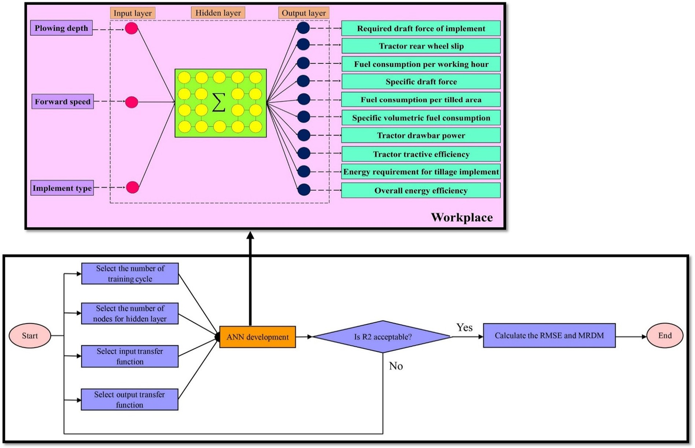](Image%20of%20Fig.%202)

Fig. 2. Flowchart for selection of the best structure of the ANN simulation workplace in accordance with schematic of simulation scenario.

fitted into the wheel hubs of the rear wheels and one on a fifth wheel employing some mechanical joints. The fifth wheel was hinged to the tractor chassis between rear and front wheels as a non-driving wheel. It was reasonable to assume that slip of left and right driving wheels of the rear axle might not be equal at the same time, owing to existence of different soil conditions in the field. Hence, average values of obtained ground speed of left and right driving wheels were considered as theoret- ical forward speed. Meanwhile, measured ground speed of the fifth wheel was considered as actual forward speed. To calculate slip percentage of rear driving wheel of the tractor, Eq.(2) was applied in data acquisition unit of the digital instrumentation system (ASAE, 2003).

S = 1−Vf × 100 (2)

Vd

Three mounted implements of disk, chisel, and moldboard plow commonly used by farmers in southern area of the country were employed in this research. Principal technical specifications of the im- plements are tabulated in Table 6. To restrict redundant and lateral forces acting on the implement in plowing process, the implement at- tached to the tractor was leveled utilizing three-point hitch links of the tractor. Prior to field operations, initial inspection of the tractor- implement system was also performed at base station.

* 1. *Field operations*

The field operations were conducted in a half day (10 AM to 4 PM) on January 16, 2017 in predetermined plots. For each implement type, arrangement of the plots was randomized and blocked based on split plot design with three replications. In this design, plowing depth and forward speed were considered as major and minor treatments, respectively.

Before entering the plots, three-point linkage height lever was acti- vated to lower the implement corresponding to the desired plowing depth. The tractor, in 2WD mode, was also operated at respective gear

and throttle settings (rated speed of engine) to achieve desired forward speed at selected plowing depth in a practice area. These settings of the tractor were remained invariable along each test plot. Before each plot, a practice area was considered to adjust operational treatments (plowing depth and forward speed) until a steady state reached. For each combi- nation of the treatments, three runs were performed to ensure repeat- ability and reliability of collected data. Arithmetic average of the collected data was then used for next step (data processing). The con- sidered levels of the treatments (independent variables) applied in field operations and the master performance parameters of tractor- implement systems measured in field operations in accordance with the slave calculated performance parameters (dependent variables) are reported in Table 7.

In the plots, as the tractor-implement system reached the first installed flag marking, data collection for the master performance pa- rameters was started utilizing the digital instrumentation system. The data collection process continued until end of the plot, and it was stopped as the tractor-implement system passed the second installed flag marking. At end of each plot, a headland area was allocated for turn- ing the tractor-implement system in order to enter into the next plot.

In each plot, required draft force of the implement was measured based on the RNAM method. According to the method, the main tractor-implement system was pulled by an auxiliary tractor (model: 4450, Company: John Deere, Country: USA), while the load cell trans- ducer of the digital instrumentation system was horizontally connected between the two tractors. During applying the RNAM method, it was ensured that the main tractor-implement system and the auxiliary trac- tor were placed on level ground in both lateral and longitudinal direc- tions and the connection line of the transducer was parallel to ground surface. The operations were carried out with the mounted implement at desired plowing depth and forward speed. Obtained data from the transducer were considered as gross traction forces. The operations were also conducted at desired forward speed with the implement in transport position and the collected data from the transducer were con- sidered as rolling resistance force of the tractor wheels. Finally, required

[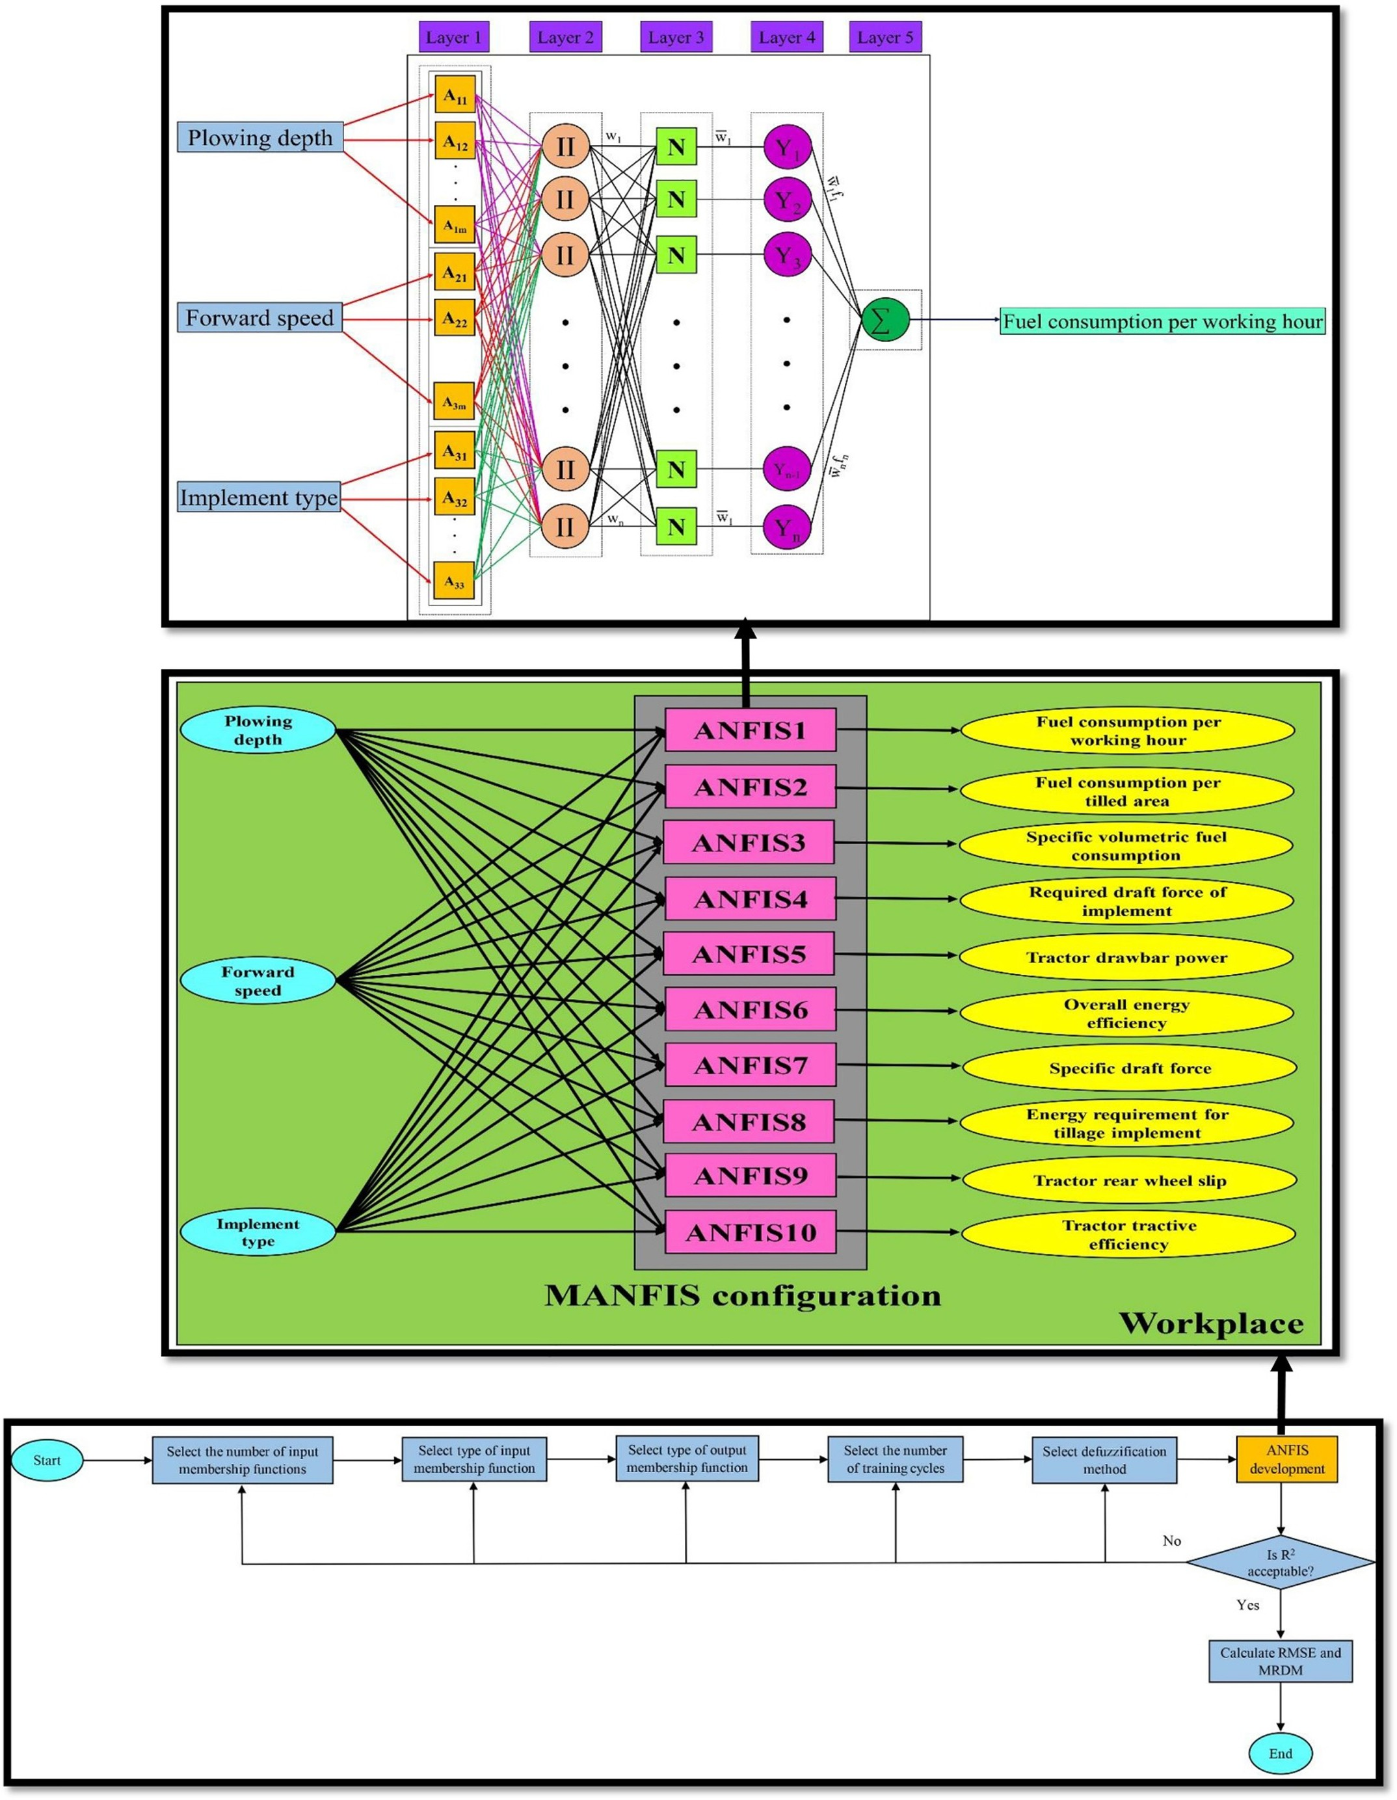](Image%20of%20Fig.%203)

Fig. 3. Flowchart for selection of the best structure of the MANFIS simulation workplace in accordance with schematic of simulation scenario and five-layered structure of the ANFIS.

[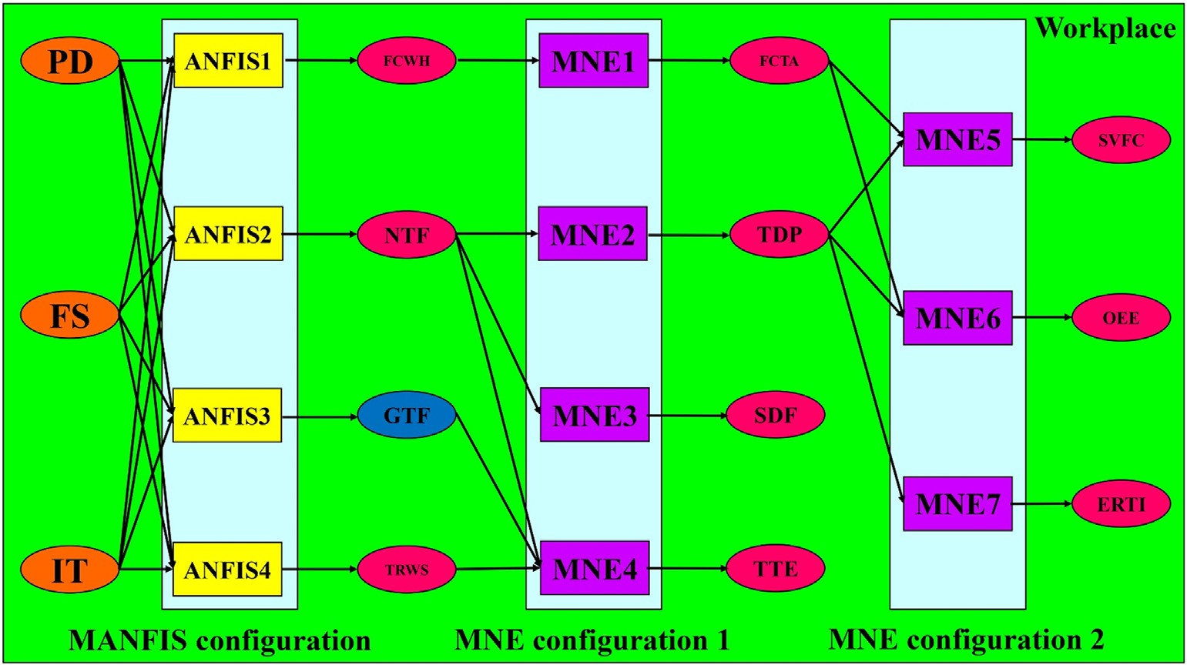](Image%20of%20Fig.%204)

Fig. 4. Schematic of new simulation scenario of the MANFIS+MNE (FS: forward speed, PD: plowing depth, IT: implement type, FCWH: fuel consumption per working hour, NTF: net traction force (required draft force of implement), GTF: gross traction force, TRWS: tractor rear wheel slip, FCTA: fuel consumption per tilled area, TDP: tractor drawbar power, SDF: specific draft force, TTE: tractor tractive efficiency, SVFC: specific volumetric fuel consumption; OEE: overall energy efficiency, ERTI: energy requirement for tillage implement).

draft force of the implement (net traction force) was calculated once rolling resistance force of the main tractor was deducted from the gross traction force. It should be noted that the operations were con-

FCTA = TFC

IFC × h

(9)

ducted, while transmission system of the main tractor was set to neutral position.

To calculate implement field capacity in order to substitute in the Eqs.(5), (6) and (9), the following Eq.(10) was used (ASAE, 2011).

* 1. *Data processing*

Collected data for the master performance parameters (required draft force of implement, tractor rear wheel slip, fuel consumption per working hour) make it possible to calculate the slave performance pa-

IFC = w × FS × Ef

10

* + 1. *Statistical descriptions*

(10)

rameters (specific volumetric fuel consumption, tractor drawbar power, energy requirement for tillage implement, overall energy effi- ciency, tractor tractive efficiency, specific draft force, and fuel consump- tion per tilled area) by means of the following equations (Jr, 1989; ASAE, 2011; Ahmadi, 2016a).

Statistical descriptions for obtained performance parameters of the tractor-implement system in plowing process were performed by utili- zation of some statistical descriptor parameters (mean, standard devia- tion, coefficient of variation, and coefficient of non-uniformity) based on the following equations (Shafaei and Kamgar, 2017).

Pi=N PPi

3.6 × TFC

SVFC = NTF × FS × h (3)

M = i=1

N

qPﬃﬃﬃﬃﬃﬃiﬃ=ﬃﬃNﬃﬃﬃﬃ(ﬃPﬃﬃﬃPﬃﬃﬃiﬃ−ﬃﬃﬃﬃﬃMﬃﬃﬃﬃ)ﬃﬃ2ﬃﬃ

(11)

TDP

NTF × FS

= 3.6 (4)

SD =

i=1

N

(12)

ERTI = TDP

IFC

OEE = 3.6 × TDP

38.7 × FCTA × IFC

(5)

× 100 (6)

CV = SD × 100 (13)

CNU = PPmax−PPmin × 100 (14)

M

M

* 1. *Execution of soft computing simulation workplace*
     1. *ANN*

The multi-layer perceptron architecture of the ANN scenario was

TTE = (1−S NTF × 100 (7)

)

GTF

employed in the simulation workplace. The architecture comprises three main layers: an input layer, hidden layer, and an output layer. Each layer includes several nodes. The number of nodes in the input

and output layer is equal to the number of input and output variables

SDF = NTF

PD × w

(8)

in the simulation workplace. The connections among the nodes in the hidden layer significantly influence prognostication accuracy. The ANN

[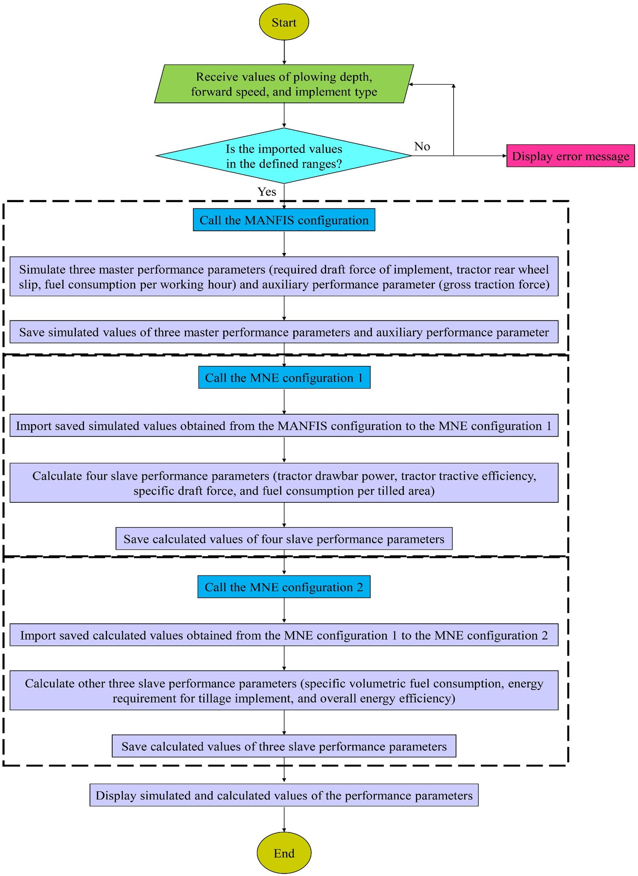](Image%20of%20Fig.%205)

Fig. 5. Operational flowchart of the program algorithm written for running the new simulation scenario of the MANFIS+MNE.

scenario repeatedly decreases overall error of prognostication through modification of its connections among hidden nodes in predetermined training algorithm. In this scenario, prognostication process is automat- ically completed by means of neural computing through the layers. The data sets in input layer are intelligently mapped to hidden layer and consequently mapped to output layer by means of input and output transfer functions, respectively.

In the simulation workplace, the ANN scenario was developed based on three layers. The values of three input variables of plowing depth (10, 20 and 30 cm), forward speed (2, 4 and 6), and implement type (mold- board, disk, and chisel plow) were imported into the input layer and the

values of ten performance parameters of tractor-implement systems in plowing process were imported into output layer, too. Therefore, the ANN scenario was established with three and ten nodes in input and output layers, respectively. In input layer of the simulation workplace, to have possibility of arbitrary selection of the implement, the integers 1, 2 and 3 were assigned for moldboard, disk, and chisel plow imple- ment, respectively.

To import data sets into the ANN simulation workplace, data sets were randomly classified into three categories of training, testing and validation sets by 70:15:15 ratios. During training the ANN simulation workplace, the ANN scenario is tested in contradiction of the test data

Table 8

The values of statistical descriptor parameters determined for required draft force of the implements in plowing process.

|  |  |  |  |  |  |  |
| --- | --- | --- | --- | --- | --- | --- |
| Implement | Minimum (kN) | Maximum (kN) | Mean (kN) | SD (kN) | CV (%) | CNU (%) |
| Chisel plow | 7.88 | 37.81 | 21.87 | 10.55 | 48.24 | 136.85 |
| Disk plow | 5.55 | 21.06 | 13.52 | 4.70 | 34.76 | 114.72 |
| Moldboard plow | 3.85 | 23.04 | 11.52 | 5.99 | 52.00 | 166.58 |

set to control correctness, and training process is stopped when the mean average error remained constant for a specific number of training cycles. This task is considered to avoid over fitting.

According to the ANN structure, several structural arrangements were tried to obtain the best structure with the highest prognostication accuracy. Various structural parameters of the scenario (the number of training cycles, input and output transfer functions, and the number of nodes in hidden layer) were run through frequent simulation tests in the ANN toolbox of STATISTICA 12 software (StatSoft Inc., Tulsa, OK, USA). During development process of the ANN scenario, the number of nodes in the hidden layer was set to a range from 2 to 10. The transfer functions of nodes were considered as follows: tangent, logistic, linear, Gaussian, sine, unit step, logarithm, and exponential. Fig. 2 illustrates the flowchart for selection of the best structure of the ANN simulation workplace in accordance with schematic of simulation scenario.

* + 1. *MANFIS*

The first order Takagi-Sugeno-Kang type of the ANFIS scenario was used to prognosticate ten performance parameters of the tractor- implement systems in plowing process, on the basis of three indepen- dent input variables of plowing depth, forward speed, and implement type. The ANFIS is a five-layered structure including different nodes in each layer. The nodes in each layer connect with the nodes in the previ- ous layer and receive input data coming from the previous nodes. These five layers are known as fuzzification, normalization, fuzzy rule, defuzzification, and output layer, respectively. The ANFIS simulation scenario is completed through passing data sets in these five layers. The scenario is described in the following paragraph.

When input data are assigned to the first layer nodes, they are graded between zero and one by input membership functions (con- stant, triangular, generalized bell (Gbell), gaussian, trapezium, and sig- moid). The graded data are shifted to the second layer nodes as input data. The numerical weights are allocated to the data in the second layer. Furthermore, the second layer normalizes the weighted input data. The weighted input data are transferred to the third layer nodes as input data of fuzzy rules. These rules are defined based on the IF and THEN structure. Output data obtained by the rules are gathered and aggregated to one output value in the fourth layer nodes. This value is converted to desired output variable by defuzzification method (weighted sum and weighted average) of the inference system. Output membership functions (constant and linear) are used for this job. The desired output variable is finally obtained in the fifth layer node.

The second layer of the ANFIS scenario normalizes the weighted input data by training itself. Training process is performed similar to that of the ANN scenario. The Hybrid algorithm is commonly used to train the simulation workplace. The algorithm is a combination of back-propagation and least square error algorithm. In the ANFIS sce- nario, the rules are also tuned automatically regarding relationships be- tween input and output data. As it has been mentioned in Section 1.2, definition of fuzzy rules based on the structure of IF and THEN is very

complex. The overall ANFIS structure has been established based on consideration of one output parameter in accordance with several input variables.

In the MANFIS simulation workplace of MATLAB R2016b software (The Mathworks, Inc., Natick, MA, USA), ten ANFIS sub-environments were individually developed for prognostication of ten performance pa- rameters based on the same input variables of plowing depth (10, 20 and 30 cm), forward speed (2, 4 and 6 km/h), and implement type (moldboard, disk, and chisel plow implement). Similar to the ANN sim- ulation workplace, to introduce implement type as input variable for the MANFIS simulation workplace, the integers 1, 2 and 3 were assigned for moldboard, disk, and chisel plow implement, respectively. Data sets ob- tained from the field operations were randomly shuffled and classified into three groups. The groups including 70, 15 and 15% of the data for training, validating and testing, respectively, of each developed ANFIS sub-environment. Calibration process was frequently performed until the best structure of the ANFIS scenario for each performance parameter with the highest prognostication accuracy was reached. The process was completed by trying different training cycles, the number of input membership functions, type of input membership functions, type of output membership functions, and defuzzification methods. Flowchart for selection of the best MANFIS scenario in accordance with schematic of simulation scenario and five-layered structure of the ANFIS are shown in Fig. 3.

* + 1. *MANFIS+MNE*

The new simulation scenario of MANFIS+MNE was considered based on one MANFIS configuration coupled with two MNE configura- tions (Fig. 4). The MANFIS configuration consisted of four ANFIS sub- environments. Three ANFIS sub-environments were applied for prog- nostication of three master performance parameters (required draft force of implement, tractor rear wheel slip, fuel consumption per work- ing hour) of tractor-implement systems in plowing process regarding three input variables of plowing depth (10, 20 and 30 cm), forward speed (2, 4 and 6 km/h), and implement type (moldboard, disk, and chisel plow). The forth ANFIS sub-environment was applied as auxiliary one for prognostication of gross traction force. The best finalized struc- tures obtained for the ANFIS1, ANFIS4, and ANFIS9 in the previous Section 2.5.2 were employed in the workplace. Similarly, calibration process was frequently performed until the best structure (training cy- cles, the number of input membership functions, type of input member- ship function, type of output membership functions, and defuzzification methods) of the ANFIS4 was obtained for prognostication of gross trac- tion force. The output prognostication values of the MANFIS configura- tion could be used in the MNE configuration1. The MNE configuration1 consisted of four MNE environments for prognostication of tractor drawbar power, tractor tractive efficiency, specific draft force, and fuel consumption per tilled area, based on the Eqs.(4), (7), (8) and (9), respectively. The values of four performance parameters calculated by the MNE configuration1 were delivered to the MNE configuration2 in

Table 9

The values of statistical descriptor parameters determined for tractor rear wheel slip in plowing process.

|  |  |  |  |  |  |  |
| --- | --- | --- | --- | --- | --- | --- |
| Implement | Minimum (%) | Maximum (%) | Mean (%) | SD (%) | CV (%) | CNU (%) |
| Chisel plow | 8.98 | 49.02 | 27.24 | 12.24 | 44.93 | 146.99 |
| Disk plow | 5.11 | 38.65 | 22.60 | 10.30 | 45.58 | 148.41 |
| Moldboard plow | 6.54 | 46.23 | 23.07 | 11.52 | 49.93 | 172.04 |

Table 10

The values of statistical descriptor parameters determined for fuel consumption per working hour in plowing process.

|  |  |  |  |  |  |  |
| --- | --- | --- | --- | --- | --- | --- |
| Implement | Minimum (L/h) | Maximum (L/h) | Mean (L/h) | SD (L/h) | CV (%) | CNU (%) |
| Chisel plow | 7.26 | 22.65 | 15.56 | 4.47 | 28.73 | 98.91 |
| Disk plow | 5.29 | 14.89 | 9.91 | 2.99 | 30.17 | 96.87 |
| Moldboard plow | 4.02 | 13.95 | 9.10 | 3.06 | 33.63 | 109.12 |

order to calculate other three performance parameters (specific volu-

metric fuel consumption, energy requirement for tillage implement,

"1 i=N #0.5

and overall energy efficiency) on the basis of the Eqs.(3), (5) and (6). Fi- nally, obtained values of ten performance parameters were achievable

N i=1

RMSE =

∑ PPsim −PP

2

(16)

;i obt;i

in the simulation workplace output.

MRDM

100 Xi=N PPsim;i −PPobt;i 17

To run the MANFIS+MNE simulation scenario, a simple code was written in Command Window of MATLAB R2016b software. When the

=

i=1

N

( )

PPobt;i

program (finalized code) was run, the prerequisite values of plowing depth in the range of 10–30 cm, forward speed in the range of 2–6 km/h, and tillage implement type (the integers 1, 2 and 3 for mold- board, disk, and chisel plow implement, respectively) were received and the MANFIS configuration, MNE configuration1, and MNE configu- ration2 were respectively called to simulate and calculate the ten per- formance parameters. The error message was displayed in Command Window, if the prerequisite values were not imported in desired ranges.

It should be also noted that required specifications (working width and

*2.7. Performance benchmark of prominent soft computing simulation workplaces*

Simulation residual errors for prominent simulation workplace of the ANN, MANFIS, and MANFIS+MNE scenario were plotted to apprise sensitivity of prognostication values to actual data. The MAVSRE was also calculated (Eq.(18)) for each prominent simulation workplace.

i=N

N

;

;

field efficiency) for each implement were defined for the program to be

used in the MNE configuration1 and MNE configuration2. Finally, the

MAVSRE = 1 X PPsim i−PPobt i

i=1

(18)

prerequisite values in accordance with the ten obtained performance parameters were placed in predetermined appropriate columns of workspace in the MATLAB software. Therefore, it can be pointed out that the defined program for simulation workplace worked like a neuro-fuzzy calculator in workspace of the MATLAB software. It means that, values of the independent input variables were received and values of the ten performance parameters were tabulated. Opera- tional flowchart of the program algorithm is shown in Fig. 5. As it can be seen in the Fig. 5, the algorithm consisted of three sub-programs for the MANFIS configuration, MNE configuration1, and MNE configura- tion2 which are called, respectively.

* 1. *Prognostication appraisal of soft computing simulation workplaces*

Goodness of prognostication accuracy of each performance parame- ter of tractor-implement systems in soft computing simulation work- places for each scenario (the ANN, MANFIS, and MANFIS+MNE) was appraised by coefficient of determination of regression analysis utilizing Eq.(15) (Shafaei et al., 2016b). Moreover, absolute and relative error of prognostication were ascertained by Eqs.(16) and (17), respectively (Shafaei et al., 2017b). The highest values of coefficient of determination closed to one and the lowest values of the RMSE and MRDM indicate the best simulation workplace for each scenario. However, prognostication accuracy of prominent simulation workplace of each scenario must be compared with that of other ones.

2 Pi=N PPobt i−PPsim i 2 !

To recognize prominent scenario for prognostication of performance parameters of tractor-implement systems, not only a comparative trend was performed between the values obtained from the Eqs.(15)–(18), but also simulation time and user-friendly configuration of three sce- narios were benchmarked. The scenario with the highest prognostica- tion accuracy, the lowest simulation time, and more user-friendly configuration was recognized as the prominent one.

1. Results and discussion
   1. *Statistical descriptions*
      1. *Required draft force of implement*

Table 8 reports values of statistical descriptor parameters obtained for required draft force of the implements in plowing process. According to the Table 8, it can be seen although the range of draft force variations of the implements has overlap, the range for chisel plow implement was higher than that of other two implements. This led to considerable higher mean value of the draft force of chisel plow implement than that of the other two implements. The possible explanation for this can be related to higher working width of chisel plow implement in comparison with that of the other ones (Table 6). Another reason for this fact might be corresponded to wheat stubble coverage of the tillage site for chiseling process. Because of wheat root concentration in 30 cm topsoil layer, resistance forces are higher and thereby, more draft forces are required to cut and break the soil.

The minimum and maximum values of draft force tabulated in the Table 8 were found in the lowest (forward speed = 2 km/h and plowing

depth = 10 cm) and the highest (forward speed = 6 km/h and plowing

R = 1−

i=1 ; ;

Pi=N PPobt i−PPobtave 2

i=1

;

(15)

depth = 30 cm) level of combination of the treatments, respectively, for

all implements. The draft force variation ranges obtained in this

Table 11

The values of statistical descriptor parameters determined for fuel consumption per tilled area in plowing process.

|  |  |  |  |  |  |  |
| --- | --- | --- | --- | --- | --- | --- |
| Implement | Minimum (L/ha) | Maximum (L/ha) | Mean (L/ha) | SD (L/ha) | CV (%) | CNU (%) |
| Chisel plow | 12.18 | 43.22 | 23.07 | 9.66 | 41.87 | 134.55 |
| Disk plow | 12.04 | 28.38 | 20.08 | 5.23 | 26.05 | 81.38 |
| Moldboard plow | 15.58 | 37.69 | 27.84 | 7.39 | 26.55 | 79.42 |

Table 12

The values of statistical descriptor parameters determined for specific volumetric fuel consumption in plowing process.

|  |  |  |  |  |  |  |
| --- | --- | --- | --- | --- | --- | --- |
| Implement | Minimum (L/kW h) | Maximum (L/kW h) | Mean (L/kW h) | SD (L/kW h) | CV (%) | CNU (%) |
| Chisel plow | 0.36 | 1.66 | 0.88 | 0.43 | 48.86 | 147.73 |
| Disk plow | 0.47 | 2.05 | 1.07 | 0.48 | 44.86 | 147.66 |
| Moldboard plow | 0.36 | 1.87 | 0.97 | 0.50 | 51.55 | 155.67 |

research were within the similar ranges reported by Smith and Williford (1988) and Almaliki (2018).

* + 1. *Tractor rear wheel slip*

The values of statistical descriptor parameters determined for tractor rear wheel slip in plowing process are tabulated in Table 9. As it can be seen in the Table 9, the wheel slip ranged from 5.11 to 49.02% for the im- plements. However, the wheel slip range for chisel plow implement was higher than that of moldboard plow followed by disk plow implement. This discrepancy might be attributable to the higher required draft force of chisel plow implement than that of other implements which is men- tioned in the previous subset. Due to lack of proper traction force gener- ated by the tractor wheels in some conditions, the wheel slip increases. Moreover, lower contact between the wheels and soil occurs, when the tillage site is covered with uniform wheat stubble. Therefore, higher wheel slip might be related to a condition that luges of the tires do not penetrate enough into the soil to make proper engagement needed for overcoming the higher implement draft.

Similar to the previous subset results, the minimum and maximum values of the wheel slip reported in the Table 9 were found in the lowest (forward speed = 2 km/h and plowing depth = 10 cm) and the highest (forward speed = 6 km/h and plowing depth = 30 cm) level of combina- tion of the treatments, respectively, for the implements. The range of the wheel slip observed in this research overlaps with the range documented by previous authors in their research study reports (Kolahloo and Loghavi, 1994; Tayel et al., 2015; Taiwo and Owusu-Sekyere, 2015).

* + 1. *Fuel consumption per working hour*

The values of statistical descriptor parameters determined for fuel consumption per working hour in plowing process are given in Table 10. With reference to the Table 10, it is clear that higher range of the fuel consumption per working hour for chisel plow implement than that of other implements led to higher associated mean value (ap- proximately 1.6 times) of the fuel consumption for the chisel plow im- plement than that of the other implements. There are two potential causes for this observation. Higher required draft force of chisel plow implement than that of other implements and consequently, higher fuel energy requirements and fuel consumption per working hour. Ad- ditionally, higher wheel slip of tractor results in higher fuel consump- tion (Thansandote et al., 1977).

In parallel with two previously discussed performance parameters, the minimum and maximum values of fuel consumption per working hour noted in the Table 10 were found in the lowest (forward speed

= 2 km/h and plowing depth = 10 cm) and the highest (forward speed = 6 km/h and plowing depth = 30 cm) level of combination of the treatments, respectively, for the implements. These results for vari- ation of the fuel consumption are in compliance with the findings of previous researchers for strip tillage machine (Sarauskis et al., 2017).

* + 1. *Fuel consumption per tilled area*

Table 11 presents values of statistical descriptor parameters de- termined for fuel consumption per tilled area in plowing process. It can be observed in the Table 11 that the fuel consumption ranged from 12.04 to 43.22 (L/ha) for the implements. However, the fuel consumption range for chisel plow implement is higher than that of other implements. According to Eq.(9), higher value of fuel con- sumption per working hour leads to calculation of higher value of fuel consumption per tilled area. Hence, higher values of fuel con- sumption per working hour of chisel plow implement than that of other implements resulted in the higher values of fuel consump- tion per tilled area of the chisel plow implement than that of other implements.

On the contrary with previously discussed performance parameters, the minimum and maximum values of the fuel consumption mentioned in the Table 11 were found in combination of the treatments of forward speed = 6 km/h and plowing depth = 10 cm, and forward speed = 2 km/h and plowing depth = 30 cm, respectively, for the implements. The variation range of the fuel consumption observed in the present re- search is consistent with the results published by previous researchers (Hughes and Baker, 1977; Hemmat and Khashoei, 1995; Stajnko et al., 2009).

* + 1. *Specific volumetric fuel consumption*

The values of statistical descriptor parameters determined for spe- cific volumetric fuel consumption in plowing process are organized in Table 12. As it can be found in the Table 12, the variation range of the fuel consumption for disk plow was higher than that of the other imple- ments. One possible explanation for this is related to the Eq.(3). The Eq.

(3) shows the inverse relation between specific volumetric fuel con- sumption and the draft force as well as direct relation between specific volumetric fuel consumption and fuel consumption per working hour. The combination of these two relations results in various values calcu- lated for specific volumetric fuel consumption.

From analogical point of view, the minimum and maximum values of specific volumetric fuel consumption were obtained in different levels of combination of the treatments against those of fuel consump- tion per working hour and fuel consumption per tilled area. The mini- mum and maximum values of specific volumetric fuel consumption were obtained in the forward speed = 6 km/h and plowing depth = 30 cm, and the forward speed = 2 km/h and plowing depth = 10, re- spectively, for the implements. The variation range of the fuel consump- tion observed in the current research is consistent with the results of Parvanloo et al. (2015).

* + 1. *Specific draft force*

The values of statistical descriptor parameters determined for spe- cific draft force in plowing process are denoted in Table 13. With refer- ence to the Table 13, the range of specific draft force for moldboard plow

Table 13

The values of statistical descriptor parameters determined for specific draft force in plowing process.

|  |  |  |  |  |  |  |
| --- | --- | --- | --- | --- | --- | --- |
| Implement | Minimum (kN/m2) | Maximum (kN/m2) | Mean (kN/m2) | SD (kN/m2) | CV (%) | CNU (%) |
| Chisel plow | 35.02 | 70.09 | 47.33 | 10.25 | 21.66 | 74.10 |
| Disk plow | 46.21 | 77.27 | 59.82 | 15.32 | 25.61 | 51.92 |
| Moldboard plow | 34.44 | 109.66 | 64.29 | 21.72 | 33.78 | 117 |

Table 14

The values of statistical descriptor parameters determined for tractor drawbar power in plowing process.

|  |  |  |  |  |  |  |
| --- | --- | --- | --- | --- | --- | --- |
| Implement | Minimum (kW) | Maximum (kW) | Mean (kW) | SD (kW) | CV (%) | CNU (%) |
| Chisel plow | 4.38 | 63.02 | 26 | 19.36 | 74.46 | 225.54 |
| Disk plow | 3.08 | 35.10 | 16.18 | 10.35 | 63.97 | 122.31 |
| Moldboard plow | 2.13 | 38.40 | 14.18 | 10.92 | 77.01 | 255.78 |

implement was higher than that of disk plow followed by chisel plow implement. This result is reasonable, since implement working width of moldboard plow was lower than that of other two implements. Ac- cording to Eq.(8), the inverse relation between specific draft force and implement working width is observed. Therefore, lower implement working width leads to higher specific draft force in the same condi- tions. From another point of view, based on Eq.(8), the value of required draft force of implement is important in specific draft force calculation. In case of chisel and moldboard plow implement, the minimum value of specific draft force was obtained in forward speed = 2 km/h and plowing depth = 20 cm, while in the case of disk plow implement, the minimum specific draft occurred in forward speed = 2 km/h and plowing depth = 30 cm. The maximum value of specific draft force for moldboard plow implement was obtained in forward speed = 6 km/h and plowing depth = 10 cm. Meanwhile, the maximum value of specific draft force for disk and chisel plow implement was obtained in forward speed = 6 km/h and plowing depth = 20 cm. These results are closely aligned with those reported by Plouffe et al. (1995) and

Arvidsson et al. (2004).

* + 1. *Tractor drawbar power*

The values of statistical descriptor parameters determined for tractor drawbar power in plowing process are classified in Table 14. In accor- dance with the values of the Table 14, it is clear that the range of the values of tractor drawbar power for chisel plow implement was consid- erably higher than that of other two implements. The reason behind this result is explained by the fact of direct relation between required draft force of implement and tractor drawbar power (Eq.(4)). Hence, based on the Eq.(4), higher required draft force of implement results in higher tractor drawbar power in the same tested conditions. Therefore, based on the Table 8, higher values of the draft force of chisel plow implement than those of other two implements lead to higher values of the draw- bar power of chisel plow implement than those of other two implements.

Similar to the results of required draft force of implement, the min- imum and maximum values of tractor drawbar power tabulated in the Table 14 were found in the lowest (forward speed = 2 km/h and plowing depth = 10 cm) and the highest (forward speed = 6 km/h and plowing depth = 30 cm) level of combination of the treatments, re- spectively, for the implements. The drawbar power results in this re- search are parallel to the results published by Chaplin et al. (1988), and Loghavi and Moradi (1996).

* + 1. *Tractor tractive efficiency*

Table 15 reports the values of statistical descriptor parameters deter- mined for tractor tractive efficiency in plowing process. According to the Table 15, tractor tractive efficiency is higher when disk plow implement was attached to the tractor. This might be attributed to lower tractor rear wheel slip (Table 9). Based on the Eq.(7), the tractive efficiency is direct function of the wheel slip and net traction force (required draft

force of implement). Therefore, on the basis of the Table 9, lower tractor rear wheel slip, as disk plow implement attached to the tractor, than that of other two implement leads to higher tractor tractive efficiency. The minimum and maximum values of tractor tractive efficiency re- ported in the Table 15 were found in the highest (forward speed = 6 km/h and plowing depth = 30 cm) and the lowest (forward speed

= 2 km/h and plowing depth = 10 cm) level of combination of the treatments, respectively, for the implements. The observed results are in general agreement with the results of previous studies conducted by Inchebron et al. (2012) and Far et al. (2015a).

* + 1. *Energy requirement for tillage implement*

Table 16 lists values of statistical descriptor parameters determined for energy requirement for tillage implements. The mean values of the energy requirement in the Table 16 tend to increase as implement varies from chisel to moldboard plow implement. A possible explana- tion for this result is related to implement working width (Eqs.(5) and (10)). Substitution of the Eq.(10) into the Eq.(5) shows that the energy requirements is an inverse function of implement working width. Ac- cordingly, considering working width of the implements noted in the Table 6, the energy requirement increased as implement working width decreased.

Similar to the results of some previously discussed performance pa- rameters, the minimum and maximum values of the energy require- ment noted in the Table 16 were found in the lowest (forward speed

= 2 km/h and plowing depth = 10 cm) and the highest (forward speed = 6 km/h and plowing depth = 30 cm) level of combination of the treatments, respectively, for the implements. The energy require- ment results reported by Jr et al. (1985) and Celik et al. (2007) are sim- ilar compared to results of this research.

* + 1. *Overall energy efficiency*

Table 17 shows values of statistical descriptor parameters deter- mined for overall energy efficiency of the tractor-implement systems in plowing process. The mean value of the efficiency of disk plow imple- ment in the Table 17 is higher than that of chisel plow followed by moldboard plow implement. This result occurred due to higher tractor tractive efficiency, when disk plow implement was attached to the trac- tor. Moreover, based on the Eq.(6), overall energy efficiency is inverse function of fuel consumption per tilled area. Therefore, the lower values of fuel consumption per tilled area for disk plow implement (Table 11) than those of other two implements were effective in obtained higher values of overall energy efficiency.

Similar to the results of some previously discussed performance pa- rameters, the minimum and maximum values of the efficiency in plowing process documented in the Table 17 were found in the lowest (forward speed = 2 km/h and plowing depth = 10 cm) and the highest (forward speed = 6 km/h and plowing depth = 30 cm) level of combi- nation of the treatments, respectively, for the implements. The obtained values for the efficiency in current research are similarly ranged with

Table 15

The values of statistical descriptor parameters determined for tractor tractive efficiency in plowing process.

|  |  |  |  |  |  |  |
| --- | --- | --- | --- | --- | --- | --- |
| Implement | Minimum (%) | Maximum (%) | Mean (%) | SD (%) | CV (%) | CNU (%) |
| Chisel plow | 43.69 | 89.23 | 68.99 | 13.23 | 19.18 | 66.01 |
| Disk plow | 65.65 | 91.26 | 75.72 | 11.25 | 14.86 | 33.82 |
| Moldboard plow | 49.43 | 87.54 | 71.06 | 10.18 | 41.33 | 53.63 |

Table 16

The values of statistical descriptor parameters determined for energy requirement for the implements in plowing process.

|  |  |  |  |  |  |  |
| --- | --- | --- | --- | --- | --- | --- |
| Implement | Minimum (MJ/ha) | Maximum (MJ/ha) | Mean (MJ/ha) | SD (MJ/ha) | CV (%) | CNU (%) |
| Chisel plow | 11.45 | 54.92 | 31.77 | 15.33 | 48.25 | 136.83 |
| Disk plow | 14.26 | 54.17 | 34.77 | 12.08 | 34.74 | 114.78 |
| Moldboard plow | 12.45 | 74.85 | 37.40 | 19.46 | 52.03 | 166.85 |

those described by Jr (1985), Sumer and Sabanci (2005), and Far et al. (2015b).

Overall view on the Tables 8–17 demonstrated high values obtained for the CV and CNU of the performance parameters. These high values imply drastic changes of the performance parameters as affected by level changes of the treatments (plowing depth and forward speed). Ac- cording to the ranges obtained for the performance parameters of tractor-implement systems in plowing process in clay loam soil, it can be claimed that these results are complementary for the research study results which were comprehensively conducted by Kheiralla et al. (2004) in sandy clay loam soil of Malaysia in case of moldboard, disk plow, disk harrow, and rotary tiller implements. Hence, it is practi- cally desired that the experts who work in respective realms focus their attention to these two published research results in order to optimize the management of machinery in plowing process in the similar condi- tions like these researches.

* 1. *Performance appraisal of soft computing simulation workplaces*
     1. *ANN*

The parameters of the several structural arrangements in accordance with corresponding R2, RMSE, and MRDM of selected twenty ANN soft computing simulation workplaces executed to prognosticate perfor- mance parameters of the tractor-implement systems in plowing process are provided in Tables 18–27. As it can be seen in the Tables 18–27, the prominent ANN soft computing simulation workplace was recognized with 6 nodes in hidden layer, 113 training cycles, and exponential and tangent transfer function in input and output layer, respectively. The corresponding values of R2 for the prominent simulation workplace ranged from 0.683 to 0.890 for ten performance parameters. Graphical presentation of this improper range is illustrated in Fig. 6. With refer- ence to the Fig. 6, the simulated and actual values of performance pa- rameters are not clustered perfectly around 1:1 line which indicates poor agreement between the simulated and actual values. Additionally, scattered distribution of simulation residual error as shown in Fig. 7 clearly depicts that there was no pattern in the errors for the prominent simulation workplace. However, distribution of the error values was centralized in wide ranges. Fig. 8 displays frequency of simulation resid- ual error that indicates scattered distribution of percentage of the errors. On the discussion about these observations, it can be stated that simula- tion residual errors of the prominent simulation workplace were sensi- tive to actual data and consequently, it is inferred that the simulation workplace was not matched well to actual data. It is related to the fact that the effect of a variable on performance parameter values was not appropriately simulated by the prominent simulation workplace. In contrast to this result, some previous investigators (Taghavifar et al., 2013; Taghavifar and Mardani, 2014a; Taghavifar and Mardani, 2014b; Taghavifar et al., 2015) pronounced excellent prognostication accuracy of well-developed ANN soft computing simulation workplaces for

estimation of unit output target on the basis of numeral multiple input variables.

* + 1. *MANFIS*

The parameters of the several structural arrangements in accordance with corresponding R2, RMSE, and MRDM of selected twenty MANFIS soft computing simulation workplaces executed to prognosticate per- formance parameters of the tractor-implement systems in plowing pro- cess are presented in Tables 28–37. As it has been emphasized in the Tables 28–37, the structural arrangements of each prominent ANFIS sub-environment are not identical in comparison with those of other sub-environments.

The Table 28 implies that prominent ANFIS soft computing simula- tion sub-environment for prognostication of required draft force of the implements in plowing process was the one with structural arrange- ments of 125 training cycles, 3 input membership functions for forward speed, plowing depth, and implement type, trapezium and linear func- tion for input and output, respectively, and weighted sum defuzzification method.

The Table 29 presents that prominent ANFIS soft computing simula- tion sub-environment for prognostication of tractor rear wheel slip in plowing process was the one with structural arrangements of 79 train- ing cycles, 2 input membership functions for forward speed, and 3 input membership functions for plowing depth and implement type, sigmoid and constant function for input and output, respectively, and weighted sum defuzzification method.

The Table 30 indicates that prominent ANFIS soft computing simula- tion sub-environment for prognostication of fuel consumption per working hour in plowing process was the one with structural arrange- ments of 124 training cycles, 4 input membership functions for plowing depth, and 3 input membership functions for forward speed and imple- ment type, sigmoid and linear function for input and output, respec- tively, and weighted sum defuzzification method.

The Table 31 address that prominent ANFIS soft computing simula- tion sub-environment for prognostication of fuel consumption per tilled area in plowing process was the one with structural arrangements of 157 training cycles, 4 input membership functions for forward speed and plowing depth, and 3 input membership functions for implement type, trapezium and constant function for input and output, respec- tively, and weighted average defuzzification method.

The Table 32 reports that prominent ANFIS soft computing simula- tion sub-environment for prognostication of specific volumetric fuel consumption in plowing process was the one with structural arrange- ments of 138 training cycles, 3 input membership functions for forward speed and implement type, and 4 input membership functions for plowing depth, triangular and linear function for input and output, re- spectively, and weighted sum defuzzification method.

The Table 33 highlights that prominent ANFIS soft computing simu- lation sub-environment for prognostication of specific draft force of the implements in plowing process was the one with structural

Table 17

The values of statistical descriptor parameters determined for overall energy efficiency of the tractor-implement systems in plowing process.

|  |  |  |  |  |  |  |
| --- | --- | --- | --- | --- | --- | --- |
| Implement | Minimum (%) | Maximum (%) | Mean (%) | SD (%) | CV (%) | CNU (%) |
| Chisel plow | 5.61 | 25.89 | 14.58 | 6.91 | 47.39 | 139.10 |
| Disk plow | 6.85 | 27.69 | 16.29 | 6.46 | 39.66 | 127.93 |
| Moldboard plow | 5.64 | 21.63 | 11.54 | 4.82 | 41.77 | 138.56 |

Table 18 The parameters of the several structural arrangements in accordance with corresponding R2, RMSE, and MRDM of selected twenty ANN soft computing simulation workplaces executed to prognosticate required draft force of the implements in plowing process.

|  |  |  |  |  |  |  |
| --- | --- | --- | --- | --- | --- | --- |
| The number of nodes in hidden layer | The number of training cycles | Transfer function |  | R2 RMSE (kN) MRDM (%) | | |
|  |  | Input | Output |  | | |
| 2 | 107 | Tangent | Tangent | 0.790 | 5.011 | 9.414 |
| 4 | 85 | Logistic | Exponential | 0.709 | 5.541 | 10.125 |
| 5 | 145 | Tangent | Sine | 0.805 | 3.514 | 9.059 |
| 9 | 161 | Tangent | Logistic | 0.814 | 4.574 | 9.037 |
| 10 | 183 | Logistic | Logistic | 0.628 | 5.763 | 11.002 |
| 10 | 96 | Exponential | Gaussian | 0.698 | 5.587 | 10.589 |
| 10 | 112 | Tangent | Gaussian | 0.623 | 5.897 | 11.020 |
| 2 | 174 | Gaussian | Tangent | 0.777 | 4.568 | 9.645 |
| 3 | 135 | Sine | Logistic | 0.781 | 4.460 | 9.541 |
| 2 | 142 | Exponential | Gaussian | 0.629 | 5.064 | 10.124 |
| 3 | 119 | Logistic | Tangent | 0.755 | 4.521 | 9.974 |
| 7 | 157 | Tangent | Logistic | 0.804 | 4.026 | 9.412 |
| 8 | 164 | Logistic | Logistic | 0.798 | 4.578 | 9.568 |
| 2 | 105 | Sine | Logistic | 0.811 | 3.596 | 9.025 |
| 6 | 113 | Exponential | Tangent | 0.825 | 3.116 | 8.979 |
| 5 | 136 | Logistic | Tangent | 0.820 | 3.158 | 9.107 |
| 6 | 154 | Tangent | Logistic | 0.785 | 3.546 | 9.620 |
| 7 | 97 | Tangent | Sine | 0.780 | 3.600 | 9.691 |
| 9 | 189 | Logistic | Sine | 0.769 | 3.845 | 9.785 |
| 5 | 140 | Logistic | Tangent | 0.792 | 3.597 | 10.004 |

The boldfaced line represents prominent simulation workplace.

arrangements of 124 training cycles, 3 input membership functions for forward speed plowing depth, and implement type, Gbell and linear function for input and output, respectively, and weighted average defuzzification method.

The Table 34 describes that prominent ANFIS soft computing simula- tion sub-environment for prognostication of tractor drawbar power in plowing process was the one with structural arrangements of 115 train- ing cycles, 2, 4 and 3 input membership functions for forward speed, plowing depth, and implement type, respectively, sigmoid and constant function for input and output, respectively, and weighted sum defuzzification method.

The Table 36 indicates that prominent ANFIS soft computing simula- tion sub-environment for prognostication of tractor energy require- ment for tillage implements was the one with structural arrangements of 146 training cycles, 4 input membership functions for forward

speed and plowing depth, 3 input membership functions for implement type, triangular and constant function for input and output, respec- tively, and weighted average defuzzification method.

The Table 37 presents that prominent ANFIS soft computing simula- tion sub-environment for prognostication of overall energy efficiency of the tractor-tillage implements was the one with structural arrange- ments of 144 training cycles, 3 input membership functions for forward speed, plowing depth, and implement type, Gbell and linear function for input and output, respectively, and weighted average defuzzification method.

An overview on the Tables 28–37 issues that the corresponding

values of R2 for the prominent sub-environment ranged from 0.971 to 0.997 for ten performance parameters. Graphical presentation of this superior range is depicted in Fig. 9. As it can be seen in the Fig. 9, the simulated and actual values of performance parameters were

Table 19 The parameters of the several structural arrangements in accordance with corresponding R2, RMSE, and MRDM of selected twenty ANN soft computing simulation workplaces executed to prognosticate tractor rear wheel slip in plowing process.

The number of nodes in hidden layer The number of training cycles Transfer function R2 RMSE (%) MRDM (%)

Input Output

|  |  |  |  |  |  |  |
| --- | --- | --- | --- | --- | --- | --- |
| 2 | 107 | Tangent | Tangent | 0.809 | 4.001 | 10.975 |
| 4 | 85 | Logistic | Exponential | 0.770 | 5.068 | 11.220 |
| 5 | 145 | Tangent | Sine | 0.819 | 3.871 | 10.447 |
| 9 | 161 | Tangent | Logistic | 0.847 | 3.547 | 10.158 |
| 10 | 183 | Logistic | Logistic | 0.794 | 4.847 | 11.024 |
| 10 | 96 | Exponential | Gaussian | 0.833 | 3.714 | 10.167 |
| 10 | 112 | Tangent | Gaussian | 0.818 | 3.899 | 10.810 |
| 2 | 174 | Gaussian | Tangent | 0.816 | 3.905 | 10.814 |
| 3 | 135 | Sine | Logistic | 0.838 | 3.875 | 9.912 |
| 2 | 142 | Exponential | Gaussian | 0.880 | 3.410 | 9.851 |
| 3 | 119 | Logistic | Tangent | 0.804 | 4.024 | 10.985 |
| 7 | 157 | Tangent | Logistic | 0.767 | 5.669 | 11.268 |
| 8 | 164 | Logistic | Logistic | 0.783 | 5.425 | 11.102 |
| 2 | 105 | Sine | Logistic | 0.773 | 5.517 | 11.161 |
| 6 | 113 | Exponential | Tangent | 0.890 | 3.319 | 9.646 |
| 5 | 136 | Logistic | Tangent | 0.760 | 5.126 | 11.215 |
| 6 | 154 | Tangent | Logistic | 0.848 | 3.895 | 9.785 |
| 7 | 97 | Tangent | Sine | 0.836 | 3.911 | 9.694 |
| 9 | 189 | Logistic | Sine | 0.811 | 4.006 | 10.012 |
| 5 | 140 | Logistic | Tangent | 0.773 | 5.547 | 11.120 |

The boldfaced line represents prominent simulation workplace.

Table 20 The parameters of the several structural arrangements in accordance with corresponding R2, RMSE, and MRDM of selected twenty ANN soft computing simulation workplaces executed to prognosticate fuel consumption per working hour in plowing process.

|  |  |  |  |  |  |  |
| --- | --- | --- | --- | --- | --- | --- |
| The number of nodes in hidden layer | The number of training cycles | Transfer function |  | R2 RMSE (L/h) MRDM (%) | | |
|  |  | Input | Output |  | | |
| 2 | 107 | Tangent | Tangent | 0.764 | 2.464 | 12.160 |
| 4 | 85 | Logistic | Exponential | 0.869 | 1.540 | 9.815 |
| 5 | 145 | Tangent | Sine | 0.772 | 2.651 | 11.895 |
| 9 | 161 | Tangent | Logistic | 0.857 | 1.884 | 10.007 |
| 10 | 183 | Logistic | Logistic | 0.838 | 1.965 | 9.984 |
| 10 | 96 | Exponential | Gaussian | 0.789 | 2.506 | 12.055 |
| 10 | 112 | Tangent | Gaussian | 0.865 | 1.823 | 10.129 |
| 2 | 174 | Gaussian | Tangent | 0.797 | 2.621 | 11.984 |
| 3 | 135 | Sine | Logistic | 0.751 | 2.776 | 12.113 |
| 2 | 142 | Exponential | Gaussian | 0.868 | 1.874 | 9.717 |
| 3 | 119 | Logistic | Tangent | 0.831 | 1.974 | 10.007 |
| 7 | 157 | Tangent | Logistic | 0.756 | 2.774 | 12.115 |
| 8 | 164 | Logistic | Logistic | 0.870 | 1.742 | 10.014 |
| 2 | 105 | Sine | Logistic | 0.789 | 2.336 | 12.060 |
| 6 | 113 | Exponential | Tangent | 0.872 | 1.472 | 9.660 |
| 5 | 136 | Logistic | Tangent | 0.782 | 2.512 | 12.057 |
| 6 | 154 | Tangent | Logistic | 0.788 | 2.498 | 12.064 |
| 7 | 97 | Tangent | Sine | 0.838 | 1.985 | 9.997 |
| 9 | 189 | Logistic | Sine | 0.750 | 2.781 | 12.117 |
| 5 | 140 | Logistic | Tangent | 0.757 | 2.779 | 12.104 |

The boldfaced line represents prominent simulation workplace.

appropriately clustered close to 1:1 line which specifies excellent corre- lation between the simulated and actual values. Furthermore, distribu- tion of simulation residual error is scattered in Fig. 10. The Fig. 10 clearly illustrates that specific pattern was not recognized in the errors for the prominent sub-environments and distribution of the error values was scattered around zero value. Fig. 11 exhibitions frequency of simulation residual error revealing low ranges of percentage of the errors. Accordingly, it can be pointed out that simulation residual error of the prominent simulation workplace was not sensitive to actual data and therefore, it is inferred that the simulation workplace was matched well to actual data.

According to the observed results, it is found that the performance parameters of the tractor-implement systems in plowing process were satisfactorily prognosticated by the prominent MANFIS soft computing simulation workplace executed in this research. This means that the ef- fect of nominal and numeral variables on the performance parameter

values was appropriately simulated by the prominent simulation workplace.

The previous authors (Taghavifar and Mardani, 2014c; Taghavifar and Mardani, 2015; Taghavifar et al., 2016; Taghavifar and Mardani, 2017) who employed the ANFIS simulation workplace in their Agricul- tural and Biosystems Engineering studies have similarly found proper adequacy of the workplace for nonlinear prognostications of desired variables.

* + 1. *MANFIS+MNE*

The parameters of the several structural arrangements in accordance with corresponding R2, RMSE, and MRDM of selected twenty ANFIS soft computing simulation sub-environment executed to prognosticate gross traction force of the tractor-implement systems in plowing pro- cess are listed in Table 38. As it can be seen in the Table 38, the promi- nent ANFIS soft sub-environment is highlighted with structural

Table 21 The parameters of the several structural arrangements in accordance with corresponding R2, RMSE, and MRDM of selected twenty ANN soft computing simulation workplaces executed to prognosticate fuel consumption per tilled area in plowing process.

|  |  |  |  |  |  |  |
| --- | --- | --- | --- | --- | --- | --- |
| The number of nodes in hidden layer | The number of training cycles | Transfer function |  | R2 RMSE (L/ha) MRDM (%) | | |
|  |  | Input | Output |  | | |
| 2 | 107 | Tangent | Tangent | 0.646 | 4.120 | 11.515 |
| 4 | 85 | Logistic | Exponential | 0.657 | 4.020 | 11.856 |
| 5 | 145 | Tangent | Sine | 0.656 | 3.895 | 11.874 |
| 9 | 161 | Tangent | Logistic | 0.614 | 4.195 | 12.154 |
| 10 | 183 | Logistic | Logistic | 0.671 | 3.822 | 10.940 |
| 10 | 96 | Exponential | Gaussian | 0.649 | 4.013 | 11.807 |
| 10 | 112 | Tangent | Gaussian | 0.623 | 3.991 | 12.074 |
| 2 | 174 | Gaussian | Tangent | 0.615 | 4.198 | 12.127 |
| 3 | 135 | Sine | Logistic | 0.632 | 4.070 | 11.954 |
| 2 | 142 | Exponential | Gaussian | 0.658 | 3.641 | 11.748 |
| 3 | 119 | Logistic | Tangent | 0.642 | 4.075 | 11.852 |
| 7 | 157 | Tangent | Logistic | 0.631 | 4.076 | 12.017 |
| 8 | 164 | Logistic | Logistic | 0.637 | 4.069 | 11.994 |
| 2 | 105 | Sine | Logistic | 0.631 | 4.077 | 11.957 |
| 6 | 113 | Exponential | Tangent | 0.701 | 3.480 | 9.074 |
| 5 | 136 | Logistic | Tangent | 0.623 | 4.125 | 12.058 |
| 6 | 154 | Tangent | Logistic | 0.666 | 3.954 | 11.954 |
| 7 | 97 | Tangent | Sine | 0.678 | 3.812 | 11.895 |
| 9 | 189 | Logistic | Sine | 0.643 | 3.710 | 11.990 |
| 5 | 140 | Logistic | Tangent | 0.654 | 3.784 | 11.826 |

The boldfaced line represents prominent simulation workplace.

Table 22 The parameters of the several structural arrangements in accordance with corresponding R2, RMSE, and MRDM of selected twenty ANN soft computing simulation workplaces executed to prognosticate specific volumetric fuel consumption in plowing process.

|  |  |  |  |  |  |  |
| --- | --- | --- | --- | --- | --- | --- |
| The number of nodes in hidden layer | The number of training cycles | Transfer function |  | R2 RMSE (L/kW h) MRDM (%) | | |
|  |  | Input | Output |  | | |
| 2 | 107 | Tangent | Tangent | 0.831 | 0.174 | 8.376 |
| 4 | 85 | Logistic | Exponential | 0.782 | 0.301 | 9.174 |
| 5 | 145 | Tangent | Sine | 0.797 | 0.284 | 9.162 |
| 9 | 161 | Tangent | Logistic | 0.779 | 0.312 | 9.184 |
| 10 | 183 | Logistic | Logistic | 0.785 | 0.294 | 9.181 |
| 10 | 96 | Exponential | Gaussian | 0.850 | 0.172 | 8.315 |
| 10 | 112 | Tangent | Gaussian | 0.754 | 0.380 | 9.234 |
| 2 | 174 | Gaussian | Tangent | 0.778 | 0.315 | 9.192 |
| 3 | 135 | Sine | Logistic | 0.751 | 0.389 | 9.241 |
| 2 | 142 | Exponential | Gaussian | 0.837 | 0.191 | 8.624 |
| 3 | 119 | Logistic | Tangent | 0.793 | 0.321 | 9.111 |
| 7 | 157 | Tangent | Logistic | 0.797 | 0.324 | 9.125 |
| 8 | 164 | Logistic | Logistic | 0.825 | 0.184 | 8.547 |
| 2 | 105 | Sine | Logistic | 0.803 | 0.215 | 9.016 |
| 6 | 113 | Exponential | Tangent | 0.859 | 0.169 | 8.292 |
| 5 | 136 | Logistic | Tangent | 0.779 | 0.304 | 9.201 |
| 6 | 154 | Tangent | Logistic | 0.815 | 0.198 | 8.541 |
| 7 | 97 | Tangent | Sine | 0.775 | 0.311 | 9.198 |
| 9 | 189 | Logistic | Sine | 0.847 | 0.178 | 8.317 |
| 5 | 140 | Logistic | Tangent | 0.775 | 0.310 | 9.205 |

The boldfaced line represents prominent simulation workplace.

arrangements of 126 training cycles, 4 input membership functions for forward speed and plowing depth, 3 input membership functions for implement type, Gbell and linear function for input and output, respec- tively, and weighted average defuzzification method. Meanwhile, its statistical performance criteria is R2 = 0.984, RMSE = 0.985 kN and MRDM = 2.167%. It should be noted that the structural arrangements of the prominent ANFIS soft computing simulation sub-environments for the three master performance parameters of required draft force of implements, tractor rear wheel slip, and fuel consumption per working hour obtained in the MANFIS soft computing simulation workplace were also employed in the MANFIS+MNE simulation workplace. Con- sequently, it is expected that the statistical performance criteria related to the three master performance parameters in two simulation scenar- ios were the same.

Table 39 presents statistical performance criteria for three mas- ter as well as seven slave performance parameters prognosticated

in the MANFIS+MNE simulation workplace. As it has been docu- mented in the Table 39, the corresponding values of R2 for prognos- tication of ten performance parameters ranged from 0.971 to 0.996. Graphical presentation of this excellent range as shown in Fig. 12 reveals that the simulated and actual values of performance pa- rameters were properly clustered close to 1:1 line which implied outstanding correlation between the simulated and actual values. Additionally, distribution of simulation residual error is scattered in Fig. 13. The Fig. 13 clearly exhibits that no specific pattern was recognized in the errors for the simulation workplace and distribu- tion of the error values was scattered around zero value. Fig. 14 dis- plays frequency of simulation residual error revealing low ranges of percentage of the errors. Accordingly, it can be stated that simu- lation residual error of the simulation workplace was not sensitive to actual data and consequently, it is inferred that the workplace was matched well to actual data.

Table 23 The parameters of the several structural arrangements in accordance with corresponding R2, RMSE, and MRDM of selected twenty ANN soft computing simulation workplaces executed to prognosticate specific draft force of the implements in plowing process.

|  |  |  |  |  |  |  |
| --- | --- | --- | --- | --- | --- | --- |
| The number of nodes in hidden layer | The number of training cycles | Transfer function |  | R2 RMSE (kN/m2) MRDM (%) | | |
|  |  | Input | Output |  | | |
| 2 | 107 | Tangent | Tangent | 0.724 | 8.142 | 9.136 |
| 4 | 85 | Logistic | Exponential | 0.727 | 7.900 | 9.130 |
| 5 | 145 | Tangent | Sine | 0.707 | 8.810 | 9.424 |
| 9 | 161 | Tangent | Logistic | 0.720 | 7.990 | 9.132 |
| 10 | 183 | Logistic | Logistic | 0.728 | 7.911 | 9.119 |
| 10 | 96 | Exponential | Gaussian | 0.704 | 9.045 | 9.541 |
| 10 | 112 | Tangent | Gaussian | 0.721 | 7.889 | 9.120 |
| 2 | 174 | Gaussian | Tangent | 0.723 | 7.902 | 9.124 |
| 3 | 135 | Sine | Logistic | 0.714 | 7.905 | 9.326 |
| 2 | 142 | Exponential | Gaussian | 0.728 | 8.006 | 9.148 |
| 3 | 119 | Logistic | Tangent | 0.727 | 7.914 | 9.143 |
| 7 | 157 | Tangent | Logistic | 0.700 | 8.987 | 9.551 |
| 8 | 164 | Logistic | Logistic | 0.723 | 7.994 | 9.098 |
| 2 | 105 | Sine | Logistic | 0.723 | 7.954 | 9.102 |
| 6 | 113 | Exponential | Tangent | 0.731 | 7.835 | 8.490 |
| 5 | 136 | Logistic | Tangent | 0.708 | 8.815 | 9.492 |
| 6 | 154 | Tangent | Logistic | 0.727 | 8.125 | 9.121 |
| 7 | 97 | Tangent | Sine | 0.707 | 8.812 | 9.432 |
| 9 | 189 | Logistic | Sine | 0.701 | 8.914 | 9.403 |
| 5 | 140 | Logistic | Tangent | 0.714 | 7.984 | 9.326 |

The boldfaced line represents prominent simulation workplace.

Table 24 The parameters of the several structural arrangements in accordance with corresponding R2, RMSE, and MRDM of selected twenty ANN soft computing simulation workplaces executed to prognosticate tractor drawbar power in plowing process.

|  |  |  |  |  |  |  |
| --- | --- | --- | --- | --- | --- | --- |
| The number of nodes in hidden layer | The number of training cycles | Transfer function |  | R2 RMSE (kW) MRDM (%) | | |
|  |  | Input | Output |  | | |
| 2 | 107 | Tangent | Tangent | 0.797 | 5.226 | 9.912 |
| 4 | 85 | Logistic | Exponential | 0.767 | 5.294 | 10.005 |
| 5 | 145 | Tangent | Sine | 0.742 | 5.312 | 10.019 |
| 9 | 161 | Tangent | Logistic | 0.838 | 5.042 | 9.551 |
| 10 | 183 | Logistic | Logistic | 0.817 | 5.159 | 9.609 |
| 10 | 96 | Exponential | Gaussian | 0.788 | 5.352 | 9.958 |
| 10 | 112 | Tangent | Gaussian | 0.763 | 5.315 | 10.012 |
| 2 | 174 | Gaussian | Tangent | 0.745 | 5.328 | 10.017 |
| 3 | 135 | Sine | Logistic | 0.780 | 5.249 | 9.962 |
| 2 | 142 | Exponential | Gaussian | 0.812 | 5.151 | 9.634 |
| 3 | 119 | Logistic | Tangent | 0.778 | 5.245 | 9.962 |
| 7 | 157 | Tangent | Logistic | 0.760 | 5.304 | 9.914 |
| 8 | 164 | Logistic | Logistic | 0.800 | 5.213 | 9.647 |
| 2 | 105 | Sine | Logistic | 0.831 | 5.042 | 9.502 |
| 6 | 113 | Exponential | Tangent | 0.841 | 5.005 | 9.482 |
| 5 | 136 | Logistic | Tangent | 0.808 | 5.203 | 9.623 |
| 6 | 154 | Tangent | Logistic | 0.836 | 5.096 | 9.586 |
| 7 | 97 | Tangent | Sine | 0.771 | 5.297 | 9.957 |
| 9 | 189 | Logistic | Sine | 0.838 | 5.012 | 9.584 |
| 5 | 140 | Logistic | Tangent | 0.810 | 5.169 | 9.625 |

The boldfaced line represents prominent simulation workplace.

* 1. *Performance benchmark of prominent soft computing simulation workplaces*

The statistical performance criteria of prominent soft computing simulation workplaces executed based on three simulation scenarios (ANN, MANFIS, and MANFIS+MNE) for prognostication of performance parameters of the tractor-implement systems in plowing process are compared in Fig. 15. According to the Fig. 15, the coefficient of determi- nation varied as 0.683 b R2 b 0.890, 0.971 b R2 b 0.997 and 0.971 b R2 b 0.996 for the prominent ANN, MANFIS, and MANFIS+MNE workplace, respectively. Additionally, the relative error of prognostication varied as 7.91% b MRDM b 9.66%, 0.91% b MRDM b 4.79% and 1.48% b MRDM

b 4.97% for the prominent ANN, MANFIS, and MANFIS+MNE workplace, respectively. Meanwhile, the RMSE and MAVSRE for the MANFIS and

MANFIS+MNE simulation scenarios ranged in a lower bond than those of the ANN simulation scenario. Hence, robustness of prognostica- tion accuracy of the MANFIS and MANFIS+MNE simulation scenario than that of the ANN simulation scenario was approved.

In this research, there was no precise relationship between perfor- mance parameters and implement type (nominal variable). Hence, weakness of several trained ANN simulation scenario based on neural strategy, to sufficiently prognosticate performance parameters resulted in uncovering this imprecise relationship. The neuro-fuzzy strategy can extract sophisticated relationship between output and input parame- ters using both neural and fuzzy benefits. The fuzzy strategy can prog- nosticate output based on multiple input variables using defined rules which are ascertained by expert knowledge. Unlike the neural strategy, the fuzzy strategy cannot find relationship between input and output

Table 25 The parameters of the several structural arrangements in accordance with corresponding R2, RMSE, and MRDM of selected twenty ANN soft computing simulation workplaces executed to prognosticate tractor tractive efficiency in plowing process.

The number of nodes in hidden layer The number of training cycles Transfer function R2 RMSE (%) MRDM (%)

Input Output

|  |  |  |  |  |  |  |
| --- | --- | --- | --- | --- | --- | --- |
| 2 | 107 | Tangent | Tangent | 0.676 | 4.198 | 8.410 |
| 4 | 85 | Logistic | Exponential | 0.669 | 4.230 | 8.569 |
| 5 | 145 | Tangent | Sine | 0.611 | 5.025 | 8.799 |
| 9 | 161 | Tangent | Logistic | 0.680 | 4.123 | 7.956 |
| 10 | 183 | Logistic | Logistic | 0.635 | 4.852 | 8.847 |
| 10 | 96 | Exponential | Gaussian | 0.625 | 4.956 | 8.927 |
| 10 | 112 | Tangent | Gaussian | 0.678 | 4.145 | 8.417 |
| 2 | 174 | Gaussian | Tangent | 0.658 | 4.789 | 8.869 |
| 3 | 135 | Sine | Logistic | 0.664 | 4.119 | 8.812 |
| 2 | 142 | Exponential | Gaussian | 0.635 | 4.927 | 9.024 |
| 3 | 119 | Logistic | Tangent | 0.610 | 5.123 | 9.011 |
| 7 | 157 | Tangent | Logistic | 0.634 | 4.911 | 9.016 |
| 8 | 164 | Logistic | Logistic | 0.618 | 5.195 | 8.902 |
| 2 | 105 | Sine | Logistic | 0.603 | 5.114 | 8.875 |
| 6 | 113 | Exponential | Tangent | 0.683 | 4.046 | 7.912 |
| 5 | 136 | Logistic | Tangent | 0.646 | 4.751 | 8.741 |
| 6 | 154 | Tangent | Logistic | 0.669 | 4.239 | 8.563 |
| 7 | 97 | Tangent | Sine | 0.666 | 4.236 | 8.560 |
| 9 | 189 | Logistic | Sine | 0.651 | 4.536 | 8.667 |
| 5 | 140 | Logistic | Tangent | 0.625 | 5.007 | 8.915 |

The boldfaced line represents prominent simulation workplace.

Table 26 The parameters of the several structural arrangements in accordance with corresponding R2, RMSE, and MRDM of selected twenty ANN soft computing simulation workplaces executed to prognosticate energy requirement for the implements in plowing process.

|  |  |  |  |  |  |  |
| --- | --- | --- | --- | --- | --- | --- |
| The number of nodes in hidden layer | The number of training cycles | Transfer function |  | R2 RMSE (MJ/ha) MRDM (%) | | |
|  |  | Input | Output |  | | |
| 2 | 107 | Tangent | Tangent | 0.728 | 6.148 | 10.201 |
| 4 | 85 | Logistic | Exponential | 0.792 | 5.691 | 9.707 |
| 5 | 145 | Tangent | Sine | 0.756 | 6.009 | 10.025 |
| 9 | 161 | Tangent | Logistic | 0.758 | 5.998 | 9.991 |
| 10 | 183 | Logistic | Logistic | 0.717 | 6.211 | 10.281 |
| 10 | 96 | Exponential | Gaussian | 0.756 | 6.004 | 10.017 |
| 10 | 112 | Tangent | Gaussian | 0.798 | 5.675 | 9.697 |
| 2 | 174 | Gaussian | Tangent | 0.757 | 6.004 | 10.021 |
| 3 | 135 | Sine | Logistic | 0.807 | 5.584 | 9.657 |
| 2 | 142 | Exponential | Gaussian | 0.796 | 5.681 | 9.710 |
| 3 | 119 | Logistic | Tangent | 0.747 | 6.094 | 10.53 |
| 7 | 157 | Tangent | Logistic | 0.710 | 6.352 | 10.301 |
| 8 | 164 | Logistic | Logistic | 0.807 | 5.571 | 9.650 |
| 2 | 105 | Sine | Logistic | 0.724 | 6.157 | 10.212 |
| 6 | 113 | Exponential | Tangent | 0.813 | 5.484 | 9.582 |
| 5 | 136 | Logistic | Tangent | 0.737 | 6.097 | 10.053 |
| 6 | 154 | Tangent | Logistic | 0.742 | 6.102 | 10.107 |
| 7 | 97 | Tangent | Sine | 0.734 | 6.102 | 10.075 |
| 9 | 189 | Logistic | Sine | 0.725 | 6.150 | 10.212 |
| 5 | 140 | Logistic | Tangent | 0.708 | 6.340 | 10.325 |

The boldfaced line represents prominent simulation workplace.

parameters by training itself. On the other hand, to appropriately prog- nosticate target, the neural strategy based simulation workplace trains itself and the fuzzy strategy based simulation workplace uses defined fuzzy rules. The neuro-fuzzy strategy finds proper fuzzy rules based on training itself. Hence, an outstanding ability of the neuro-fuzzy strat- egy based simulation scenario is to find compound and uncertain rela- tionships between output and input parameters. In this research, it was found that the prominent MANFIS and MANFIS+MNE simulation workplaces could detect exhaustive relationships between performance parameters (dependent variables) and independent numeral variables of plowing depth and forward speed, and nominal variable of imple- ment type. These relationships were ruled in fuzzy form and then trained to attain minimum value of simulation residual errors.

In parallel with this obtained result, satisfactory prognostication ac- curacy of the ANFIS simulation workplace versus the ANN simulation workplace in several previous Biosystems Engineering researches has

been covered by Khoshnevisan et al. (2014) and Khoshnevisan et al. (2015).

Profound appraisal of structural arrangements of the prominent MANFIS and MANFIS+MNE simulation workplaces in the Figs. 3 and 4, and Tables 28–38 confirms that the statistical performance criteria of two simulation workplaces were approximately identical. However, in the MANFIS simulation workplace, ten different ANFIS simulation sub-environments with various structural arrangements must be run to acceptably prognosticate the performance parameters of the tractor-implement systems in plowing process. While, in the MANFIS

+MNE simulation workplace, four different ANFIS simulation sub- environments must be run. In other words, the ten performance param- eters could be adequately prognosticated with the lower simulation time and more user-friendly configuration in the MANFIS+MNE simu- lation workplace than MANFIS simulation workplace. Hence, it can be stated that the MANFIS+MNE simulation workplace is trustworthy

Table 27 The parameters of the several structural arrangements in accordance with corresponding R2, RMSE, and MRDM of selected twenty ANN soft computing simulation workplaces executed to prognosticate overall energy efficiency of the tractor-implement systems in plowing process.

The number of nodes in hidden layer The number of training cycles Transfer function R2 RMSE (%) MRDM (%)

Input Output

|  |  |  |  |  |  |  |
| --- | --- | --- | --- | --- | --- | --- |
| 2 | 107 | Tangent | Tangent | 0.825 | 2.851 | 9.256 |
| 4 | 85 | Logistic | Exponential | 0.848 | 2.610 | 9.117 |
| 5 | 145 | Tangent | Sine | 0.803 | 3.181 | 9.704 |
| 9 | 161 | Tangent | Logistic | 0.852 | 2.591 | 9.125 |
| 10 | 183 | Logistic | Logistic | 0.848 | 2.527 | 9.019 |
| 10 | 96 | Exponential | Gaussian | 0.821 | 3.007 | 9.410 |
| 10 | 112 | Tangent | Gaussian | 0.804 | 3.179 | 9.611 |
| 2 | 174 | Gaussian | Tangent | 0.839 | 2.819 | 9.367 |
| 3 | 135 | Sine | Logistic | 0.811 | 3.124 | 9.527 |
| 2 | 142 | Exponential | Gaussian | 0.839 | 2.682 | 9.303 |
| 3 | 119 | Logistic | Tangent | 0.852 | 2.548 | 9.073 |
| 7 | 157 | Tangent | Logistic | 0.831 | 2.911 | 9.417 |
| 8 | 164 | Logistic | Logistic | 0.831 | 2.917 | 9.426 |
| 2 | 105 | Sine | Logistic | 0.803 | 3.180 | 9.715 |
| 6 | 113 | Exponential | Tangent | 0.878 | 2.142 | 8.666 |
| 5 | 136 | Logistic | Tangent | 0.827 | 2.806 | 9.220 |
| 6 | 154 | Tangent | Logistic | 0.836 | 2.709 | 9.174 |
| 7 | 97 | Tangent | Sine | 0.830 | 2.711 | 9.210 |
| 9 | 189 | Logistic | Sine | 0.859 | 2.523 | 9.006 |
| 5 | 140 | Logistic | Tangent | 0.865 | 2.421 | 8.954 |

The boldfaced line represents prominent simulation workplace.

[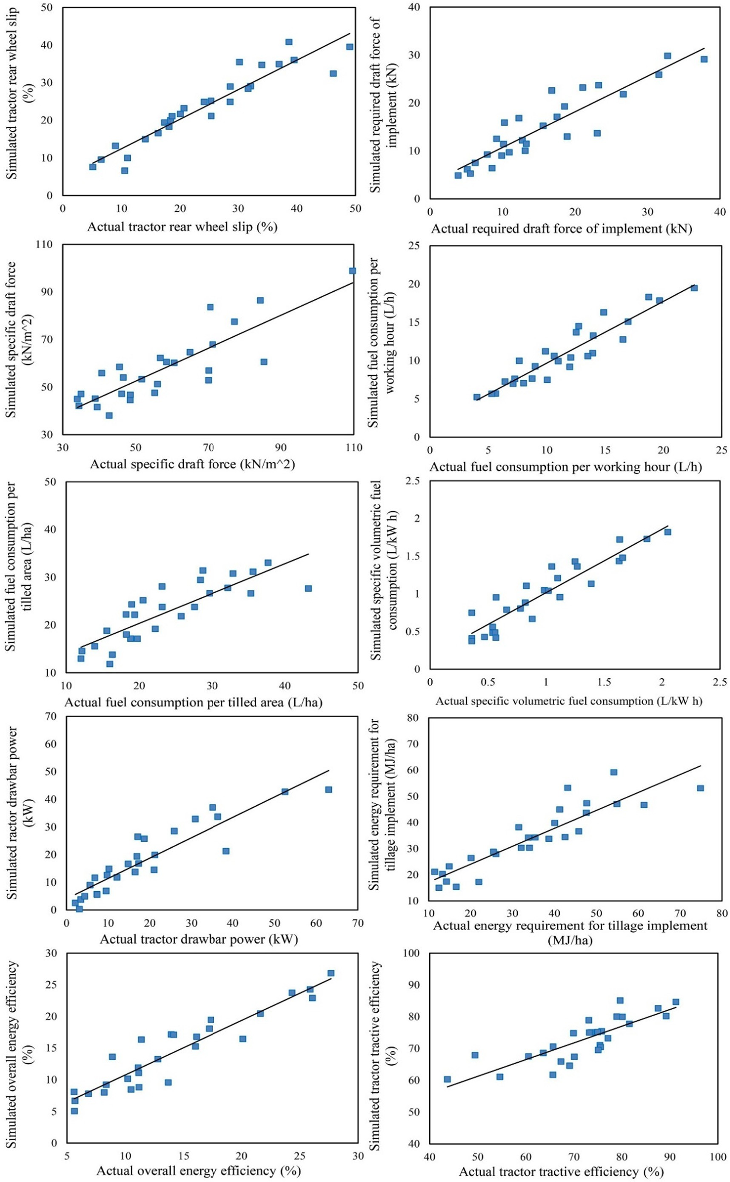](Image%20of%20Fig.%206)

Fig. 6. Graphical presentation of correlation between the simulated values by the prominent ANN simulation workplace and actual values of performance parameters of tractor-implement systems in plowing process.

[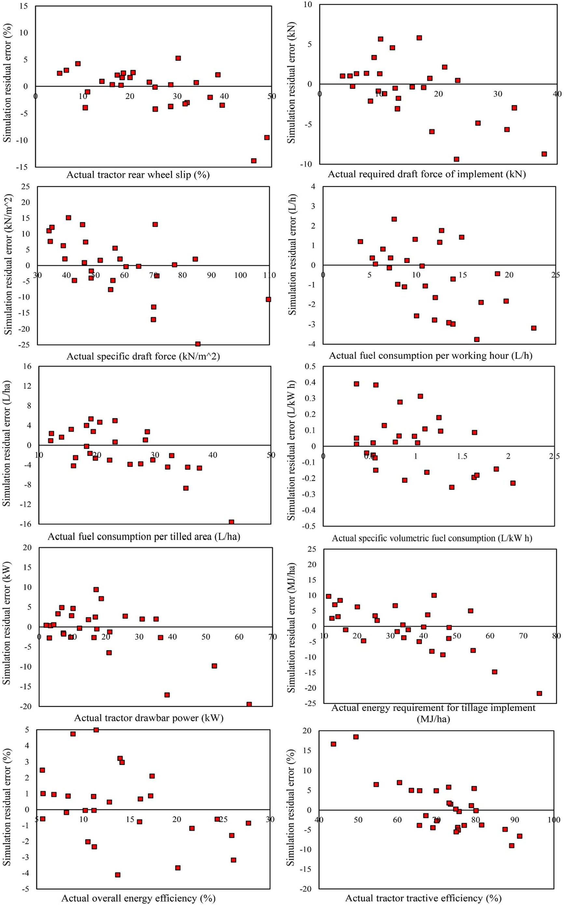](Image%20of%20Fig.%207)

Fig. 7. Simulation residual error plots for the simulated values by the prominent ANN simulation workplace for performance parameters of tractor-implement systems in plowing process.

[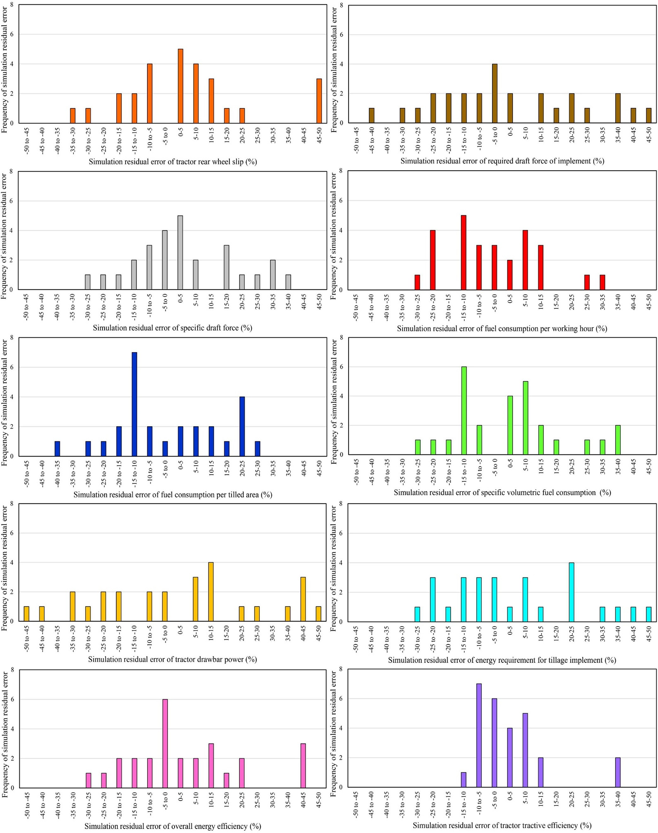](Image%20of%20Fig.%208)

Fig. 8. Frequency plots of simulation residual error for the simulated values by the prominent ANN simulation workplace for performance parameters of tractor-implement systems in plowing process.

Table 28

The parameters of the several structural arrangements in accordance with corresponding R2, RMSE, and MRDM of selected twenty ANFIS soft computing simulation sub-environment ex- ecuted to prognosticate required draft force of the implements in plowing process.

The number of training cycles The number of input membership functions Membership function Defuzzification method R2 RMSE (kN) MRDM (%)

|  |  |  |  |  |  |  |  |
| --- | --- | --- | --- | --- | --- | --- | --- |
|  | | Input | Output |  | | | |
| 125 | 3,2,3 | Gaussian | Linear | Weighted sum | 0.893 | 2.006 | 3.019 |
| 93 | 4,4,3 | Sigmoid | Constant | Weighted sum | 0.882 | 2.058 | 3.084 |
| 80 | 4,2,3 | Gaussian | Linear | Weighted sum | 0.914 | 1.422 | 2.601 |
| 83 | 3,3,3 | Sigmoid | Linear | Weighted average | 0.934 | 1.416 | 2.623 |
| 96 | 2,2,3 | Gaussian | Linear | Weighted average | 0.914 | 1.420 | 2.615 |
| 111 | 2,4,3 | Triangular | Constant | Weighted average | 0.905 | 1.653 | 2.729 |
| 134 | 4,4,3 | Gbell | Constant | Weighted average | 0.949 | 1.330 | 2.511 |
| 125 | 3,3,3 | Trapezium | Linear | Weighted sum | 0.985 | 1.117 | 2.267 |
| 72 | 2,2,3 | Gbell | Constant | Weighted average | 0.947 | 1.337 | 2.519 |
| 108 | 3,4,3 | Gaussian | Linear | Weighted sum | 0.969 | 1.221 | 2.325 |
| 114 | 4,3,3 | Triangular | Constant | Weighted sum | 0.892 | 2.011 | 3.028 |
| 75 | 2,2,3 | Pi | Linear | Weighted average | 0.971 | 1.198 | 2.312 |
| 106 | 3,3,3 | Gbell | Constant | Weighted average | 0.899 | 1.952 | 2.913 |
| 121 | 3,4,3 | Gaussian | Linear | Weighted sum | 0.890 | 1.984 | 2.910 |
| 88 | 2,3,3 | Gaussian | Linear | Weighted sum | 0.958 | 1.296 | 2.410 |
| 95 | 3,2,3 | Trapezium | Linear | Weighted sum | 0.971 | 1.192 | 2.296 |
| 138 | 4,4,3 | Trapezium | Constant | Weighted sum | 0.903 | 1.782 | 2.756 |
| 120 | 4,2,3 | Triangular | Constant | Weighted sum | 0.971 | 1.188 | 2.294 |
| 138 | 3,3,3 | Pi | Constant | Weighted average | 0.910 | 1.477 | 2.665 |
| 79 | 3,3,3 | Gbell | Constant | Weighted average | 0.915 | 1.418 | 2.591 |

The boldfaced line represents distinguished simulation framework.

and simple enough to be employed by the users for direct prognostica- tion of the ten performance parameters based on forward speed, plowing depth, and implement type. Therefore, for presentation of clear physical perceptions of performance parameters of the tractor- implement systems in plowing process in this research, the MANFIS

+MNE simulation workplace was employed.

* 1. *Prognostication of performance parameters of tractor-implement systems*
     1. *Required draft force of implement*

Fig. 16 displays surface and contour plots obtained from the MANFIS

+MNE simulation workplace for prognostication of required draft force of the implements in plowing process. As it is obvious in the surface plots of the Fig. 16, the draft force for each implement increased

nonlinearly as plowing depth and forward speed increased. Moreover, the contour plots of the Fig. 16 clarify that the dual interaction effect of forward speed and plowing depth on the draft force was increasingly synergistic. It is clear in the contour plots of the Fig. 16 that the draft force increased from the lowest bound (b4 kN) to the highest bound (N35 kN) when plowing depth along with forward speed increased from 10 to 30 cm and 2 to 6 km/h, respectively.

To interpret this obtained result, various physical perception have been indicated by previous investigators. Zhang et al. (2001) have stated that at higher plowing depth, the soil might become denser, and density, cohesion and the tensile strength of the soil would increase further and results in higher draft force requirement. Additionally, Al- Suhaibani and Ghaly (2013) indicated that with plowing depth incre- ment, the soil volume which should be cut, dispersed and moved in- creases and whereby, higher draft force is required for plowing higher

Table 29

The parameters of the several structural arrangements in accordance with corresponding R2, RMSE, and MRDM of selected twenty ANFIS soft computing simulation sub-environment ex- ecuted to prognosticate tractor rear wheel slip in plowing process.

The number of training cycles The number of input membership functions Membership function Defuzzification method R2 RMSE (%) MRDM (%)

|  |  |  |  |  |  |  |  |
| --- | --- | --- | --- | --- | --- | --- | --- |
|  | | Input | Output |  | | | |
| 60 | 2,2,3 | Triangular | Linear | Weighted average | 0.946 | 1.911 | 4.123 |
| 64 | 3,4,3 | Pi | Constant | Weighted average | 0.943 | 1.946 | 4.169 |
| 123 | 4,3,3 | Gbell | Linear | Weighted sum | 0.913 | 2.113 | 4.369 |
| 83 | 2,2,3 | Sigmoid | Constant | Weighted sum | 0.953 | 1.903 | 4.058 |
| 94 | 3,3,3 | Gaussian | Linear | Weighted sum | 0.937 | 2.103 | 4.355 |
| 120 | 2,2,3 | Triangular | Linear | Weighted sum | 0.948 | 1.910 | 4.119 |
| 76 | 2,3,3 | Sigmoid | Linear | Weighted average | 0.927 | 2.004 | 4.264 |
| 131 | 3,2,3 | Trapezium | Constant | Weighted sum | 0.957 | 1.894 | 4.014 |
| 94 | 4,4,3 | Gbell | Constant | Weighted sum | 0.876 | 2.412 | 4.703 |
| 119 | 4,2,3 | Gaussian | Constant | Weighted average | 0.922 | 2.078 | 4.239 |
| 72 | 3,3,3 | Triangular | Linear | Weighted average | 0.909 | 2.213 | 4.404 |
| 61 | 3,4,3 | Sigmoid | Linear | Weighted sum | 0.970 | 1.812 | 3.993 |
| 65 | 2,3,3 | Gbell | Linear | Weighted average | 0.917 | 2.096 | 4.313 |
| 118 | 3,3,3 | Gbell | Constant | Weighted average | 0.960 | 1.869 | 4.007 |
| 82 | 3,3,3 | Gbell | Constant | Weighted average | 0.912 | 2.103 | 4.364 |
| 79 | 2,3,3 | Sigmoid | Constant | Weighted sum | 0.979 | 1.716 | 3.906 |
| 63 | 2,2,3 | Gaussian | Linear | Weighted sum | 0.900 | 2.259 | 4.510 |
| 109 | 3,3,3 | Sigmoid | Linear | Weighted sum | 0.915 | 2.023 | 4.298 |
| 116 | 3,4,3 | Gaussian | Constant | Weighted sum | 0.890 | 2.310 | 4.594 |
| 73 | 2,3,3 | Sigmoid | Constant | Weighted sum | 0.889 | 2.398 | 4.652 |

The boldfaced line represents prominent simulation workplace.

Table 30

The parameters of the several structural arrangements in accordance with corresponding R2, RMSE, and MRDM of selected twenty ANFIS soft computing simulation sub-environment ex- ecuted to prognosticate fuel consumption per working hour in plowing process.

The number of training cycles The number of input membership functions Membership function Defuzzification method R2 RMSE (L/h) MRDM (%)

|  |  |  |  |  |  |  |  |
| --- | --- | --- | --- | --- | --- | --- | --- |
|  | | Input | Output |  | | | |
| 140 | 2,3,3 | Trapezium | Constant | Weighted sum | 0.927 | 1.112 | 3.785 |
| 99 | 3,2,3 | Trapezium | Linear | Weighted average | 0.911 | 1.203 | 4.007 |
| 141 | 4,4,3 | Trapezium | Constant Constant  Linear | Weighted average | 0.942 | 1.007 | 3.512 |
| 158 | 4,2,3 | Gbell | Linear | Weighted sum | 0.938 | 1.010 | 3.687 |
| 119 | 3,3,3 | Sigmoid | Linear | Weighted average | 0.888 | 1.302 | 4.107 |
| 106 | 2,2,3 | Gaussian | Linear | Weighted average | 0.919 | 1.159 | 3.918 |
| 119 | 3,4,3 | Triangular | Constant | Weighted average | 0.899 | 1.259 | 4.056 |
| 151 | 4,3,3 | Sigmoid | Linear | Weighted average | 0.928 | 1.078 | 3.594 |
| 110 | 2,2,3 | Trapezium | Constant | Weighted average | 0.958 | 0.956 | 3.311 |
| 133 | 3,3,3 | Trapezium | Linear | Weighted average | 0.899 | 1.263 | 4.077 |
| 124 | 2,2,3 | Gaussian | Linear | Weighted sum | 0.881 | 1.387 | 4.342 |
| 144 | 2,3,3 | Triangular | Linear | Weighted sum | 0.872 | 1.523 | 4.523 |
| 114 | 3,2,3 | Sigmoid | Constant | Weighted average | 0.953 | 0.910 | 3.298 |
| 153 | 3,2,3 | Gaussian | Constant | Weighted average | 0.969 | 0.896 | 3.259 |
| 91 | 4,4,3 | Triangular | Constant | Weighted sum | 0.950 | 0.922 | 3.303 |
| 136 | 2,2,3 | Sigmoid | Constant | Weighted sum | 0.962 | 0.918 | 3.290 |
| 124 | 3,4,3 | Sigmoid | Linear | Weighted sum | 0.971 | 0.803 | 3.204 |
| 116 | 3,3,3 | Sigmoid | Constant | Weighted sum | 0.876 | 1.475 | 4.400 |
| 142 | 2,2,3 | Sigmoid | Constant | Weighted sum | 0.887 | 1.314 | 4.210 |
| 128 | 3,4,3 | Sigmoid | Constant | Weighted sum | 0.947 | 0.963 | 3.456 |

The boldfaced line represents prominent simulation workplace.

soil volume. Moreover, increment of soil mass gathered around shank, disk or bottom of the implement causes higher normal stress on the shank, disk or bottom and consequently, friction force between shank, disk or bottom surface and soil increases. To overcome higher produced friction force, higher draft force is required (Almaliki, 2018; Upadhyay and Raheman, 2019a).

On the other side, with increment of forward speed, soil particles are subjected to higher acceleration. The higher acceleration forces result in increase of normal loads which are acted on shanks, disks or bottoms of the implement. Higher normal loads lead to higher frictional forces and thereby, higher draft force is required (Kepner et al., 2005). Meanwhile, it is comprehensible that higher forward speed leads to higher shear rate and greater throw of the soil and therefore, higher draft force is ex- pected (Upadhyay and Raheman, 2019a).

The results of increasing effect of plowing depth on the draft force of the implements in a clay loam soil (current research) were similar to

those announced by Mouazen and Ramon (2002) and Naderloo et al. (2009) for subsoiler implement in a sandy loam soil and moldboard plow implement in a clay loam soil, respectively. Besides, the increasing effect of forward speed on the draft force has been addressed for one- way disk with seeder (Cullum et al., 1989) and cultivator (Novak et al., 2014), which is paralleled to the results of the present research.

* + 1. *Tractor rear wheel slip*

Fig. 17 shows surface and contour plots obtained from the MANFIS

+MNE simulation workplace for prognostication of tractor rear wheel slip in plowing process. As it can be seen in the surface plots of the Fig. 17, the wheel slip increased nonlinearly as plowing depth and for- ward speed increased. Additionally, the contour plots of the Fig. 17 elu- cidate that the dual interaction effect of forward speed and plowing depth on the wheel slip was increasingly synergistic. It is observable in the contour plots of the Fig. 17 that the wheel slip increased from

Table 31

The parameters of the several structural arrangements in accordance with corresponding R2, RMSE, and MRDM of selected twenty ANFIS soft computing simulation sub-environment ex- ecuted to prognosticate fuel consumption per tilled area in plowing process.

The number of training cycles The number of input membership functions Membership function Defuzzification method R2 RMSE (L/ha) MRDM (%)

Input Output

|  |  |  |  |  |  |  |  |
| --- | --- | --- | --- | --- | --- | --- | --- |
| 152 | 2,2,3 | Gbell | Constant | Weighted average | 0.916 | 1.603 | 5.571 |
| 134 | 3,4,3 | Sigmoid | Constant | Weighted average | 0.895 | 1.723 | 5.519 |
| 168 | 4,3,3 | Gaussian | Constant | Weighted average | 0.961 | 1.412 | 5.114 |
| 168 | 2,2,3 | Triangular | Constant | Weighted average | 0.955 | 1.358 | 5.012 |
| 163 | 2,3,3 | Sigmoid | Constant | Weighted average | 0.929 | 1.525 | 5.367 |
| 169 | 3,2,3 | Trapezium | Linear | Weighted sum | 0.898 | 1.720 | 5.523 |
| 128 | 3,2,3 | Trapezium | Linear | Weighted sum | 0.923 | 1.574 | 5.406 |
| 148 | 4,4,3 | Trapezium | Linear | Weighted average | 0.963 | 1.392 | 5.007 |
| 158 | 2,3,3 | Trapezium | Constant | Weighted sum | 0.896 | 1.750 | 5.222 |
| 157 | 4,4,3 | Trapezium | Constant | Weighted average | 0.979 | 1.258 | 4.792 |
| 127 | 2,2,3 | Sigmoid | Linear | Weighted sum | 0.949 | 1.492 | 5.190 |
| 106 | 3,3,3 | Gaussian | Constant | Weighted sum | 0.915 | 1.611 | 5.585 |
| 148 | 2,2,3 | Triangular | Linear | Weighted sum | 0.884 | 1.589 | 5.613 |
| 114 | 4,4,3 | Pi | Linear | Weighted sum | 0.879 | 1.692 | 5.721 |
| 150 | 4,2,3 | Sigmoid | Linear | Weighted sum | 0.879 | 1.690 | 5.843 |
| 119 | 3,3,3 | Sigmoid | Linear | Weighted sum | 0.870 | 1.775 | 6.121 |
| 168 | 2,2,3 | Trapezium | Constant | Weighted sum | 0.875 | 1.701 | 5.916 |
| 162 | 3,4,3 | Trapezium | Linear | Weighted sum | 0.873 | 1.746 | 6.014 |
| 98 | 3,3,3 | Gbell | Constant | Weighted sum | 0.952 | 1.450 | 5.106 |
| 114 | 3,3,3 | Gbell | Linear | Weighted sum | 0.959 | 1.311 | 4.859 |

Table 32

The parameters of the several structural arrangements in accordance with corresponding R2, RMSE, and MRDM of selected twenty ANFIS soft computing simulation sub-environment ex- ecuted to prognosticate specific volumetric fuel consumption in plowing process.

The number of training cycles The number of input membership functions Membership function Defuzzification method R2 RMSE (L/kW h) MRDM (%)

|  |  |  |  |  |  |  |  |
| --- | --- | --- | --- | --- | --- | --- | --- |
|  | | Input | Output |  | | | |
| 134 | 3,3,3 | Pi | Linear | Weighted sum | 0.964 | 0.084 | 3.926 |
| 147 | 2,2,3 | Pi | Linear | Weighted sum | 0.912 | 0.159 | 4.412 |
| 117 | 2,2,3 | Gaussian | Constant | Weighted sum | 0.908 | 0.178 | 4.536 |
| 54 | 2,3,3 | Triangular | Constant | Weighted sum | 0.922 | 0.113 | 4.198 |
| 65 | 3,2,3 | Triangular | Linear | Weighted average | 0.877 | 0.225 | 4.917 |
| 95 | 2,2,3 | Triangular | Constant | Weighted average | 0.965 | 0.085 | 3.911 |
| 138 | 3,4,3 | Triangular | Linear | Weighted average | 0.977 | 0.075 | 3.885 |
| 123 | 3,2,3 | Triangular | Constant | Weighted average | 0.960 | 0.089 | 3.916 |
| 59 | 4,4,3 | Sigmoid | Constant | Weighted average | 0.855 | 0.231 | 5.213 |
| 80 | 4,4,3 | Gaussian | Linear | Weighted average | 0.918 | 0.118 | 4.250 |
| 110 | 4,2,3 | Triangular | Linear | Weighted average | 0.917 | 0.111 | 4.256 |
| 80 | 3,3,3 | Pi | Linear | Weighted average | 0.904 | 0.182 | 4.591 |
| 92 | 2,2,3 | Sigmoid | Constant | Weighted sum | 0.886 | 0.214 | 4.807 |
| 137 | 3,4,3 | Trapezium | Constant | Weighted sum | 0.876 | 0.233 | 4.912 |
| 138 | 4,4,3 | Gaussian | Constant | Weighted average | 0.859 | 0.276 | 5.103 |
| 122 | 3,2,3 | Gaussian | Linear | Weighted sum | 0.891 | 0.196 | 4.698 |
| 81 | 2,2,3 | Trapezium | Linear | Weighted sum | 0.926 | 0.097 | 4.117 |
| 71 | 3,4,3 | Trapezium | Linear | Weighted sum | 0.885 | 0.211 | 4.884 |
| 65 | 3,3,3 | Gbell | Linear | Weighted sum | 0.898 | 0.189 | 4.634 |
| 113 | 3,3,3 | Gaussian | Linear | Weighted sum | 0.869 | 0.249 | 5.009 |

The boldfaced line represents prominent simulation workplace.

the lowest bound (b10%) to the highest bound (N35%) when plowing depth along with forward speed increased from 10 to 30 cm and 2 to 6 km/h, respectively.

The possible explanation for this observation is associated with higher draft force required to pull the implement at higher plowing depth. As a result of lack of adequate traction force produced by the tractor rear driv- ing wheels, at higher plowing depth, the wheel slip increases. It was also revealed by previous researchers that required draft force for pulling the implement grows with increase of forward speed. Consequently, the trac- tion force generated by the tractor might be inadequate and accordingly, the wheel slip increases (Raheman and Jha, 2007).

Similar to this observed result, the increasing effect of plowing depth and forward speed on the wheel slip in plowing process has been docu- mented in previous published papers (Raheman and Jha, 2007; Kumar et al., 2017b).

* + 1. *Fuel consumption per working hour*

Fig. 18 illustrates surface and contour plots obtained from the MANFIS+MNE simulation workplace for prognostication of fuel con- sumption per working hour in plowing process. As it can be seen in the surface plots of the Fig. 18, the fuel consumption increased nonlinearly as plowing depth and forward speed increased. Further- more, the contour plots of the Fig. 18 reveal that the dual interaction ef- fect of forward speed and plowing depth on the fuel consumption was increasingly synergistic. It is visible in the contour plots of the Fig. 18 that the fuel consumption increased from the lowest bound (b6 L/h) to the highest bound (N22 L/h) as plowing depth along with forward speed increased from 10 to 30 cm and 2 to 6 km/h, respectively.

As forward speed increases, the time required for movement of an assumed distance becomes smaller and therefore, time decrement will result in increment of the fuel consumption rate. Moreover, higher

Table 33

The parameters of the several structural arrangements in accordance with corresponding R2, RMSE, and MRDM of selected twenty ANFIS soft computing simulation sub-environment ex- ecuted to prognosticate specific draft force of the implements in plowing process.

The number of training cycles The number of input membership functions Membership function Defuzzification method R2 RMSE (kN/m2) MRDM (%)

|  |  |  |  |  |  |  |  |
| --- | --- | --- | --- | --- | --- | --- | --- |
|  |  | Input | Output |  |  |  |  |
| 117 | 3,3,3 | Trapezium | Linear | Weighted average | 0.901 | 3.526 | 5.019 |
| 124 | 3,3,3 | Gbell | Linear | Weighted average | 0.980 | 2.651 | 4.253 |
| 114 | 2,2,3 | Gbell | Constant | Weighted average | 0.971 | 2.968 | 4.380 |
| 108 | 2,3,3 | Triangular | Constant | Weighted average | 0.954 | 3.090 | 4.680 |
| 73 | 3,3,3 | Triangular | Linear | Weighted average | 0.957 | 3.102 | 4.661 |
| 72 | 3,2,3 | Pi | Linear | Weighted sum | 0.968 | 3.041 | 4.512 |
| 36 | 4,4,3 | Gaussian | Linear | Weighted sum | 0.945 | 3.170 | 4.721 |
| 105 | 4,4,3 | Gaussian | Linear | Weighted average | 0.975 | 2.914 | 4.313 |
| 47 | 4,2,3 | Gaussian | Constant | Weighted sum | 0.924 | 3.357 | 4.832 |
| 121 | 3,3,3 | Trapezium | Constant | Weighted sum | 0.946 | 3.173 | 4.716 |
| 35 | 3,3,3 | Trapezium | Linear | Weighted sum | 0.921 | 3.392 | 4.894 |
| 120 | 2,2,3 | Gbell | Linear | Weighted sum | 0.906 | 3.517 | 5.003 |
| 102 | 2,2,3 | Gaussian | Constant | Weighted average | 0.933 | 3.330 | 4.811 |
| 57 | 3,4,3 | Gbell | Constant | Weighted average | 0.937 | 3.267 | 4.756 |
| 39 | 4,4,3 | Gbell | Constant | Weighted average | 0.953 | 3.156 | 4.655 |
| 109 | 3,2,3 | Triangular | Linear | Weighted average | 0.977 | 2.886 | 4.298 |
| 56 | 2,2,3 | Sigmoid | Linear | Weighted average | 0.912 | 3.416 | 4.916 |
| 73 | 3,4,3 | Gaussian | Constant | Weighted average | 0.901 | 3.517 | 5.025 |
| 66 | 3,3,3 | Triangular | Constant | Weighted average | 0.901 | 3.569 | 5.063 |
| 128 | 3,3,3 | Pi | Constant | Weighted average | 0.901 | 3.525 | 5.034 |

Table 34

The parameters of the several structural arrangements in accordance with corresponding R2, RMSE, and MRDM of selected twenty ANFIS soft computing simulation sub-environment ex- ecuted to prognosticate tractor drawbar power in plowing process.

The number of training cycles The number of input membership functions Membership function Defuzzification method R2 RMSE (kW) MRDM (%)

|  |  |  |  |  |  |  |  |
| --- | --- | --- | --- | --- | --- | --- | --- |
|  |  | Input | Output |  |  |  |  |
| 99 | 3,3,3 | Gaussian | Constant | Weighted sum | 0.900 | 1.587 | 3.207 |
| 78 | 3,3,3 | Gaussian | Constant | Weighted sum | 0.953 | 1.195 | 2.648 |
| 115 | 2,4,3 | Sigmoid | Constant | Weighted sum | 0.997 | 0.821 | 2.101 |
| 75 | 2,3,3 | Trapezium | Constant | Weighted average | 0.953 | 1.103 | 2.412 |
| 129 | 3,3,3 | Trapezium | Constant | Weighted sum | 0.921 | 1.370 | 2.944 |
| 130 | 3,2,3 | Trapezium | Constant | Weighted sum | 0.945 | 1.017 | 2.369 |
| 34 | 4,4,3 | Gaussian | Constant | Weighted sum | 0.965 | 0.954 | 2.298 |

|  |  |  |  |  |  |  |  |
| --- | --- | --- | --- | --- | --- | --- | --- |
| 84 | 4,4,3 | Triangular | Linear | Weighted average | 0.934 | 1.216 | 2.704 |
| 71 | 4,4,3 | Gbell | Linear | Weighted sum | 0.988 | 0.897 | 2.156 |
| 86 | 3,2,3 | Gaussian | Linear | Weighted average | 0.916 | 1.455 | 3.004 |
| 49 | 2,3,3 | Gaussian | Linear | Weighted average | 0.956 | 1.025 | 2.388 |
| 96 | 3,3,3 | Triangular | Linear | Weighted average | 0.904 | 1.511 | 3.118 |
| 109 | 3,2,3 | Triangular | Constant | Weighted average | 0.956 | 1.188 | 2.598 |
| 61 | 4,4,3 | Pi | Linear | Weighted sum | 0.951 | 1.185 | 2.652 |
| 89 | 4,4,3 | Gaussian | Linear | Weighted sum | 0.975 | 0.916 | 2.217 |
| 73 | 4,2,3 | Gaussian | Constant | Weighted average | 0.926 | 1.354 | 2.884 |
| 49 | 3,3,3 | Gaussian | Constant | Weighted average | 0.950 | 1.196 | 2.742 |
| 80 | 2,2,3 | Trapezium | Constant | Weighted average | 0.928 | 1.356 | 2.818 |
| 80 | 3,4,3 | Trapezium | Linear | Weighted average | 0.922 | 1.371 | 2.935 |
| 73 | 4,4,3 | Trapezium | Linear | Weighted average | 0.927 | 1.312 | 2.750 |

The boldfaced line represents prominent simulation workplace.

draft force at higher plowing depth results in higher required fuel en- ergy and subsequently, the fuel consumption increment.

The same results for increase of the fuel consumption as a result of plowing depth increment have been found by Sarauskis et al. (2017) for strip tillage machine.

* + 1. *Fuel consumption per tilled area*

Fig. 19 exhibits surface and contour plots obtained from the MANFIS

+MNE simulation workplace for prognostication of fuel consumption

per tilled area in plowing process. As it can be seen in the surface plots of the Fig. 19, the fuel consumption changed nonlinearly as plowing depth and forward speed increased. Besides, the contour plots of the Fig. 19 reveal that the dual interaction effect of forward speed and plowing depth on the fuel consumption was nonlinearly antagonism. It is obvious in the contour plots of the Fig. 19 that the fuel consumption changed from the lowest bound (b14 L/ha) to the highest bound (N40 L/ha) as plowing depth along with forward speed increased from 10 to 30 cm and 2 to 6 km/h, respectively.

Table 35

The parameters of the several structural arrangements in accordance with corresponding R2, RMSE, and MRDM of selected twenty ANFIS soft computing simulation sub-environment ex- ecuted to prognosticate tractor tractive efficiency in plowing process.

The number of training cycles The number of input membership functions Membership function Defuzzification method R2 RMSE (%) MRDM (%)

|  |  |  |  |  |  |  |
| --- | --- | --- | --- | --- | --- | --- |
|  | Input | Output |  | | | |
| 90 4,4,3 | Triangular | Constant | Weighted sum | 0.954 | 1.213 | 1.303 |

|  |  |  |  |  |  |  |  |
| --- | --- | --- | --- | --- | --- | --- | --- |
| 150 | 4,4,3 | Gbell | Linear | Weighted sum | 0.963 | 1.159 | 1.243 |
| 79 | 3,2,3 | Gaussian | Constant | Weighted sum | 0.943 | 1.312 | 1.512 |
| 61 | 2,3,3 | Gaussian | Constant | Weighted average | 0.942 | 1.315 | 1.503 |
| 92 | 3,3,3 | Pi | Linear | Weighted average | 0.910 | 1.562 | 1.912 |
| 128 | 4,4,3 | Gaussian | Linear | Weighted average | 0.917 | 1.512 | 1.867 |
| 85 | 4,2,3 | Gaussian | Constant | Weighted average | 0.955 | 1.311 | 1.458 |
| 142 | 3,3,3 | Trapezium | Linear | Weighted sum | 0.918 | 1.487 | 1.852 |
| 142 | 2,2,3 | Gaussian | Constant | Weighted sum | 0.930 | 1.467 | 1.617 |
| 130 | 3,4,3 | Triangular | Constant | Weighted average | 0.930 | 1.450 | 1.623 |
| 125 | 3,3,3 | Triangular | Constant | Weighted sum | 0.972 | 1.016 | 1.051 |
| 146 | 3,3,3 | Triangular | Linear | Weighted sum | 0.962 | 1.124 | 1.187 |
| 107 | 3,4,3 | Trapezium | Constant | Weighted sum | 0.994 | 0.871 | 0.913 |
| 109 | 3,3,3 | Triangular | Constant | Weighted average | 0.990 | 0.914 | 0.994 |

|  |  |  |  |  |  |  |  |
| --- | --- | --- | --- | --- | --- | --- | --- |
| 57 | 4,4,3 | Triangular | Linear | Weighted average | 0.973 | 1.011 | 1.088 |
| 60 | 3,2,3 | Trapezium | Linear | Weighted average | 0.943 | 1.290 | 1.369 |
| 52 | 2,3,3 | Trapezium | Constant | Weighted average | 0.952 | 1.215 | 1.310 |
| 84 | 3,3,3 | Gaussian | Constant | Weighted sum | 0.912 | 1.554 | 1.903 |
| 101 | 3,2,3 | Triangular | Constant | Weighted sum | 0.965 | 1.136 | 1.800 |
| 100 | 3,3,3 | Triangular | Linear | Weighted sum | 0.969 | 1.147 | 1.326 |

The boldfaced line represents prominent simulation workplace.

Table 36

The parameters of the several structural arrangements in accordance with corresponding R2, RMSE, and MRDM of selected twenty ANFIS soft computing simulation sub-environment ex- ecuted to prognosticate energy requirement for the implements in plowing process.

The number of training cycles The number of input membership functions Membership function Defuzzification method R2 RMSE (MJ/ha) MRDM (%)

Input Output

|  |  |  |  |  |  |  |  |
| --- | --- | --- | --- | --- | --- | --- | --- |
| 170 | 3,3,3 | Gbell | Constant | Weighted sum | 0.985 | 1.013 | 2.086 |
| 53 | 3,2,3 | Triangular | Linear | Weighted sum | 0.995 | 0.885 | 1.823 |
| 107 | 2,3,3 | Triangular | Constant | Weighted sum | 0.969 | 1.152 | 2.313 |
| 95 | 3,3,3 | Gaussian | Constant | Weighted sum | 0.977 | 1.137 | 2.287 |
| 126 | 4,4,3 | Gaussian | Constant | Weighted average | 0.980 | 1.086 | 2.165 |
| 103 | 4,2,3 | Gaussian | Linear | Weighted average | 0.979 | 1.110 | 2.207 |
| 86 | 3,3,3 | Gaussian | Linear | Weighted average | 0.955 | 1.281 | 2.410 |
| 154 | 2,2,3 | Trapezium | Constant | Weighted sum | 0.944 | 1.311 | 2.710 |
| 122 | 3,3,3 | Gaussian | Constant | Weighted sum | 0.989 | 0.985 | 1.911 |
| 51 | 3,2,3 | Gaussian | Constant | Weighted sum | 0.966 | 1.181 | 2.315 |
| 128 | 3,2,3 | Pi | Constant | Weighted average | 0.940 | 1.387 | 2.852 |
| 167 | 2,3,3 | Gaussian | Linear | Weighted average | 0.958 | 1.198 | 2.357 |
| 95 | 4,4,3 | Gaussian | Constant | Weighted average | 0.974 | 1.139 | 2.272 |
| 95 | 2,3,3 | Trapezium | Constant | Weighted sum | 0.988 | 1.004 | 2.007 |

|  |  |  |  |  |  |  |  |
| --- | --- | --- | --- | --- | --- | --- | --- |
| 99 | 3,3,3 | Gaussian | Constant | Weighted sum | 0.970 | 1.145 | 2.301 |
| 161 | 4,4,3 | Triangular | Constant | Weighted average | 0.976 | 1.140 | 2.283 |
| 190 | 2,3,3 | Gaussian | Linear | Weighted average | 0.990 | 0.968 | 1.983 |
| 101 | 3,3,3 | Gaussian | Linear | Weighted sum | 0.993 | 0.894 | 1.915 |
| 146 | 4,4,3 | Triangular | Constant | Weighted average | 0.997 | 0.873 | 1.809 |
| 58 | 3,3,3 | Gbell | Linear | Weighted sum | 0.941 | 1.352 | 2.804 |

The boldfaced line represents prominent simulation workplace.

The physical perception for this observed result can be explained as an assumed distance is traveled in shorter time when forward speed in- creases. Thus, the fuel consumption decrease as caused by time decre- ment. Meanwhile, it should be considered that higher draft force required for higher plowing depth might result in higher required fuel energy in hectare scale and accordingly, the fuel consumption increment.

The same trend of fuel consumption increment as affected by plowing depth increment was previously described by Sirhan et al. (2002) and Ajav and Adewoyin (2012). This phenomenon was also found by Serrano et al. (2003) and Gulsoylu et al. (2012) for forward speed increment of offset disk harrow and chisel plow implement, respectively.

* + 1. *Specific volumetric fuel consumption*

Fig. 20 presents surface and contour plots obtained from the MANFIS+MNE simulation workplace for prognostication of specific volumetric fuel consumption in plowing process. As it can be seen in the surface plots of the Fig. 20, the fuel consumption decreased nonlinearly as plowing depth and forward speed increased. More- over, the contour plots of the Fig. 20 indicate that the dual interaction effect of forward speed and plowing depth on the fuel consumption was decreasingly synergistic. It is evident in the contour plots of the Fig. 20 that the fuel consumption decreased from the highest bound (N3 L/kW h) to the lowest bound (b0.4 L/kW h) as plowing depth along with forward speed increased from 10 to 30 cm and 2 to 6 km/h, respectively.

Table 37

The parameters of the several structural arrangements in accordance with corresponding R2, RMSE, and MRDM of selected twenty ANFIS soft computing simulation sub-environment ex- ecuted to prognosticate overall energy efficiency of the tractor-implement systems in plowing process.

The number of training cycles The number of input membership functions Membership function Defuzzification method R2 RMSE (%) MRDM (%)

|  |  |  |  |  |  |  |  |
| --- | --- | --- | --- | --- | --- | --- | --- |
|  | | Input | Output |  | | | |
| 142 | 4,2,3 | Trapezium | Linear | Weighted average | 0.917 | 1.303 | 4.455 |
| 88 | 3,3,3 | Triangular | Linear | Weighted average | 0.936 | 1.159 | 4.368 |
| 37 | 2,2,3 | Gaussian | Constant | Weighted sum | 0.945 | 1.123 | 4.230 |
| 53 | 3,3,3 | Gaussian | Constant | Weighted sum | 0.953 | 1.103 | 4.117 |
| 54 | 3,2,3 | Gaussian | Constant | Weighted sum | 0.930 | 1.211 | 4.401 |
| 149 | 3,2,3 | Gaussian | Constant | Weighted average | 0.960 | 0.986 | 4.103 |
| 120 | 2,3,3 | Triangular | Constant | Weighted average | 0.960 | 0.988 | 4.110 |
| 42 | 4,4,3 | Triangular | Constant | Weighted average | 0.957 | 1.051 | 4.092 |
| 144 | 3,3,3 | Sigmoid | Linear | Weighted average | 0.984 | 0.817 | 3.809 |
| 138 | 3,2,3 | Trapezium | Constant | Weighted sum | 0.966 | 0.977 | 4.076 |
| 52 | 3,3,3 | Trapezium | Constant | Weighted sum | 0.959 | 1.084 | 4.111 |
| 115 | 2,2,3 | Gbell | Linear | Weighted sum | 0.972 | 0.898 | 3.926 |
| 121 | 3,2,3 | Triangular | Linear | Weighted sum | 0.960 | 1.075 | 4.109 |
| 136 | 3,2,3 | Triangular | Constant | Weighted sum | 0.944 | 1.156 | 4.268 |
| 116 | 3,3,3 | Gaussian | Constant | Weighted average | 0.961 | 1.066 | 4.098 |
| 141 | 2,2,3 | Trapezium | Constant | Weighted sum | 0.963 | 0.958 | 4.028 |
| 99 | 3,3,3 | Gaussian | Constant | Weighted sum | 0.953 | 1.103 | 4.169 |
| 47 | 3,2,3 | Gaussian | Constant | Weighted sum | 0.927 | 1.269 | 4.498 |
| 79 | 3,2,3 | Pi | Constant | Weighted sum | 0.952 | 1.105 | 4.220 |
| 149 | 2,3,3 | Triangular | Constant | Weighted average | 0.933 | 1.202 | 4.387 |

The boldfaced line represents prominent simulation workplace.

[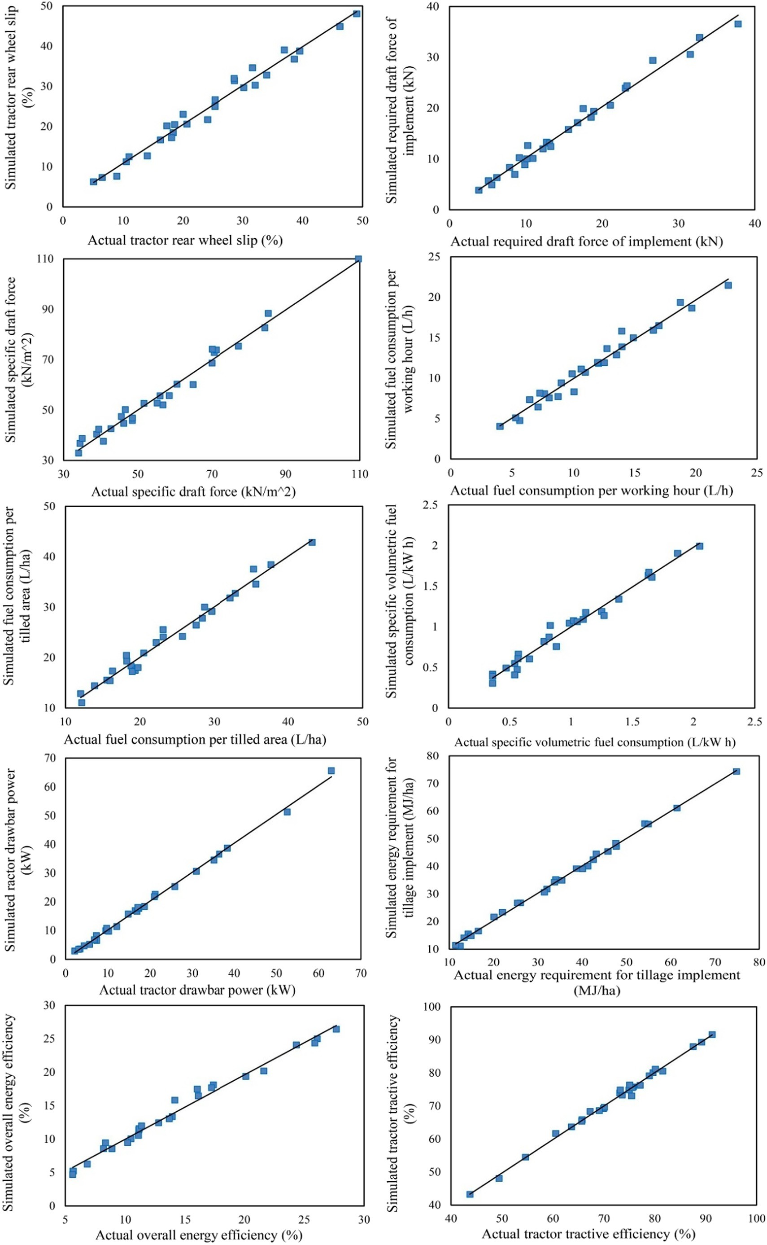](Image%20of%20Fig.%209)

Fig. 9. Graphical presentation of correlation between the simulated values by the prominent MANFIS simulation workplace and actual values of performance parameters of tractor- implement systems in plowing process.

[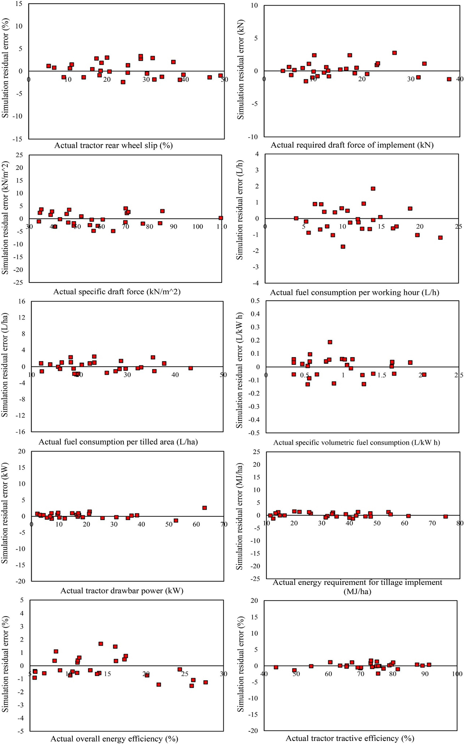](Image%20of%20Fig.%2010)

Fig. 10. Simulation residual error plots for the simulated values by the prominent MANFIS simulation workplace for performance parameters of tractor-implement systems in plowing process.

[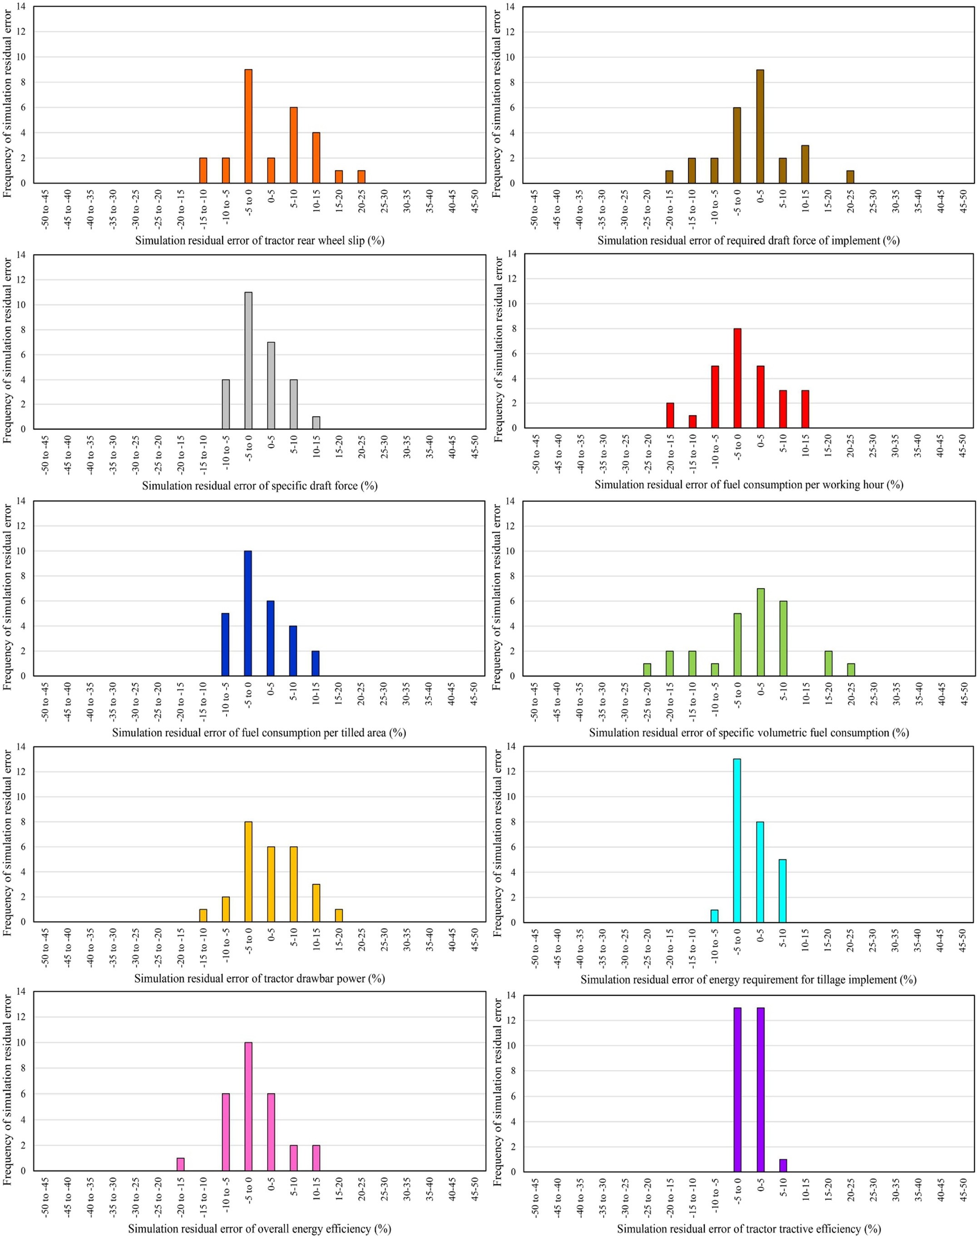](Image%20of%20Fig.%2011)

Fig. 11. Frequency plots of simulation residual error for the simulated values by the prominent MANFIS simulation workplace for performance parameters of tractor-implement systems in plowing process.

Table 38

The parameters of the several structural arrangements in accordance with corresponding R2, RMSE, and MRDM of selected twenty ANFIS soft computing simulation sub-environment ex- ecuted to prognosticate gross traction force of the tractor-implement systems in plowing process.

The number of training cycles The number of input membership functions Membership function Defuzzification method R2 RMSE (kN) MRDM (%)

|  |  |  |  |  |  |  |  |
| --- | --- | --- | --- | --- | --- | --- | --- |
|  | | Input | Output |  | | | |
| 91 | 2,2,3 | Gaussian | Linear | Weighted sum | 0.974 | 1.018 | 2.220 |
| 137 | 3,2,3 | Triangular | Linear | Weighted average | 0.953 | 1.120 | 2.352 |
| 144 | 3,2,3 | Triangular | Linear | Weighted sum | 0.911 | 1.552 | 2.689 |
| 165 | 3,3,3 | Sigmoid | Linear | Weighted average | 0.959 | 1.113 | 2.357 |
| 150 | 2,2,3 | Trapezium | Linear | Weighted average | 0.973 | 1.016 | 2.221 |
| 155 | 2,2,3 | Trapezium | Constant | Weighted average | 0.949 | 1.218 | 2.368 |
| 75 | 4,4,3 | Gbell | Constant | Weighted sum | 0.944 | 1.320 | 2.437 |
| 83 | 4,4,3 | Gbell | Constant | Weighted average | 0.904 | 1.601 | 2.712 |
| 126 | 4,4,3 | Gbell | Linear | Weighted average | 0.984 | 0.985 | 2.167 |
| 101 | 4,2,3 | Gaussian | Constant | Weighted sum | 0.973 | 1.021 | 2.118 |
| 167 | 3,3,3 | Trapezium | Constant | Weighted sum | 0.945 | 1.320 | 2.511 |
| 86 | 2,2,3 | Gaussian | Linear | Weighted sum | 0.900 | 1.615 | 2.714 |
| 75 | 3,3,3 | Gaussian | Linear | Weighted average | 0.901 | 1.626 | 2.756 |
| 138 | 3,2,3 | Pi | Linear | Weighted sum | 0.897 | 1.789 | 2.803 |
| 150 | 3,2,3 | Gaussian | Linear | Weighted sum | 0.914 | 1.465 | 2.551 |
| 99 | 2,3,3 | Gbell | Linear | Weighted average | 0.949 | 1.222 | 2.352 |
| 163 | 4,4,3 | Triangular | Linear | Weighted average | 0.901 | 1.612 | 2.659 |
| 164 | 4,4,3 | Triangular | Linear | Weighted average | 0.969 | 1.156 | 2.207 |
| 169 | 4,4,3 | Gbell | Linear | Weighted average | 0.975 | 0.991 | 2.194 |
| 145 | 4,4,3 | Gbell | Constant | Weighted average | 0.945 | 1.324 | 2.412 |

The boldfaced line represents prominent simulation workplace.

Specific volumetric fuel consumption indicates how much fuel is consumed per each unit of effective engine power output. According to the obtained results, the fuel consumption diminishes due to forward speed growth because the fuel consumption is an inverse function of forward speed (Eq.(3)). The fuel consumption decrease regarding plowing depth increment is due to increase of the draft force.

The observed trend in this research for the fuel consumption as af- fected by forward speed in plowing process is consistent with the trend found by Parvanloo et al. (2015) in previous research.

* + 1. *Specific draft force*

Fig. 21 shows surface and contour plots obtained from the MANFIS

+MNE simulation workplace for prognostication of specific draft force of the implements in plowing process. As it can be seen in the surface plots of the Fig. 21, specific draft force changed nonlinearly as plowing depth and forward speed increased. In addition, the contour plots of the Fig. 21 represent that the dual interaction effect of forward speed and plowing depth on specific draft force was nonlinearly antagonism. It is recognizable in the contour plots of the Fig. 21 that specific draft force changed from the lowest bound (b40 kN/m2) to the highest bound (N100 kN/m2) as plowing depth along with forward speed in- creased from 10 to 30 cm and 2 to 6 km/h, respectively.

According to the Eq.(8), specific draft force is direct function of draft force and invers function of plowing depth. Taking note that draft force is direct function of plowing depth and forward speed. Therefore, the component direct effect of plowing depth and forward speed, and

inverse effect of plowing depth on specific draft force is effective. The surface plots in the Fig. 21 demonstrate that specific draft force in- creased as forward speed increased (the direct effect of forward speed). However, in case of moldboard plow implement, it firstly de- creased and in the following increased nonlinearly as plowing depth in- creased. In case of disk and chisel plow implement, it firstly increased and then decreased nonlinearly as plowing depth increased. For the moldboard plow implement, in the first stage, it seems the inverse effect of plowing depth was more effective than direct effect of plowing depth and therefore, specific draft force decreased. In the second stage, the di- rect effect of plowing depth was more pronounced than the inverse ef- fect of plowing depth. In case of disk and chisel plow implement, it seems the direct effect of plowing depth was predominant over the in- verse effect of plowing depth in the first stage and therefore, specific draft force increased. In the second stage, the inverse effect of plowing depth was greater than the direct effect of plowing depth.

The direct positive effect of forward speed on specific draft force based on N/mm was similarly reported by Al-Suhaibani and Al-Janobi (1997), and Al-Janobi and Al-Suhaibani (1998) for chisel, offset disk harrow, moldboard plow, and disk plow implements.

* + 1. *Tractor drawbar power*

Fig. 22 provides surface and contour plots obtained from the MANFIS

+MNE simulation workplace for prognostication of tractor drawbar power in plowing process. As it can be seen in the surface plots of the Fig. 22, the drawbar power increased nonlinearly as plowing depth

Table 39

The values of the statistical performance criteria for prognostication of ten performance parameters of the tractor-implement systems in plowing process obtained from MANFIS+MNE simulation workplace.

|  |  |  |  |  |
| --- | --- | --- | --- | --- |
| Performance parameter Unit R2 RMSE | | | | MRDM (%) |
| Required draft force of the implements | kN | 0.985 | 1.117 | 2.267 |
| Tractor rear wheel slip | % | 0.979 | 1.716 | 3.906 |
| Fuel consumption per working hour | L/h | 0.971 | 0.803 | 3.204 |
| Fuel consumption per tilled area | L/ha | 0.990 | 0.786 | 3.036 |
| Specific volumetric fuel consumption | L/kW h | 0.985 | 0.062 | 4.965 |
| Specific draft force | kN/m2 | 0.995 | 1.264 | 1.931 |
| Tractor drawbar power | kW | 0.996 | 1.031 | 4.175 |
| Tractor tractive efficiency | % | 0.984 | 1.416 | 1.479 |
| Energy requirement for tillage implements | MJ/ha | 0.996 | 1.095 | 2.918 |
| Overall energy efficiency | % | 0.985 | 0.808 | 4.202 |

[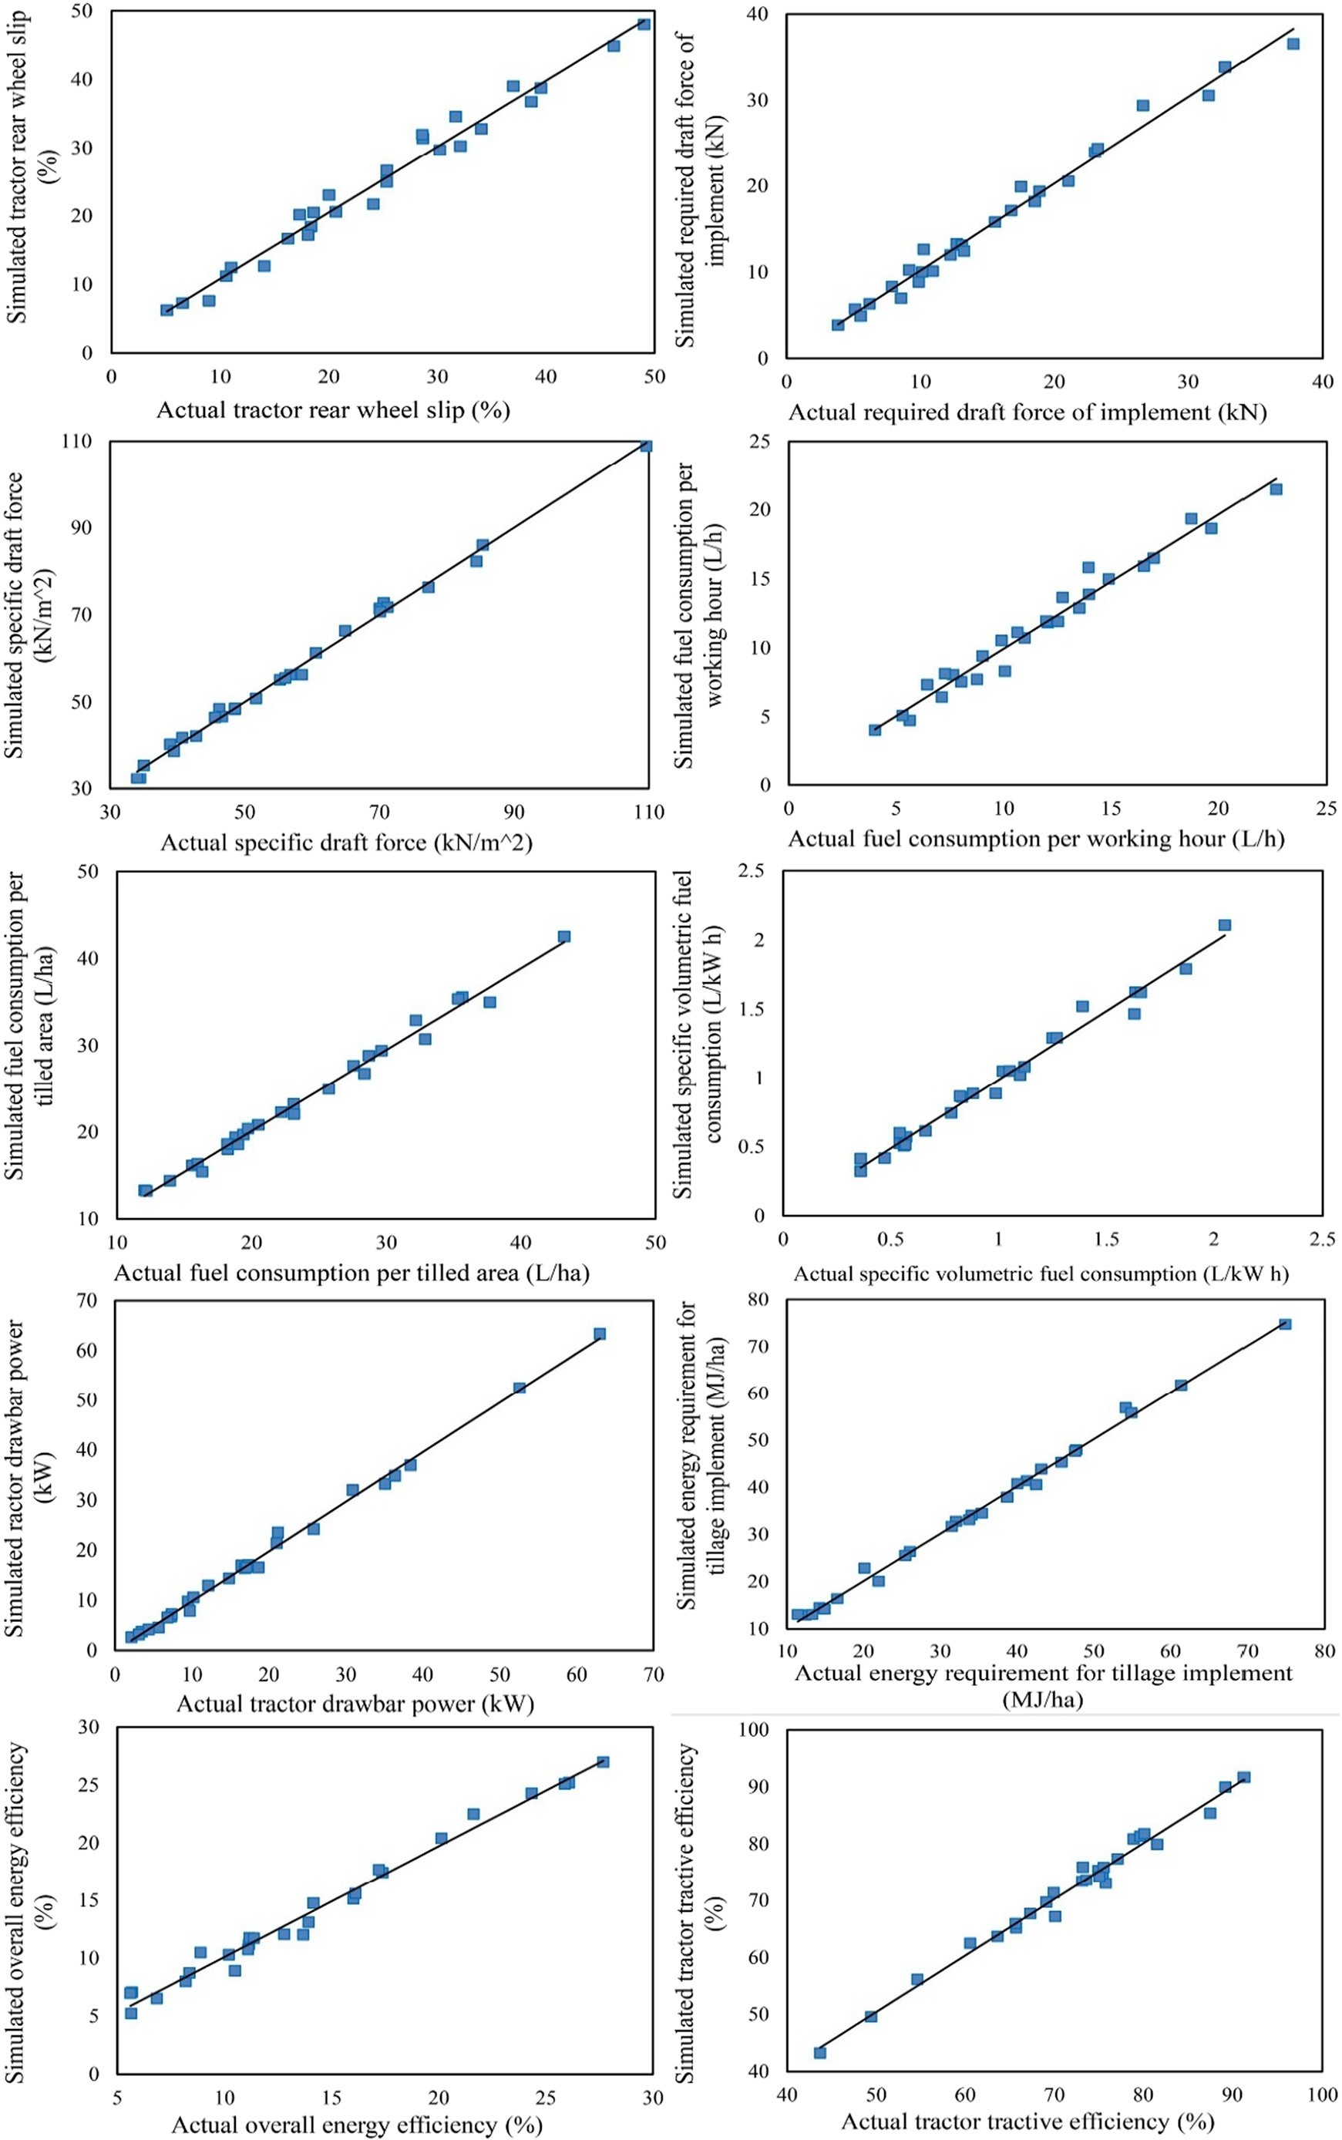](Image%20of%20Fig.%2012)

Fig. 12. Graphical presentation of correlation between the simulated values by the prominent MANFIS+MNR simulation workplace and actual values of performance parameters of tractor-implement systems in plowing process.

[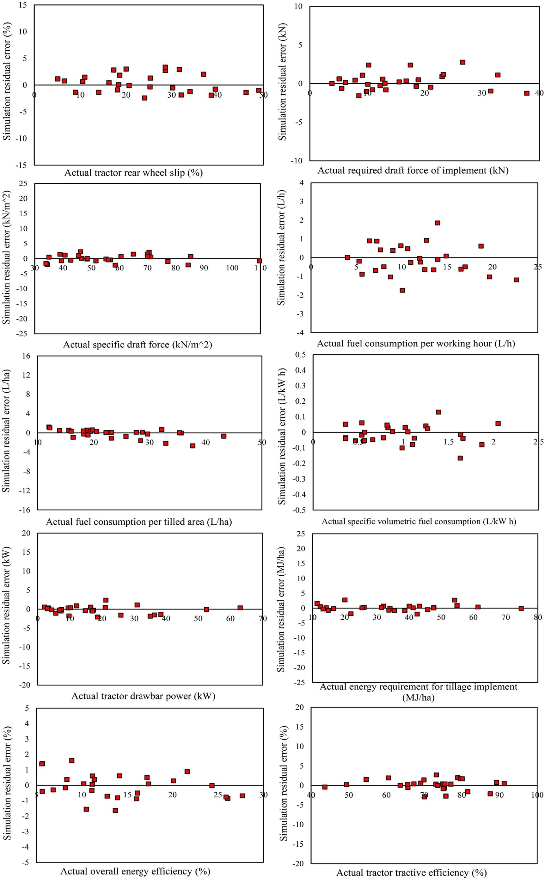](Image%20of%20Fig.%2013)

Fig. 13. Simulation residual error plots for the simulated values by the prominent MANFIS+MNR simulation workplace for performance parameters of tractor-implement systems in plowing process.

[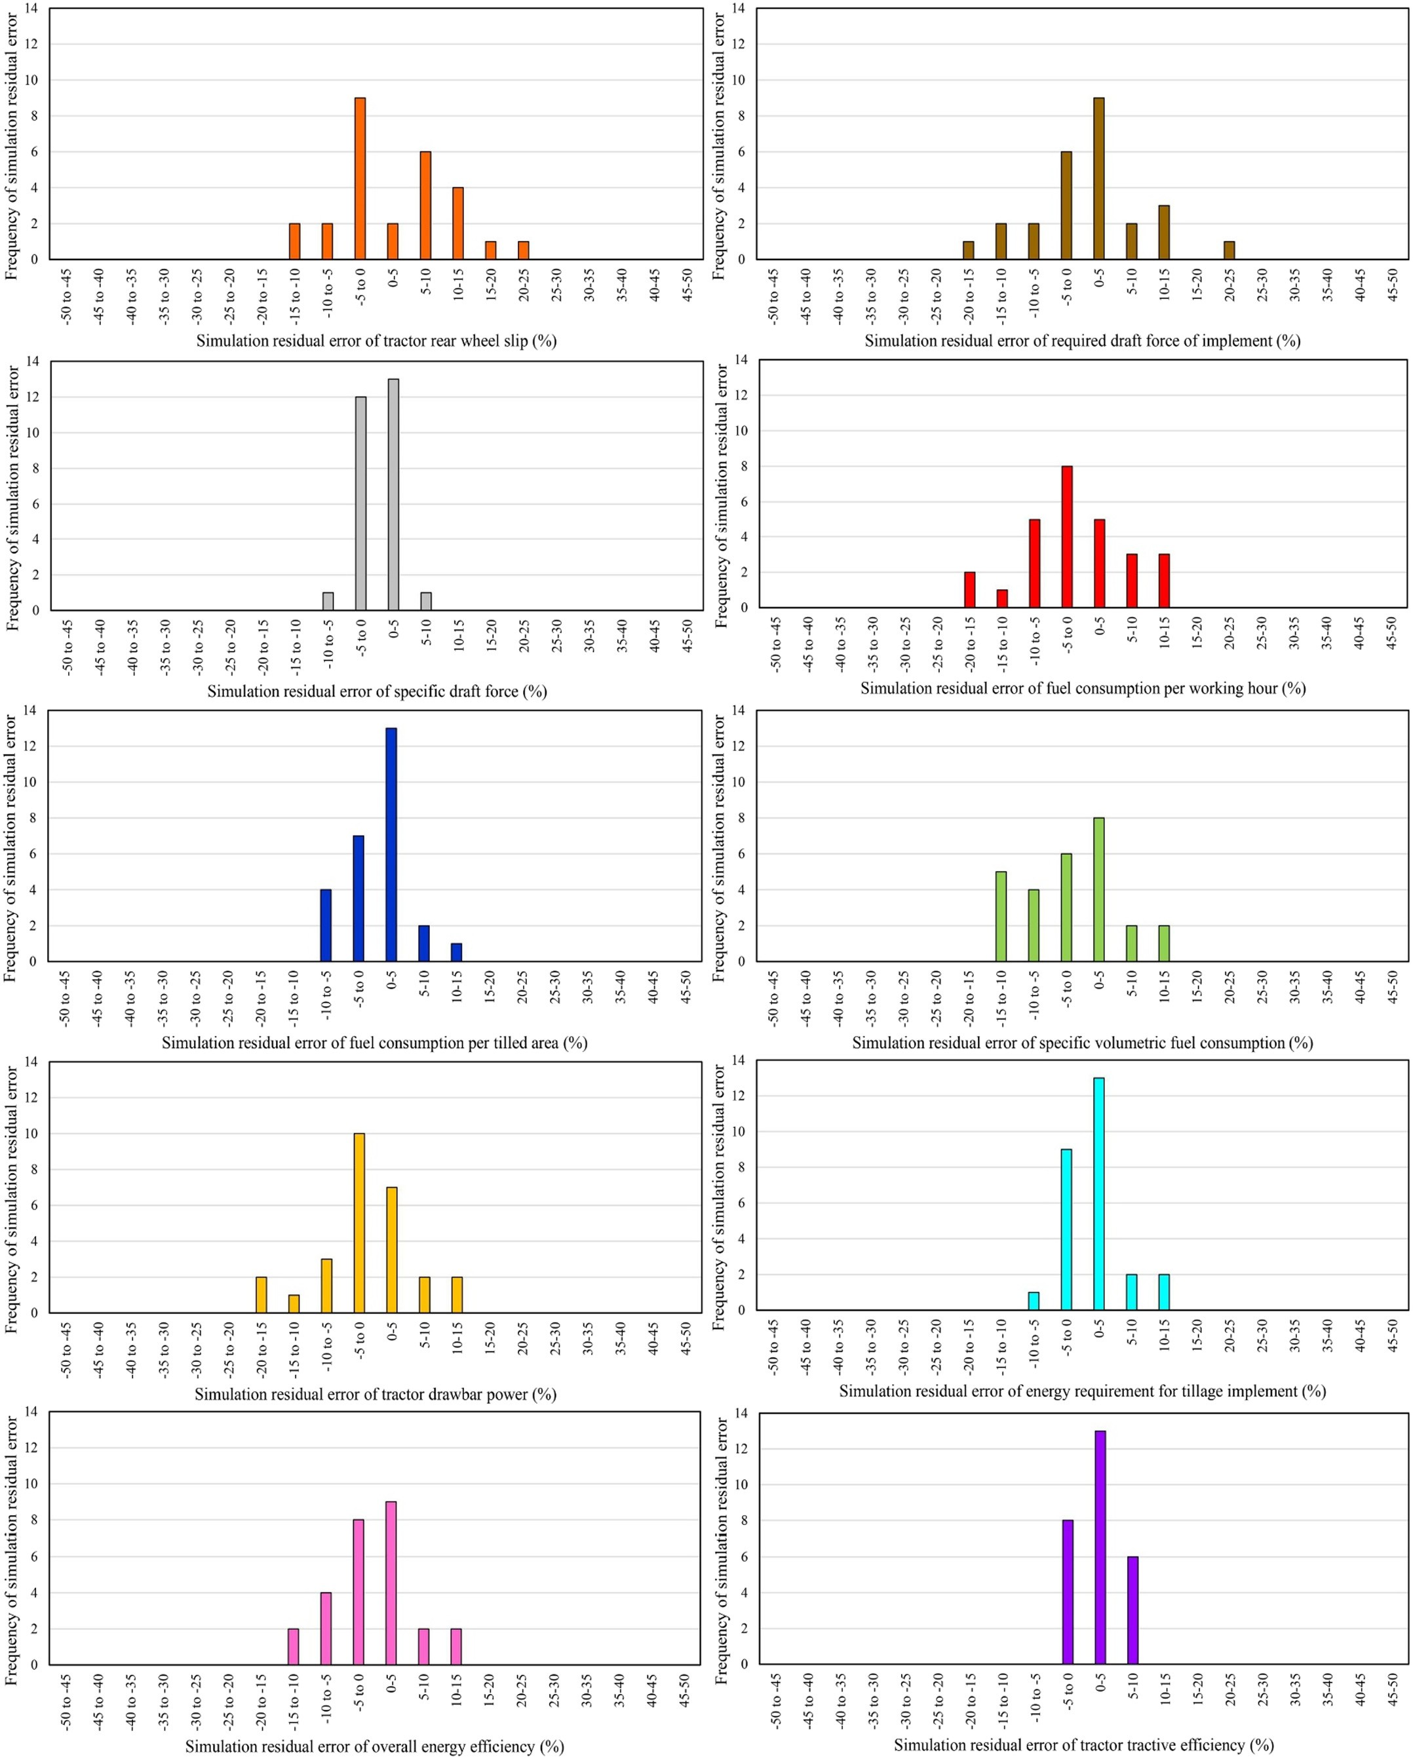](Image%20of%20Fig.%2014)

Fig. 14. Frequency plots of simulation residual error for the simulated values by the prominent MANFIS+MNE simulation workplace for performance parameters of tractor-implement systems in plowing process.

[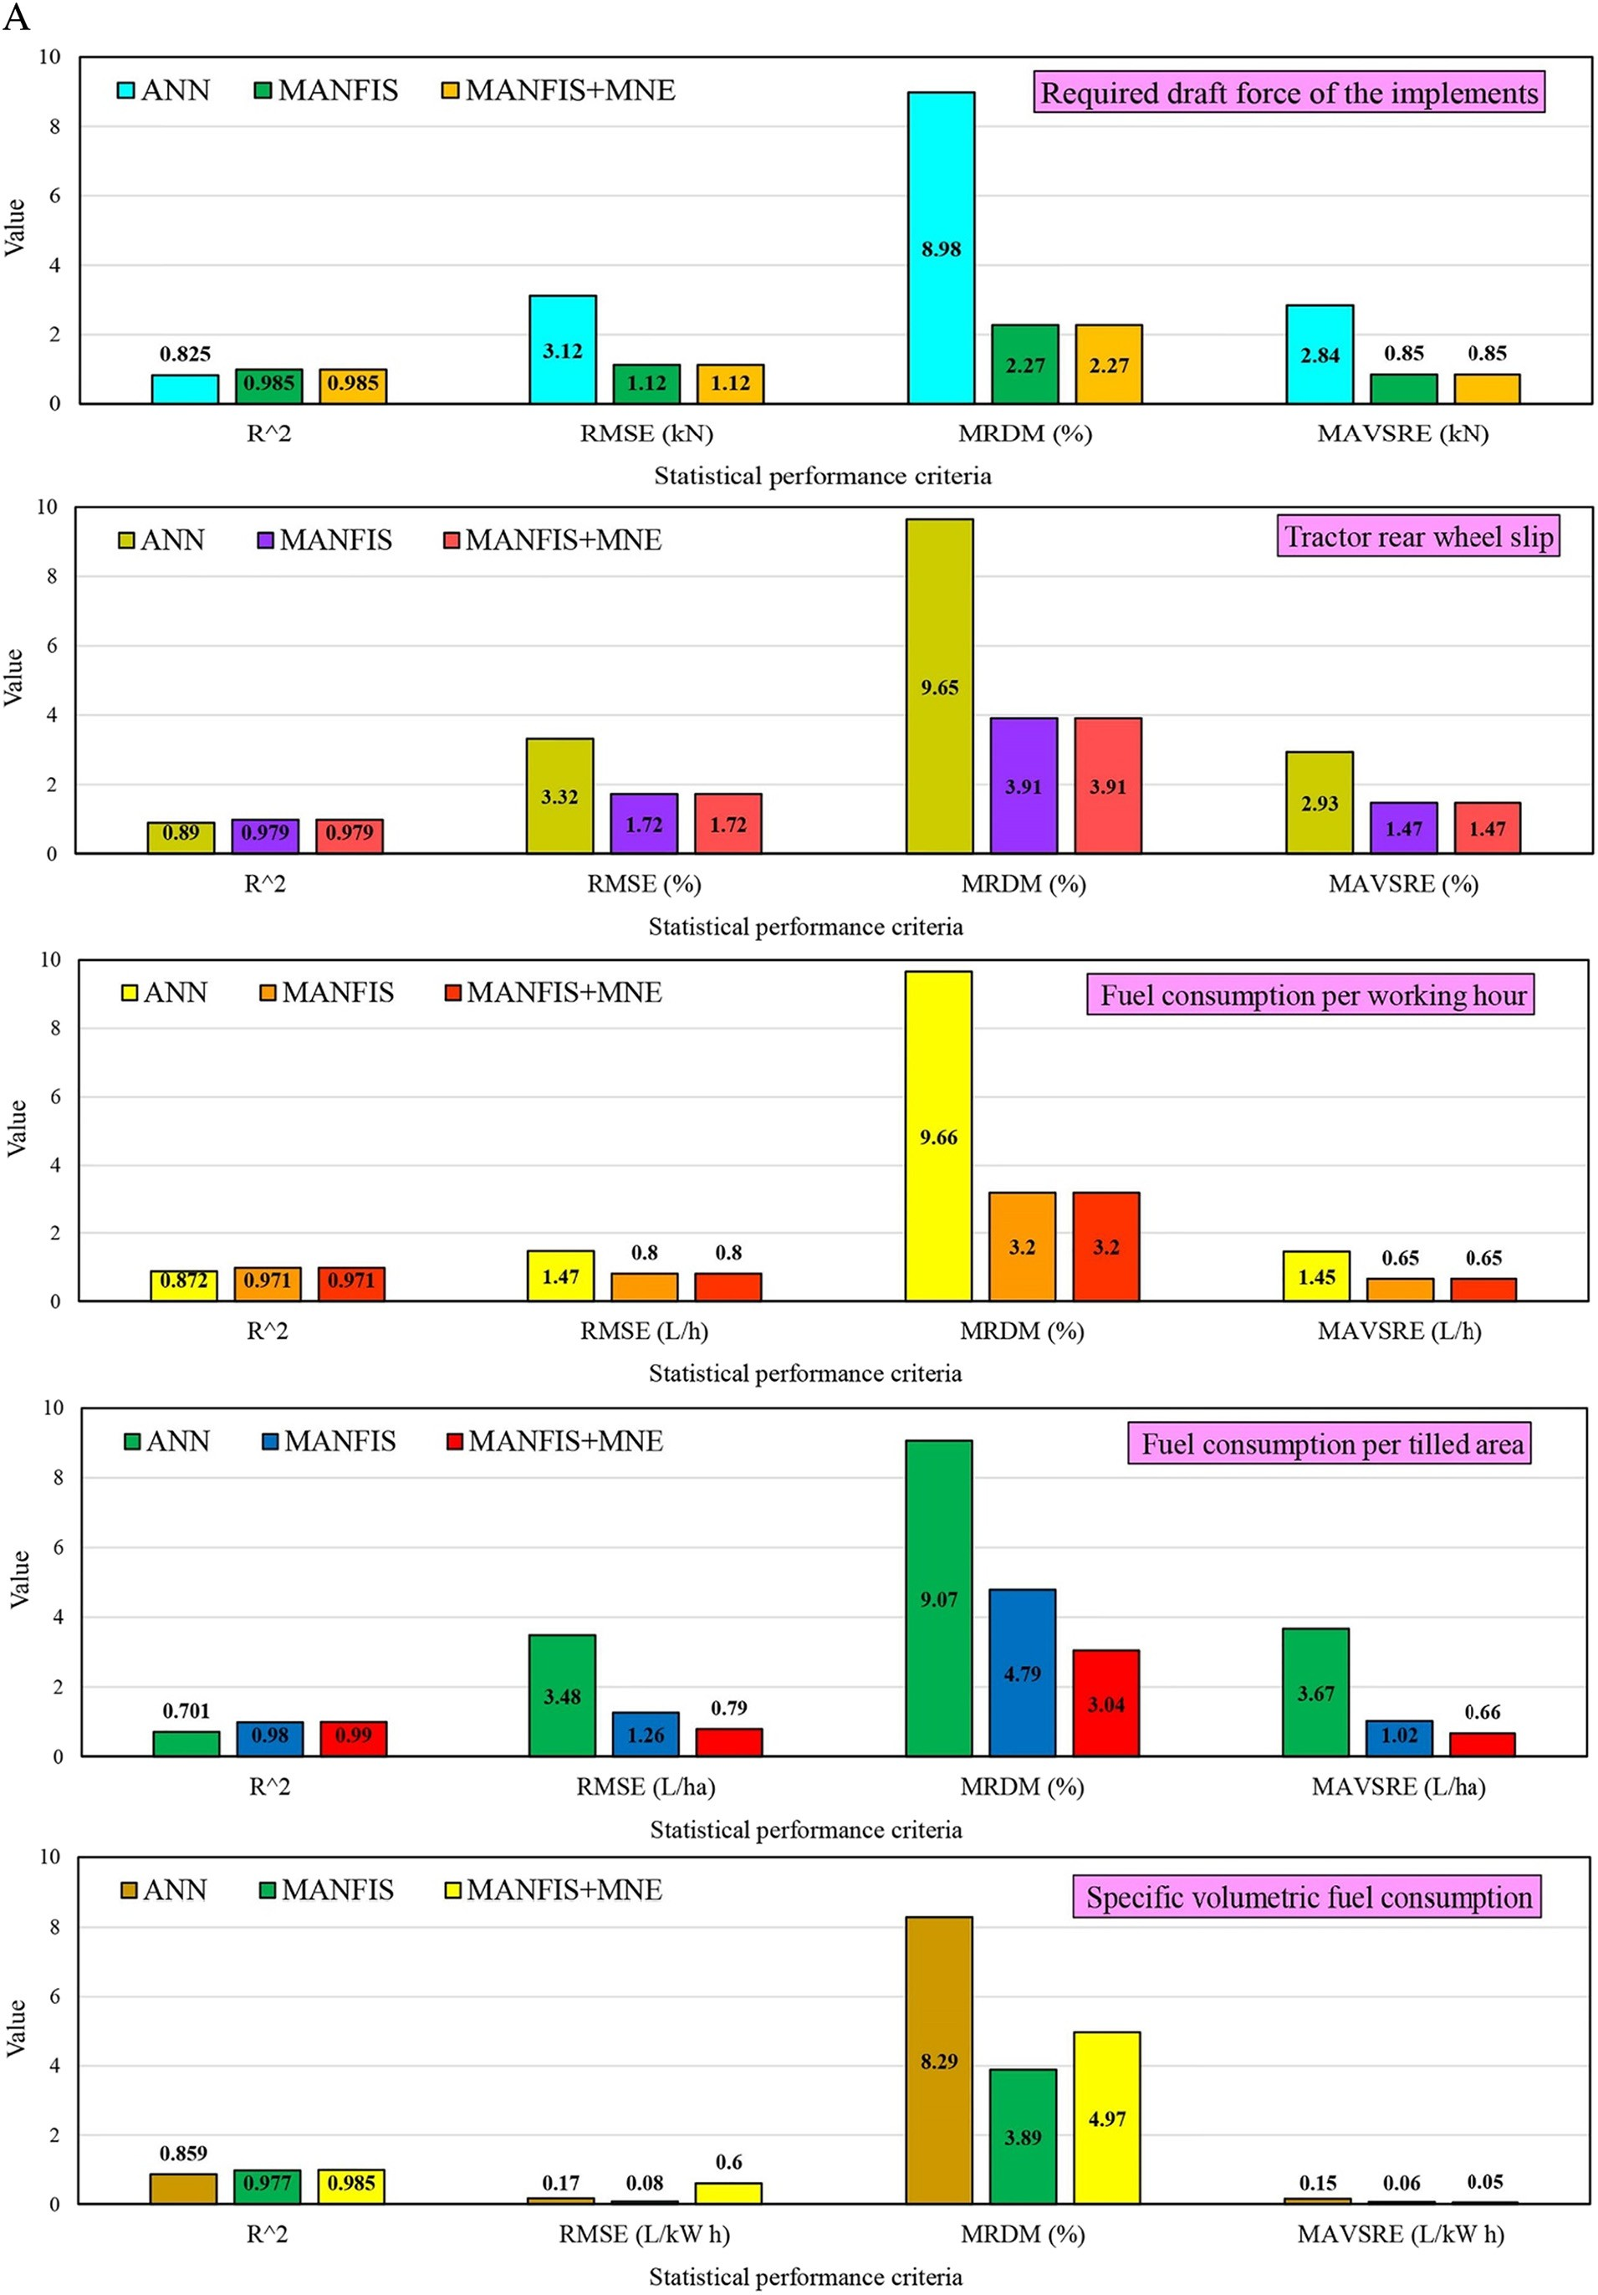](Image%20of%20Fig.%2015)

[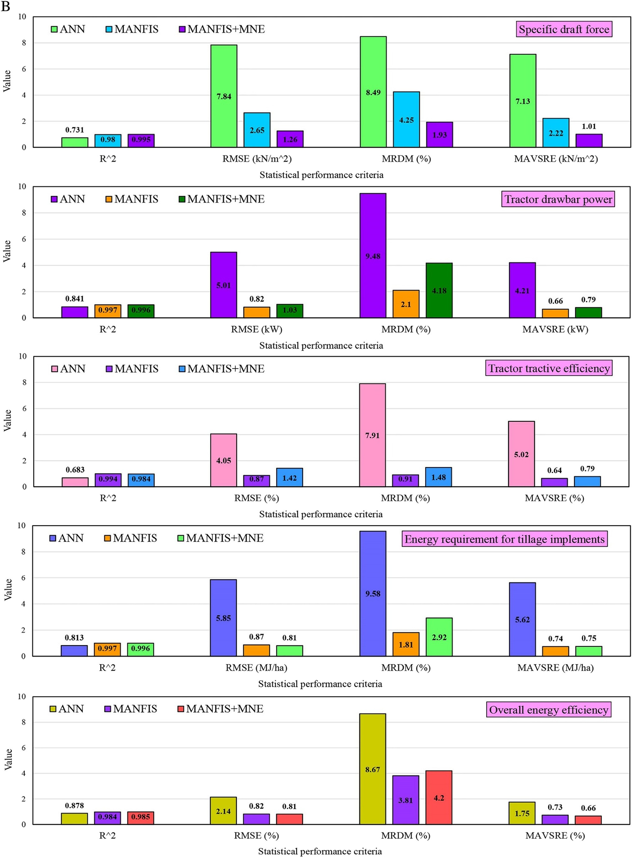](Image%20of%20Fig.%2015)

Fig. 15. a–b Comparison between the statistical performance criteria of three simulation scenarios for prognostication of performance parameters of tractor-implement systems in plowing process.

[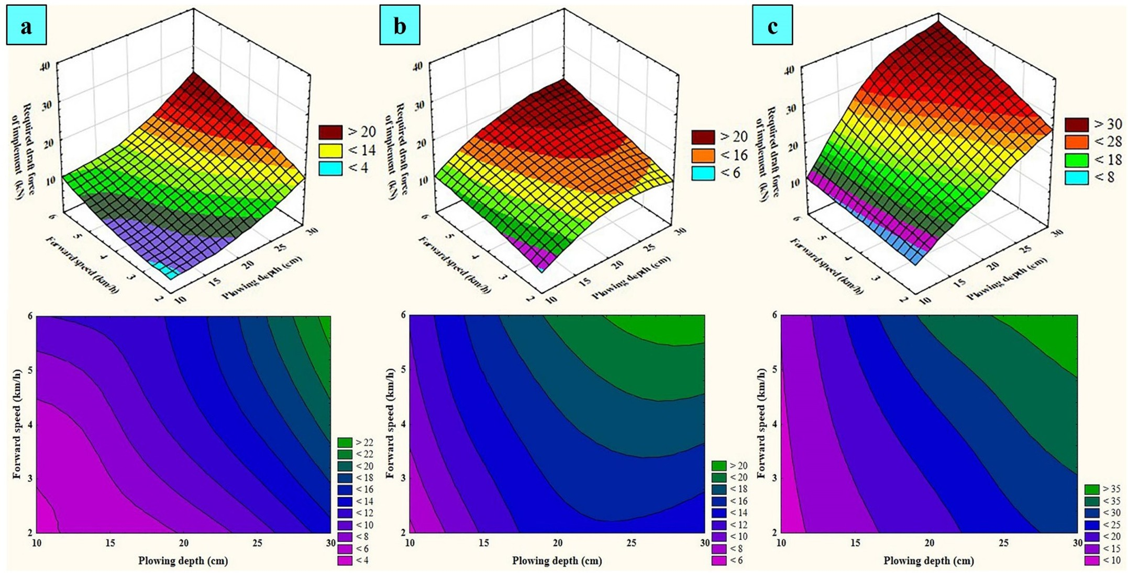](Image%20of%20Fig.%2016)

Fig. 16. Surface and contour plots obtained from the MANFIS+MNE simulation workplace for prognostication of required draft force of the implement in plowing process (a: moldboard, b: disk, and c: chisel plow implement).

and forward speed increased. Furthermore, the contour plots of the Fig. 22 clarify that the dual interaction effect of forward speed and plowing depth on the drawbar power was increasingly synergistic. It is plausible in the contour plots of the Fig. 22 that the drawbar power in- creased from the lowest bound (b5 kW) to the highest bound (N60 kW)

as plowing depth along with forward speed increased from 10 to 30 cm and 2 to 6 km/h, respectively.

According to the Eq.(4), the drawbar power is direct function of for- ward speed and draft force. The draft force is direct function of plowing depth and forward speed. Therefore, it can be inferred that the drawbar

[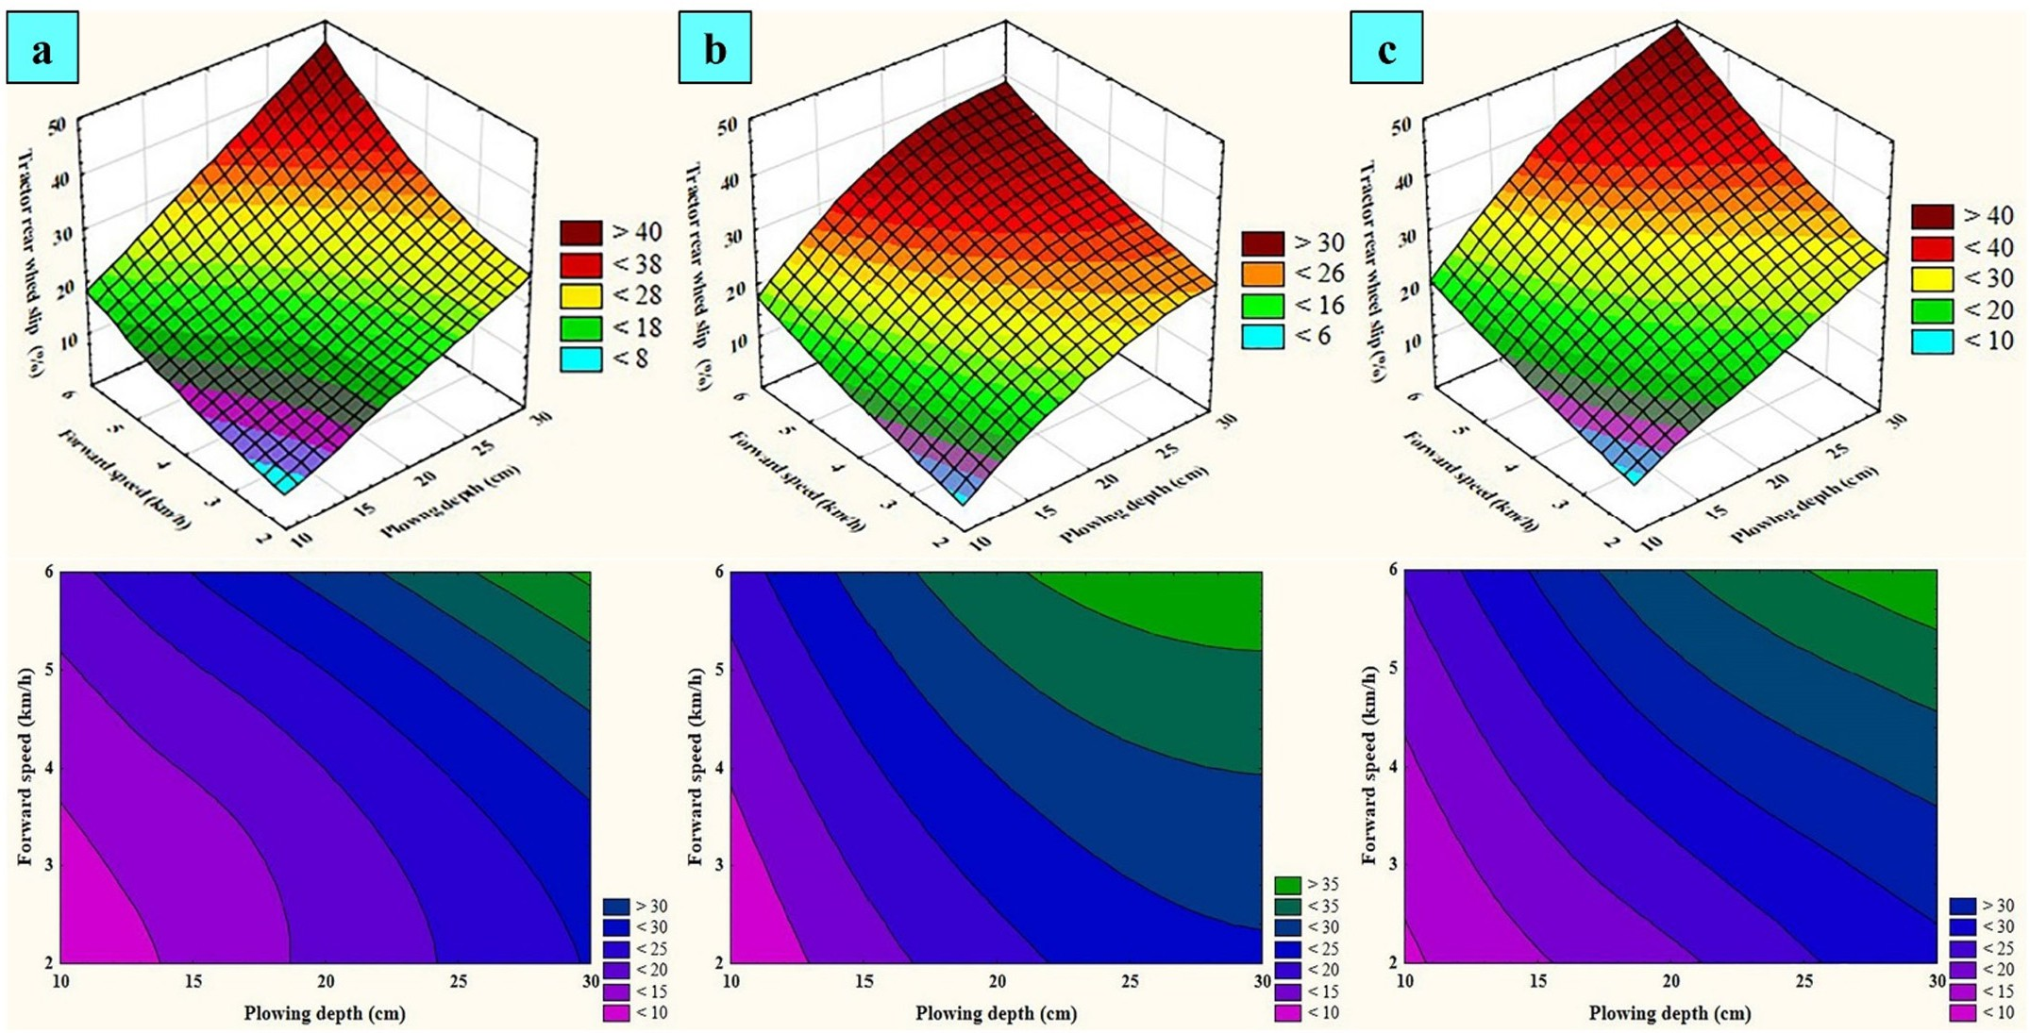](Image%20of%20Fig.%2017)

Fig. 17. Surface and contour plots obtained from the MANFIS+MNE simulation workplace for prognostication of tractor rear wheel slip in plowing process (a: moldboard, b: disk, and c: chisel plow implement).

[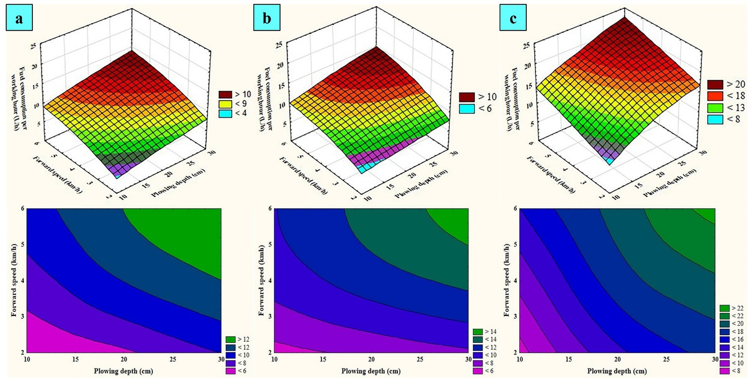](Image%20of%20Fig.%2018)

Fig. 18. Surface and contour plots obtained from the MANFIS+MNE simulation workplace for prognostication of fuel consumption per working hour in plowing process (a: moldboard, b: disk, and c: chisel plow implement).

power is direct function of forward speed and plowing depth. Accord- ingly, the drawbar power increases with increase of forward speed and plowing depth.

The increasing effect of plowing depth on the drawbar power in plowing process was also addressed by KarimiInchebron et al. (2012) which is associate with the result of this research.

* + 1. *Tractor tractive efficiency*

Fig. 23 depicts surface and contour plots obtained from the MANFIS

+MNE simulation workplace for prognostication of tractor tractive effi- ciency in plowing process. As it can be seen in the surface plots of the Fig. 23, the tractive efficiency decreased nonlinearly as plowing depth and forward speed increased. Moreover, the contour plots of the

[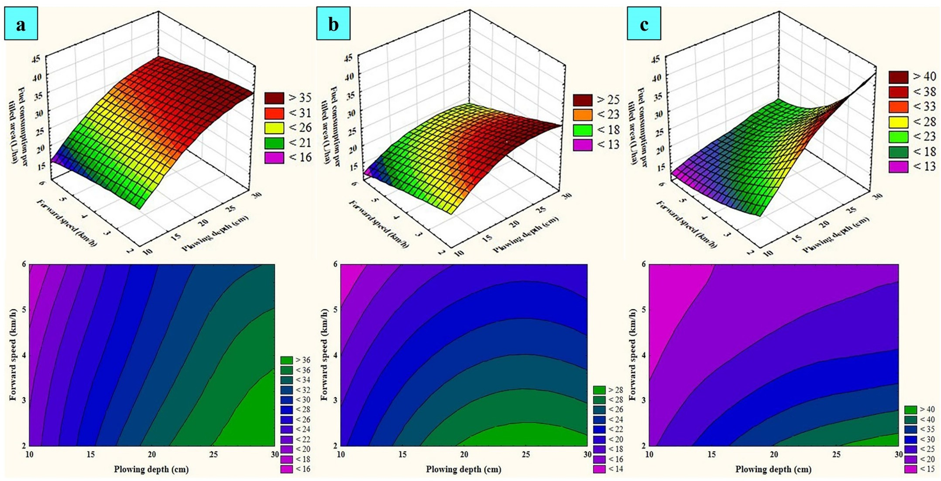](Image%20of%20Fig.%2019)

Fig. 19. Surface and contour plots obtained from the MANFIS+MNE simulation workplace for prognostication of fuel consumption per tilled area in plowing process (a: moldboard, b: disk, and c: chisel plow implement).

[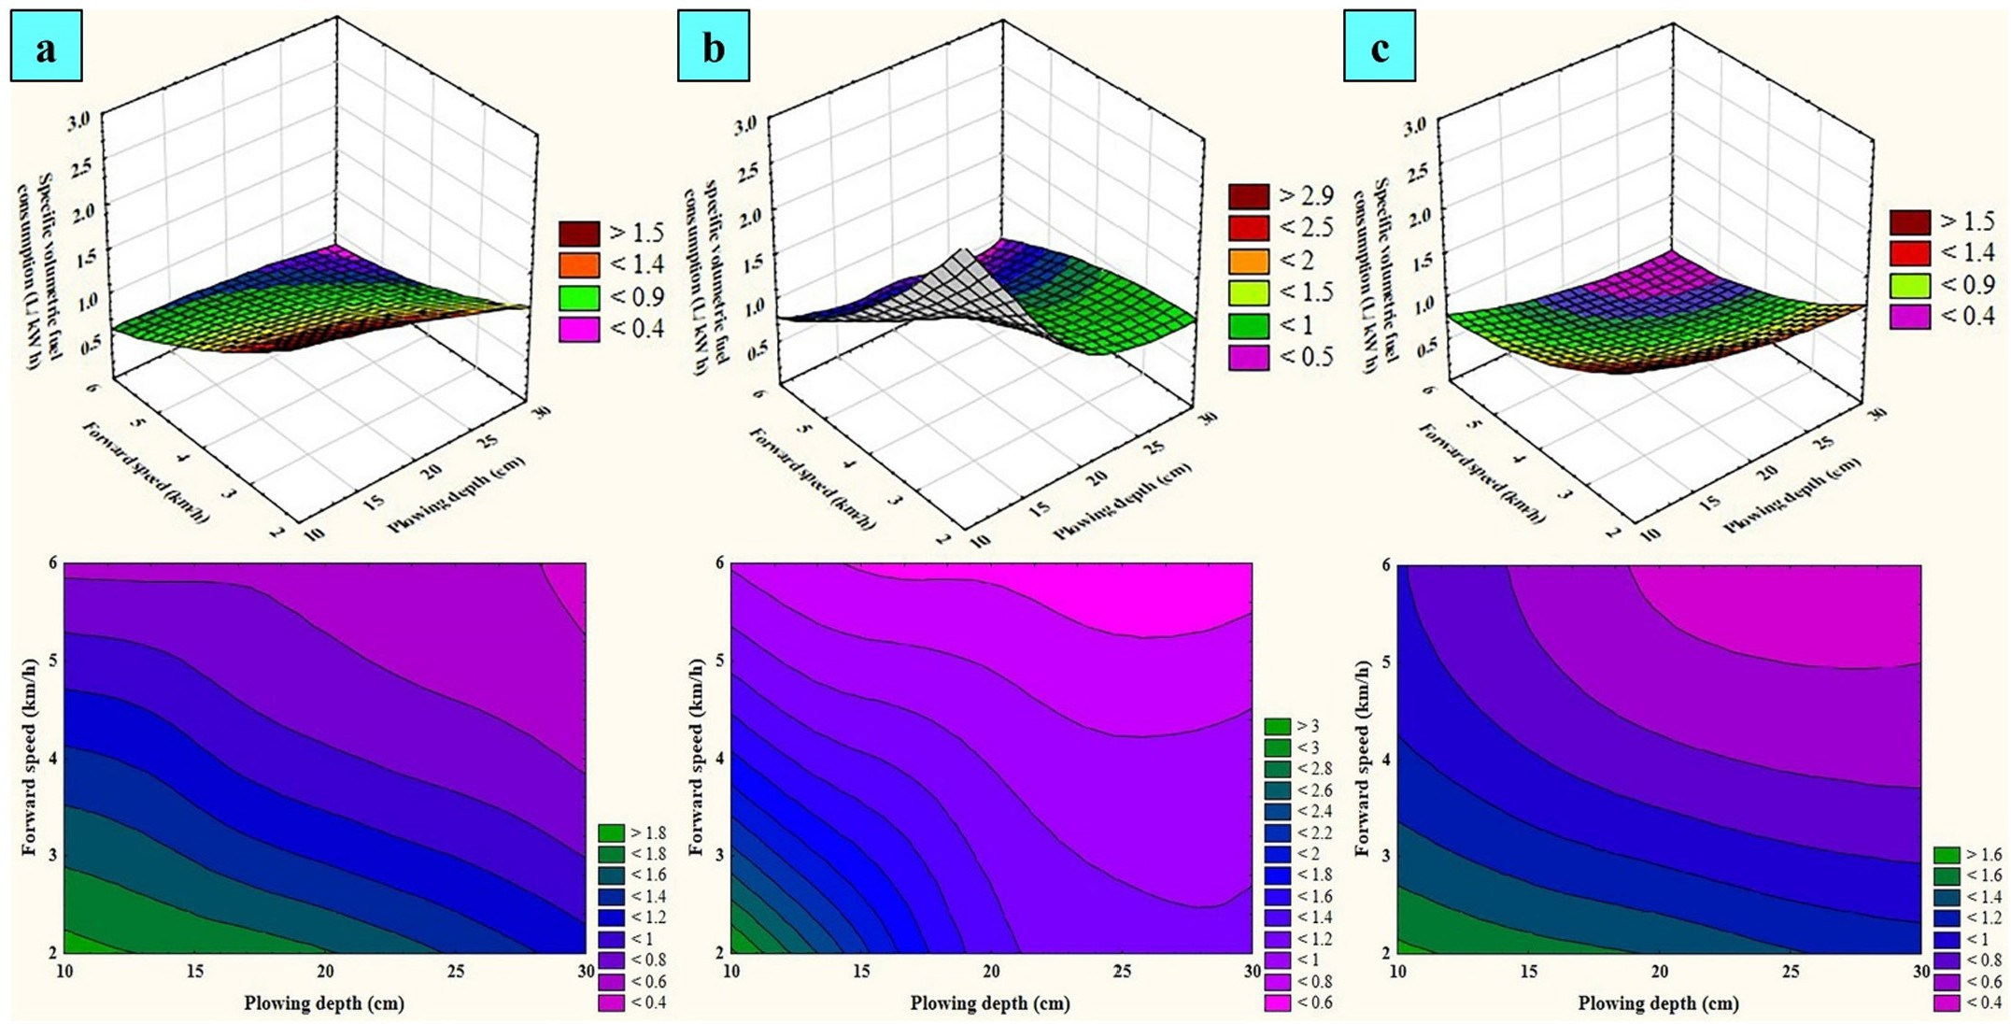](Image%20of%20Fig.%2020)

Fig. 20. Surface and contour plots obtained from the MANFIS+MNE simulation workplace for prognostication of specific volumetric fuel consumption in plowing process (a: moldboard, b: disk, and c: chisel plow implement).

Fig. 23 state that the dual interaction effect of forward speed and plowing depth on the tractive efficiency was decreasingly synergistic. It is observable in the contour plots of the Fig. 23 that the tractive effi- ciency decreased from the highest bound (N90%) to the lowest bound (b50%) as plowing depth along with forward speed increased from 10 to 30 cm and 2 to 6 km/h, respectively.

To interpret the obtained trend, it should be considered that with in- crease of plowing depth and forward speed, tractor rear wheel slip in- creases (Section 3.4.2). According to the Eq.(7), the tractive efficiency is negative direct function of the wheel slip. Therefore, as plowing depth or forward speed increases, the wheel slip increases and conse- quently, the tractive efficiency decreases. Another interpretation is

[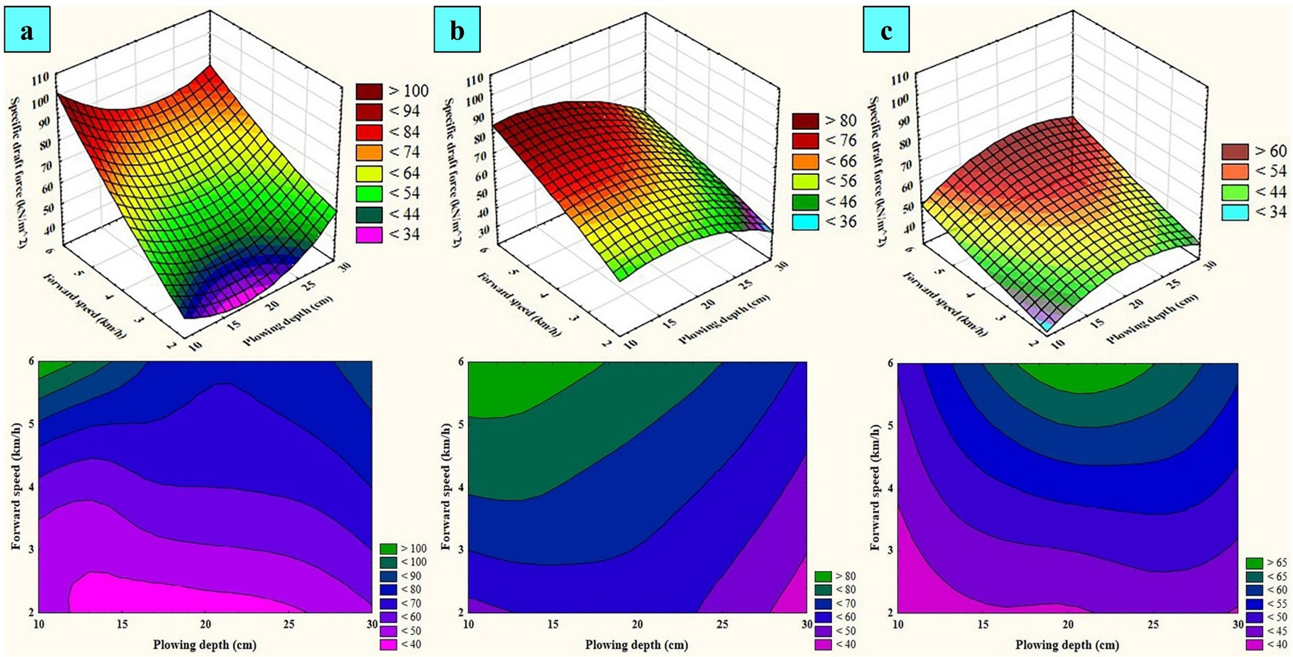](Image%20of%20Fig.%2021)

Fig. 21. Surface and contour plots obtained from the MANFIS+MNE simulation workplace for prognostication of specific draft force of the implements in plowing process (a: moldboard, b: disk, and c: chisel plow implement).

[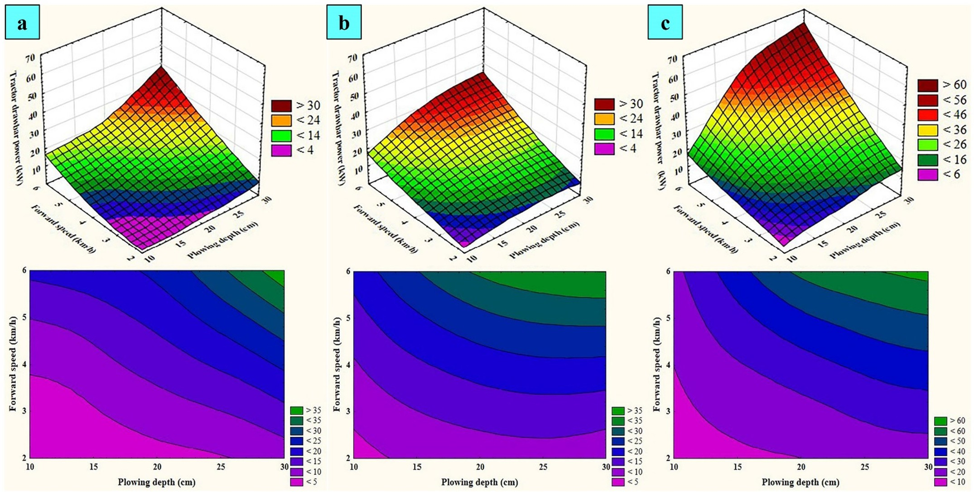](Image%20of%20Fig.%2022)

Fig. 22. Surface and contour plots obtained from the MANFIS+MNE simulation workplace for prognostication of tractor drawbar power in plowing process (a: moldboard, b: disk, and c: chisel plow implement).

attributed to gross traction force (draft force plus rolling resistance force). According to the Eq.(7), the tractive efficiency is inverse function of gross traction force. Increment of plowing depth or forward speed leads to draft force increment (Section 3.4.1). Increment of draft force results in the tractive efficiency decrease.

The observed decreasing trend of the tractive efficiency as influ- enced by increment of plowing depth and forward speed was in general

agreement with the results of previous researches conducted by Inchebron et al. (2012) and Ranjbarian et al. (2017).

* + 1. *Energy requirement for tillage implement*

Fig. 24 illustrates surface and contour plots obtained from the MANFIS+MNE simulation workplace for prognostication of energy re- quirement for tillage implements in plowing process. As it can be seen

[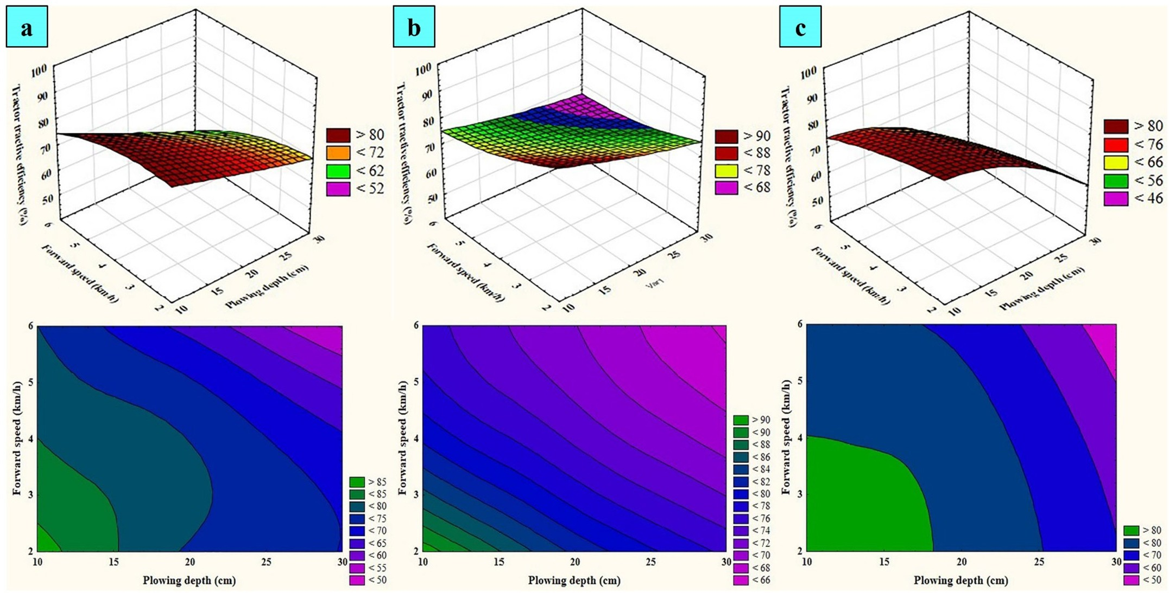](Image%20of%20Fig.%2023)

Fig. 23. Surface and contour plots obtained from the MANFIS+MNE simulation workplace for prognostication of tractor tractive efficiency in plowing process (a: moldboard, b: disk, and c: chisel plow implement).

[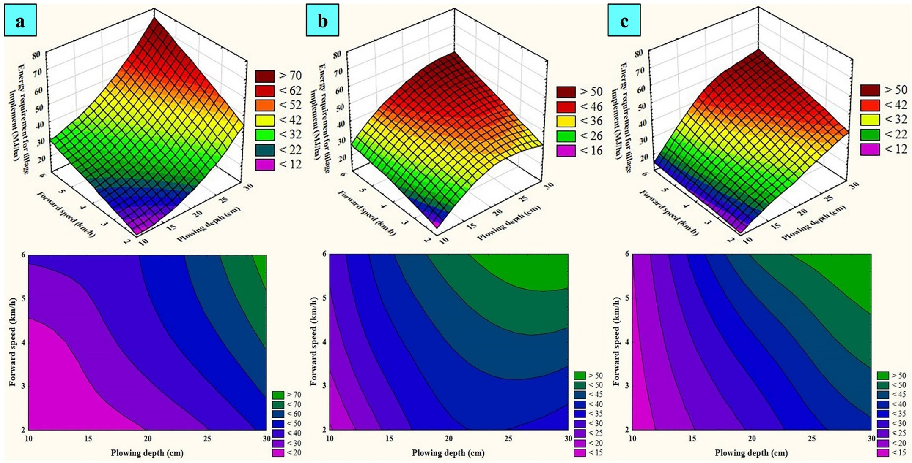](Image%20of%20Fig.%2024)

Fig. 24. Surface and contour plots obtained from the MANFIS+MNE simulation workplace for prognostication of energy requirement for the implements in plowing process (a: moldboard, b: disk, and c: chisel plow implement).

in the surface plots of the Fig. 24, the energy requirement increased nonlinearly as plowing depth and forward speed increased. Besides, the contour plots of the Fig. 24 display that the dual interaction effect of forward speed and plowing depth on the energy requirement was in- creasingly synergistic. It is perceptible in the contour plots of the Fig. 24 that the energy requirement increased from the lowest bound

(b15 MJ/ha) to the highest bound (N70 MJ/ha) as plowing depth along with forward speed increased from 10 to 30 cm and 2 to 6 km/h, respectively.

According to the Eqs.(4) and (5), the energy requirement is directly related to the draft force. As it has been discussed in the Section 3.4.1, the draft force increases as increment of plowing depth and forward

[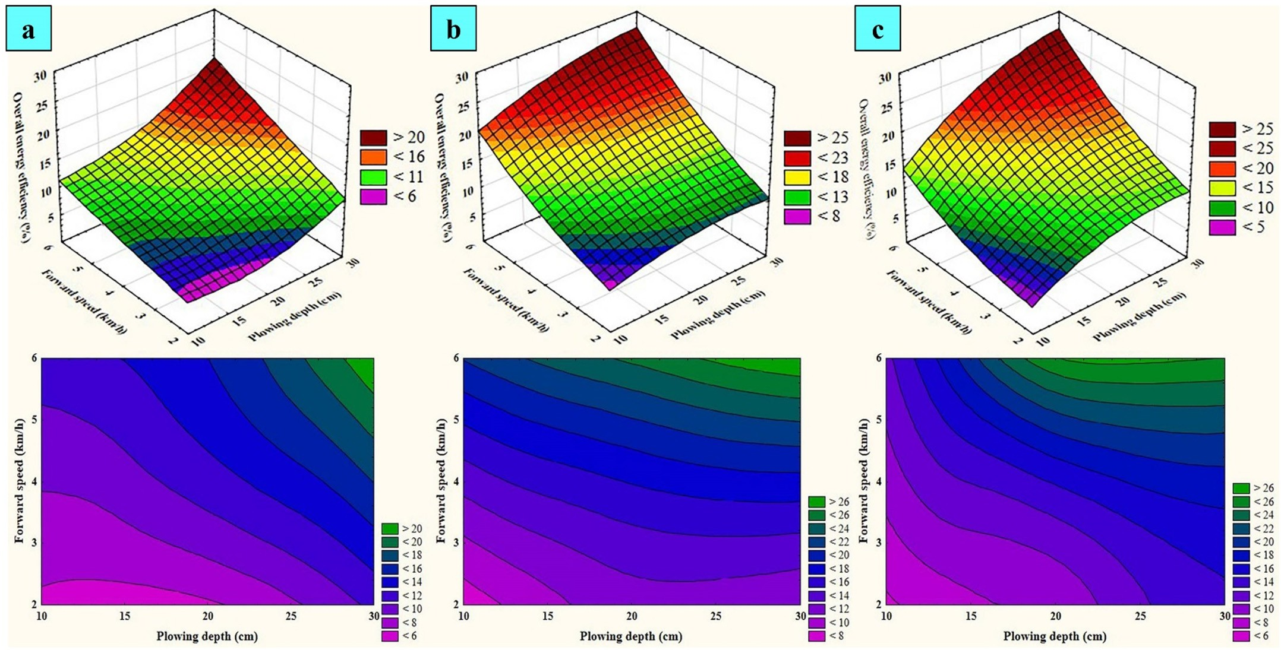](Image%20of%20Fig.%2025)

Fig. 25. Surface and contour plots obtained from the MANFIS+MNE simulation workplace for prognostication of overall energy efficiency of tractor-implement systems in plowing process (a: moldboard, b: disk, and c: chisel plow implement).

speed. Thus, the energy requirement rises due to increment of forward speed and plowing depth. The increasing effect of forward speed on the energy requirement was also mentioned in the published paper by Thomas and Singh (2002).

* + 1. *Overall energy efficiency*

Fig. 25 shows surface and contour plots obtained from the MANFIS

+MNE simulation workplace for prognostication of overall energy effi- ciency of the tractor-implement systems in plowing process. As it can be seen in the surface plots of the Fig. 25, the efficiency increased nonlinearly as plowing depth and forward speed increased. Moreover, the contour plots of the Fig. 25 indicate that the dual interaction effect of forward speed and plowing depth on the efficiency was increasingly synergistic. It is visible in the contour plots of the Fig. 25 that the effi- ciency increased from the lowest bound (b6%) to the highest bound (N26%) as plowing depth along with forward speed increased from 10 to 30 cm and 2 to 6 km/h, respectively.

According to the Eq.(6), overall energy efficiency is direct function of tractor drawbar power. The drawbar power is function of forward speed and the draft force (Eq.(4)). The draft force is direct function of plowing depth and forward speed (Section 3.4.1). Therefore, it can be stated that the efficiency is direct function of plowing depth and forward speed. Hence, it is anticipated that the efficiency increases with increment of plowing depth and forward speed.

Jr (1985) has pointed out that the range of 10–20% for overall energy efficiency should be considered as normal range. The efficiency b10% is known as poor tractive efficiency and/or load matching. It is also consid- ered as good tractive efficiency and/or load match for the efficiency above 20%. In this research, the efficiency ranged from 5.61 to 27.69% for three tillage implements (Table 17). The efficiency b10% was related to treatment of plowing depth = 10 cm and forward speed = 2 km/h. With increment of plowing depth and forward speed, the efficiency ranged from 10 to 20% and finally, it reached above 20%. Therefore, it can be stated that in this research, proper tractive efficiency of the trac- tor and good load match between implement and the tractor were achieved at the upper levels of the plowing depth and forward speed.

The previous study results of Kheiralla et al. (2004) are similar to the range and trend of overall energy efficiency of tractor-implement sys- tems in this research.

1. Summary and conclusion

This research focused on development of soft computing simulation workplaces for performance prognostication of tractor-implement sys- tems in plowing process. Three simulation scenarios (ANN, MANFIS, and MANFIS+MNE) were executed in the workplace. The operational variables of plowing depth (10, 20 and 30 cm), forward speed (2, 4 and 6 km/h), and tillage implement type (moldboard, disk, and chisel plow) were taken as the workplace inputs and ten performance param- eters (required draft force of implement, tractor rear wheel slip, fuel consumption per working hour, specific draft force, fuel consumption per tilled area, specific volumetric fuel consumption, tractor drawbar power, tractor tractive efficiency, energy requirement for tillage imple- ment, and overall energy efficiency) were considered as the workplace outputs. According to aggregation of the results obtained in this re- search, it can be asserted that this research satisfied both quantity and quality aspects concerned in this realm, and the following conclusions were drawn from the results:

1. In case of chisel plow implement with higher working width than that of other implements, draft force, fuel energy, and drawbar power required to pull the implement within soil were higher than those of other implements.
2. Comparison of prognostication accuracy of two soft computing sce- narios of the MANFIS and the ANN simulation workplace indicated higher performance of the MANFIS against the ANN, based on the

obtained statistical performance criteria. Therefore, the hypotheses of higher performance of neuro-fuzzy strategy than neural strategy in prognostication of desired output targets based on the compound effect of nominal and numeral input variables was approved.

1. According to obtained prognostication accuracy based on statistical performance criteria, simulation time, and user-friendly configura- tion of two neuro-fuzzy strategies based on the MANFIS and MANFIS+MNE, the MANFIS+MNE simulation workplace was rec- ognized as prominent simulation scenario. Therefore, the claim of applicability of new simulation scenario of the MANFIS+MNE as a simple neuro-fuzzy calculator was asserted. Accordingly, it can be mentioned that difficulties of utilization of puzzling tables and graphical charts for calculation of performance parameters are elim- inated by means of neuro-fuzzy calculator.
2. In accordance with previous conclusions 2 and 3, the prominent sim- ulation scenario among three simulation scenarios (ANN, MANFIS, and MANFIS+MNE), executed in the workplace, was the MANFIS

+MNE simulation scenario.

1. The MANFIS+MNE simulation results revealed that simultaneous increase of forward speed and plowing depth led to nonlinear incre- ment of required draft force of implement, tractor rear wheel slip, fuel consumption per working hour, tractor drawbar power, energy requirement for tillage implement, and overall energy efficiency for each tillage implement. Moreover, it demonstrated that simulta- neous increase of forward speed and plowing depth led to nonlinear decrement of specific volumetric fuel consumption and tractor trac- tive efficiency.
2. The exhaustive physical perception obtained from the MANFIS

+MNE simulation results presented that the dual interaction effect of forward speed and plowing depth on some performance parame- ters (required draft force of implement, tractor rear wheel slip, fuel consumption per working hour, specific volumetric fuel consump- tion, tractor drawbar power, energy requirement for tillage imple- ment, overall energy efficiency, and tractor tractive efficiency) was nonlinearly synergetic. However, it was nonlinearly antagonism for specific draft force and fuel consumption per tilled area. Based on these interpretations, it can be advocated that the physical percep- tion obtained from the MANFIS+MNE simulation results enrich state of the art in the domain of comprehending behavior of the per- formance of tractor-implement systems in plowing process.

These remarkable conclusions are in response to the fundamental questions presented in the Section 1.4. Hence, it is desired to apply the MANFIS+MNE simulation workplace and related physical perceptions by technical farmer associations involved in the decision-making of ag- ricultural machinery management in plowing process.

1. Recommendations for future research requirements

* Deficiency of soil moisture content and tractor driving mode (2WD and 4WD) as input variables and tractor front wheel slip as output variable of robust soft computing simulation workplace found on the MANFIS+MNE scenario indicates requirement for further re- searches to extend capability of the workplace. Hence, the associated researchers in this realm are strongly encouraged to follow this exten- sion in their future research works.
* Parametric analysis to ascertain the interaction effect of independent

variables (forward speed, plowing depth, and implement type) on de- pendent variables (required draft force of implement, tractor rear wheel slip, fuel consumption per working hour, specific draft force, fuel consumption per tilled area, specific volumetric fuel consump- tion, tractor drawbar power, tractor tractive efficiency, energy re- quirement for tillage implement, and overall energy efficiency) was not considered in the framework of the present research. Hence, it should be investigated in more detail utilizing the MANOVA tech- nique.

* Prior to recommendation of this MANFIS+MNE simulation scenario for practical applications, its employment is recommended as a re- source for forthcoming commercial attempts to release an exhaustive user friendly graphical software package for prognostication of the performance parameters of tractor-implement systems in plowing process. The software package could be applied, as a new computa- tional tool (neuro-fuzzy calculator), by the associated researchers, en- gineers, managements and students in order to familiarize fundamental concepts of variation trends of the performance param- eters as influenced by field operational variables.

References

Aboukarima, A.E.W.M., 2007. [Draft models of chisel plow based on simulation using arti-](http://refhub.elsevier.com/S2589-7217(19)30021-2/rf0005)

[ficial neural networks. Misr J. Ag. Eng. 24 (1), 42–61](http://refhub.elsevier.com/S2589-7217(19)30021-2/rf0005).

Aboukarima, A.E.W.M., Saad, A.F., 2006. [Assessment of different indices depicting soil tex-](http://refhub.elsevier.com/S2589-7217(19)30021-2/rf0010) [ture for predicting chisel plow draft using neural networks. ASEJ 27 (2), 170–18](http://refhub.elsevier.com/S2589-7217(19)30021-2/rf0010)0.

Adewoyin, A.O., 2013. [Fuel consumption evaluation of some commonly used farm trac-](http://refhub.elsevier.com/S2589-7217(19)30021-2/rf0015) [tors for ploughing operations on the sandy-loam soil of Oyo state, Nigeria. Res.](http://refhub.elsevier.com/S2589-7217(19)30021-2/rf0015)

[J. Appl. Sci. Eng. Technol. 6 (15), 2865–2871](http://refhub.elsevier.com/S2589-7217(19)30021-2/rf0015).

Adewoyin, A.O., Ajav, E.A., 2013. [Fuel consumption of some tractor models for ploughing](http://refhub.elsevier.com/S2589-7217(19)30021-2/rf0020) [operations in the sandy-loam soil of Nigeria at various speeds and ploughing depths.](http://refhub.elsevier.com/S2589-7217(19)30021-2/rf0020) [Agric. Eng. Int. CIGR J. 15 (3), 67–74](http://refhub.elsevier.com/S2589-7217(19)30021-2/rf0020).

Ahmadi, I., 2016a. [Development and evaluation of a draft force calculator for moldboard](http://refhub.elsevier.com/S2589-7217(19)30021-2/rf0025) [plow using the laws of classical mechanics. Soil Tillage Res. 161 (1), 129–13](http://refhub.elsevier.com/S2589-7217(19)30021-2/rf0025)4.

Ahmadi, I., 2016b. [Development and assessment of a draft force calculator for disk plow](http://refhub.elsevier.com/S2589-7217(19)30021-2/rf0030) [using the laws of classical mechanics. Soil Tillage Res. 163 (1), 32–40](http://refhub.elsevier.com/S2589-7217(19)30021-2/rf0030).

Ahmadi, I., 2016c. [Effect of soil, machine, and working state parameters on the required](http://refhub.elsevier.com/S2589-7217(19)30021-2/rf0035) [draft force of a subsoiler using a theoretical draft-calculating model. Soil Res. 55](http://refhub.elsevier.com/S2589-7217(19)30021-2/rf0035) [(4), 389–400](http://refhub.elsevier.com/S2589-7217(19)30021-2/rf0035).

Ahmadi, I., 2017a. [A torque calculator for rotary tiller using the laws of classical mechan-](http://refhub.elsevier.com/S2589-7217(19)30021-2/rf0040) [ics. Soil Tillage Res. 165 (1), 137–143](http://refhub.elsevier.com/S2589-7217(19)30021-2/rf0040).

Ahmadi, I., 2017b. [A power estimator for an integrated active-passive tillage machine](http://refhub.elsevier.com/S2589-7217(19)30021-2/rf0045) [using the laws of classical mechanics. Soil Tillage Res. 171 (1), 1–](http://refhub.elsevier.com/S2589-7217(19)30021-2/rf0045)8.

Ahmadi, I., 2018. [A draught force estimator for disc harrow using the laws of classical soil](http://refhub.elsevier.com/S2589-7217(19)30021-2/rf0050) [mechanics. Biosyst. Eng. 171 (1), 52–62](http://refhub.elsevier.com/S2589-7217(19)30021-2/rf0050).

AI-Hamed, S.A., Grisso, R.D., Zoz, F.M., Bargen, K.V., 1994. [Tractor performance spread-](http://refhub.elsevier.com/S2589-7217(19)30021-2/rf0055) [sheet for radial tires. Comput. Electron. Agric. 10 (1), 45–62](http://refhub.elsevier.com/S2589-7217(19)30021-2/rf0055).

Ajav, E.A., Adewoyin, A.O., 2012. [Effect of ploughing depth and speed on tractor fuel con-](http://refhub.elsevier.com/S2589-7217(19)30021-2/rf0060) [sumption in a sandy-loam soil of Oyo State-Nigeria. J. Agric. Eng. Technol. 20 (2),](http://refhub.elsevier.com/S2589-7217(19)30021-2/rf0060) [1–10](http://refhub.elsevier.com/S2589-7217(19)30021-2/rf0060).

Akbarnia, A., Mohammadi, A., Farhani, F., Alimardani, R., 2014. [Simulation of draft force of](http://refhub.elsevier.com/S2589-7217(19)30021-2/rf0065) [winged share tillage tool using artificial neural network model. Agric. Eng. Int. CIGR J.](http://refhub.elsevier.com/S2589-7217(19)30021-2/rf0065) [16 (4), 57–65](http://refhub.elsevier.com/S2589-7217(19)30021-2/rf0065).

Alele, J.O., Ngunjiri, G.M.N., Njue, M.R., 2018. [Effects of depth and speed on power require-](http://refhub.elsevier.com/S2589-7217(19)30021-2/rf0070) [ments for disc and mouldboard ploughs in silt loam soils. Int. J. Sci. Technol. Res. 7](http://refhub.elsevier.com/S2589-7217(19)30021-2/rf0070) [(8), 167–174](http://refhub.elsevier.com/S2589-7217(19)30021-2/rf0070).

Al-Hamed, S.A., Al-Janobi, A.A., 2001. [A program for predicting tractor performance in vi-](http://refhub.elsevier.com/S2589-7217(19)30021-2/rf0075) [sual C++. Comput. Electron. Agric. 31 (2), 137–14](http://refhub.elsevier.com/S2589-7217(19)30021-2/rf0075)9.

Al-Hamed, S.A., Al-Suhaibani, S.A., Mohammad, F.S., Wahby, M.F.I., 2010. [Development of](http://refhub.elsevier.com/S2589-7217(19)30021-2/rf0080) [a comprehensive computer program for predicting farm energy. Am. J. Agric. Biol. Sci.](http://refhub.elsevier.com/S2589-7217(19)30021-2/rf0080) [5 (1), 89–101](http://refhub.elsevier.com/S2589-7217(19)30021-2/rf0080).

Al-Hamed, S.A., Wahby, M.F., Al-Saqer, S.M., Aboukarima, A.M., Sayedahmed, A.A., 2013. [Artificial neural network model for predicting draft and energy requirements of](http://refhub.elsevier.com/S2589-7217(19)30021-2/rf0085) [disk plow. J. Anim. Plant Sci. 23 (6), 1714–1724.](http://refhub.elsevier.com/S2589-7217(19)30021-2/rf0085)

Alimardani, R., Colvin, T.S., Marley, S.J., 1989. [Verification of the “TERMS” traction predic-](http://refhub.elsevier.com/S2589-7217(19)30021-2/rf0090) [tion model. Trans. ASAE 32 (3), 817–82](http://refhub.elsevier.com/S2589-7217(19)30021-2/rf0090)1.

Alimardani, R., Abbaspour-Gilandeh, Y., Khalilian, A., Keyhani, A., Sadati, S.H., 2009. [Pre-](http://refhub.elsevier.com/S2589-7217(19)30021-2/rf0095) [diction of draft force and energy of subsoiling operation using ANN model. J. Food](http://refhub.elsevier.com/S2589-7217(19)30021-2/rf0095) [Agric. Environ. 7 (3&4), 537–54](http://refhub.elsevier.com/S2589-7217(19)30021-2/rf0095)2.

Al-Janobi, A.A., Al-Suhaibani, S.A., 1998. [Draft of primary tillage implements in sandy loam](http://refhub.elsevier.com/S2589-7217(19)30021-2/rf0100) [soil. Appl. Eng. Agric. 14 (4), 343–348](http://refhub.elsevier.com/S2589-7217(19)30021-2/rf0100).

Al-Janobi, A.A., Aboukarima, A.M., Ahmed, K.A., 2001. [Prediction of specific draft of differ-](http://refhub.elsevier.com/S2589-7217(19)30021-2/rf0105) [ent tillage implements using neural networks. Misr J. Ag. Eng. 18 (3), 699–71](http://refhub.elsevier.com/S2589-7217(19)30021-2/rf0105)4.

Al-Janobi, A., Al-Hamed, S., Aboukarima, A.M., 2010. [An excel spreadsheet to estimate per-](http://refhub.elsevier.com/S2589-7217(19)30021-2/rf0110) [formance parameters for chisel plow-tractor combination based on trained an artifi-](http://refhub.elsevier.com/S2589-7217(19)30021-2/rf0110) [cial neural network. Bull. USAMV Agric. 67 (2), 1–](http://refhub.elsevier.com/S2589-7217(19)30021-2/rf0110)9.

Almaliki, S., 2018. [Simulation of draft force for three types of plow using response surface](http://refhub.elsevier.com/S2589-7217(19)30021-2/rf0115) [method under various field conditions. Iraqi J. Agri. Sci. 49 (6), 1123–1131](http://refhub.elsevier.com/S2589-7217(19)30021-2/rf0115).

Almaliki, S., Alimardani, R., Omid, M., 2016a. [Fuel consumption models of MF285 tractor](http://refhub.elsevier.com/S2589-7217(19)30021-2/rf0120) [under various field conditions. Agric. Eng. Int. CIGR J. 18 (3), 147–158](http://refhub.elsevier.com/S2589-7217(19)30021-2/rf0120).

Almaliki, S., Alimardani, R., Omid, M., 2016b. [Artificial neural network based modeling of](http://refhub.elsevier.com/S2589-7217(19)30021-2/rf0125) [tractor performance at different field conditions. Agric. Eng. Int. CIGR J. 18 (4),](http://refhub.elsevier.com/S2589-7217(19)30021-2/rf0125) [262–27](http://refhub.elsevier.com/S2589-7217(19)30021-2/rf0125)4.

Al-Suhaibani, S.A., Al-Janobi, A.A., 1997. [Draught requirements of tillage implements op-](http://refhub.elsevier.com/S2589-7217(19)30021-2/rf0130) [erating on sandy loam soil. J. Agric. Eng. Res. 66 (3), 177–182](http://refhub.elsevier.com/S2589-7217(19)30021-2/rf0130).

Al-Suhaibani, S.A., Ghaly, A.E., 2013. [Comparative study of the kinetic parameters of three](http://refhub.elsevier.com/S2589-7217(19)30021-2/rf0135) [chisel plows operating at different depths and forward speed in a sandy soil. Int.](http://refhub.elsevier.com/S2589-7217(19)30021-2/rf0135)

[J. Eng. Sci. 2 (7), 42–59](http://refhub.elsevier.com/S2589-7217(19)30021-2/rf0135).

Al-Suhaibani, S.A., Al-Janobi, A.A., Al-Majhadi, Y.N., 2010. [Development and evaluation of](http://refhub.elsevier.com/S2589-7217(19)30021-2/rf0140) [tractors and tillage implements instrumentation system. Am. J. Eng. Appl. Sci. 3 (2),](http://refhub.elsevier.com/S2589-7217(19)30021-2/rf0140) [363–37](http://refhub.elsevier.com/S2589-7217(19)30021-2/rf0140)1.

Al-Suhaibani, S.A., Wahby, M.F., Aboukarima, A.M., Tabash, I.S., 2015. [Study on the effect](http://refhub.elsevier.com/S2589-7217(19)30021-2/rf0145) [of soil moisture content and plowing speed on draft requirements of a moldboard](http://refhub.elsevier.com/S2589-7217(19)30021-2/rf0145) [plow. J. Adv. Agric. 4 (3), 477–48](http://refhub.elsevier.com/S2589-7217(19)30021-2/rf0145)6.

Arvidsson, J., Keller, T., Gustafsson, K., 2004. [Specific draught for mouldboard plough,](http://refhub.elsevier.com/S2589-7217(19)30021-2/rf0150) [chisel plough and disc harrow at different water contents. Soil Tillage Res. 79 (2),](http://refhub.elsevier.com/S2589-7217(19)30021-2/rf0150) [221–23](http://refhub.elsevier.com/S2589-7217(19)30021-2/rf0150)1.

ASAE, 2003. [ANSI/ASAE S296.5. General Terminology for Traction of Agricultural Traction](http://refhub.elsevier.com/S2589-7217(19)30021-2/rf0155) [and Transport Devices and Vehicles. ASAE, St. Joseph, MI, US](http://refhub.elsevier.com/S2589-7217(19)30021-2/rf0155)A.

ASAE, 2011. [ASAE D497.7. Agricultural Machinery Management Data. ASAE, St. Joseph, MI,](http://refhub.elsevier.com/S2589-7217(19)30021-2/rf0160) [US](http://refhub.elsevier.com/S2589-7217(19)30021-2/rf0160)A.

Askari, M., Khalifahamzehghasem, S., 2013. [Draft force inputs for primary and secondary](http://refhub.elsevier.com/S2589-7217(19)30021-2/rf0165) [tillage implements in a clay loam soil. World Appl. Sci. J. 21 (12), 1789–1794](http://refhub.elsevier.com/S2589-7217(19)30021-2/rf0165).

Askari, M., Shahgholi, G., Abbaspour-Gilandeh, Y., Tash-Shamsabadi, H., 2016. [The effect of](http://refhub.elsevier.com/S2589-7217(19)30021-2/rf0170) [new wings on subsoiler performance. Appl. Eng. Agric. 32 (3), 353–36](http://refhub.elsevier.com/S2589-7217(19)30021-2/rf0170)2.

Askari, M., Shahgholi, G., Abbaspour-Gilandeh, Y., 2017. [The effect of tine, wing, operating](http://refhub.elsevier.com/S2589-7217(19)30021-2/rf0175) [depth and speed on the draft requirement of subsoil tillage tines. Res. Agric. Eng. 63](http://refhub.elsevier.com/S2589-7217(19)30021-2/rf0175) [(4), 160–167](http://refhub.elsevier.com/S2589-7217(19)30021-2/rf0175).

Bashford, L.L., Byerly, D.V., Grisso, R.D., 1991. [Draft and energy requirements of agricul-](http://refhub.elsevier.com/S2589-7217(19)30021-2/rf0180) [tural implements in semi-arid regions of Morocco. Agric. Mech. Asia Afr. Lat. Am.](http://refhub.elsevier.com/S2589-7217(19)30021-2/rf0180) [22 (3), 79–82](http://refhub.elsevier.com/S2589-7217(19)30021-2/rf0180).

Battiato, A., Diserens, E., 2017. [Tractor traction performance simulation on differently tex-](http://refhub.elsevier.com/S2589-7217(19)30021-2/rf0185) [tured soils and validation: a basic study to make traction and energy requirements](http://refhub.elsevier.com/S2589-7217(19)30021-2/rf0185) [accessible to the practice. Soil Tillage Res. 166 (1), 18–32](http://refhub.elsevier.com/S2589-7217(19)30021-2/rf0185).

Catalan, H., Linares, P., Mendez, V., 2008. [Tractor PT: a traction prediction software for ag-](http://refhub.elsevier.com/S2589-7217(19)30021-2/rf0190) [ricultural tractors. Comput. Electron. Agric. 60 (2), 289–29](http://refhub.elsevier.com/S2589-7217(19)30021-2/rf0190)5.

Celik, A., Boydas, M.G., Turgut, N., 2007. [Comparison of the energy requirements of an ex-](http://refhub.elsevier.com/S2589-7217(19)30021-2/rf0195) [perimental plow, a moldboard plow and a disk plow. Philipp. Agric. Sci. 9 (2),](http://refhub.elsevier.com/S2589-7217(19)30021-2/rf0195) [173–17](http://refhub.elsevier.com/S2589-7217(19)30021-2/rf0195)8.

Chaplin, J., Jenane, C., Lueders, M., 1988. [Drawbar energy use for tillage operations on](http://refhub.elsevier.com/S2589-7217(19)30021-2/rf0200) [loamy sand. Trans. ASAE 31 (6), 1692–1694](http://refhub.elsevier.com/S2589-7217(19)30021-2/rf0200).

Choi, Y.S., Lee, K.S., Park, W.Y., 2000. [Application of a neural network to dynamic draft](http://refhub.elsevier.com/S2589-7217(19)30021-2/rf0205) [model. Agric. Biosyst. Eng. 1 (2), 67–72](http://refhub.elsevier.com/S2589-7217(19)30021-2/rf0205).

Coffman, B.A., Kocher, M.F., Adamchuk, V.I., Hoy, R.M., Blankenship, E.E., 2010. [Testing fuel](http://refhub.elsevier.com/S2589-7217(19)30021-2/rf0210) [efficiency of a tractor with a continuously variable transmission. Appl. Eng. Agric. 26](http://refhub.elsevier.com/S2589-7217(19)30021-2/rf0210) [(1), 31–36](http://refhub.elsevier.com/S2589-7217(19)30021-2/rf0210).

Colvin, T.S., McConnell, K.L., Catus, B.J., 1989. [“TERMS”: a computer model for field simu-](http://refhub.elsevier.com/S2589-7217(19)30021-2/rf0215) [lation. Trans. ASAE 32 (2), 391–39](http://refhub.elsevier.com/S2589-7217(19)30021-2/rf0215)6.

Cullum, R.F., Graham, W.D., Gaultney, L.D., 1989. [Tillage energy requirements in interior](http://refhub.elsevier.com/S2589-7217(19)30021-2/rf0220) [Alaska. Soil Tillage Res. 13 (3), 317–327](http://refhub.elsevier.com/S2589-7217(19)30021-2/rf0220).

Dahab, M.H., Kheiry, A.N.O., Talha, T.H.A., 2016. [A computer model of fuel consumption](http://refhub.elsevier.com/S2589-7217(19)30021-2/rf0225) [estimation for different agricultural farm operations. Int. J. Env. Agr. Res. 2 (3), 77–85](http://refhub.elsevier.com/S2589-7217(19)30021-2/rf0225).

Fakhraei, O., Karparvarfard, S.H., 2008. [Development of a general equation for estimation](http://refhub.elsevier.com/S2589-7217(19)30021-2/rf0230) [of tractive efficiency by dimensional analysis. J. Agric. Machin. Sci. 4 (1), 19–26](http://refhub.elsevier.com/S2589-7217(19)30021-2/rf0230).

Far, S.A., Kazemi, N., Rahnama, M., Nejad, M.G., 2015a. [Effect of ballasting and changing of](http://refhub.elsevier.com/S2589-7217(19)30021-2/rf0235) [angles disk offset on performance of tractors. Euro J. Acad. Ess. 2 (5), 5–](http://refhub.elsevier.com/S2589-7217(19)30021-2/rf0235)9.

Far, S.A., Kazemi, N., Rahnama, M., Nejad, M.G., 2015b. [Simultaneous comparison of the](http://refhub.elsevier.com/S2589-7217(19)30021-2/rf0240) [effects of shaft load and shaft positions on tractor OEE in two soil conditions (culti-](http://refhub.elsevier.com/S2589-7217(19)30021-2/rf0240) [vated and uncultivated). Int. J. Farm Alli. Sci. 4 (3), 215–22](http://refhub.elsevier.com/S2589-7217(19)30021-2/rf0240)1.

Fathollahzadeh, H., Mobli, H., Tabatabaie, S.M.H., 2009. [Effect of ploughing depth on aver-](http://refhub.elsevier.com/S2589-7217(19)30021-2/rf0245) [age and instantaneous tractor fuel consumption with three-share disc plough. Int.](http://refhub.elsevier.com/S2589-7217(19)30021-2/rf0245) [Agrophys. 23 (4), 399–40](http://refhub.elsevier.com/S2589-7217(19)30021-2/rf0245)2.

Fathollahzadeh, H., Mobli, H., Rajabipour, A., Minaee, S., Jafari, A., Tabatabaie, S.M.H., 2010. [Average and instantaneous fuel consumption of Iranian conventional tractor with](http://refhub.elsevier.com/S2589-7217(19)30021-2/rf0250) [moldboard plow in tillage. ARPN J. Eng. Appl. Sci. 5 (2), 30–35](http://refhub.elsevier.com/S2589-7217(19)30021-2/rf0250).

Gee-Clough, D., McAllister, M., Pearson, G., Evernden, D.W., 1978. [The empirical predic-](http://refhub.elsevier.com/S2589-7217(19)30021-2/rf0255) [tion of tractor-implement field performance. J. Terrramech. 15 (2), 81–94](http://refhub.elsevier.com/S2589-7217(19)30021-2/rf0255).

Glancey, J.L., Upadhyaya, S.K., 1995. [An improved technique for agricultural implement](http://refhub.elsevier.com/S2589-7217(19)30021-2/rf0260) [draught analysis. Soil Tillage Res. 35 (4), 175–18](http://refhub.elsevier.com/S2589-7217(19)30021-2/rf0260)2.

Glancey, J.L., Upadhyaya, S.K., Chancellor, W.J., Rumsey, J.W., 1996. [Prediction of agricul-](http://refhub.elsevier.com/S2589-7217(19)30021-2/rf0265) [tural implement draft using an instrumented analog tillage tool. Soil Tillage Res. 37](http://refhub.elsevier.com/S2589-7217(19)30021-2/rf0265) [(1), 47–65](http://refhub.elsevier.com/S2589-7217(19)30021-2/rf0265).

Godwin, R.J., O'Dogherty, M.J., Saunders, C., Balafoutis, A.T., 2007. [A force prediction model](http://refhub.elsevier.com/S2589-7217(19)30021-2/rf0270) [for mouldboard ploughs incorporating the effects of soil characteristic properties,](http://refhub.elsevier.com/S2589-7217(19)30021-2/rf0270) [plough geometric factors and ploughing speed. Biosyst. Eng. 97 (1), 117–129](http://refhub.elsevier.com/S2589-7217(19)30021-2/rf0270).

Grisso, R.D., Yasin, M., Kocher, M.F., 1996. [Tillage implement forces operating in silty clay](http://refhub.elsevier.com/S2589-7217(19)30021-2/rf0275) [loam. Trans. ASAE 39 (6), 977–1982](http://refhub.elsevier.com/S2589-7217(19)30021-2/rf0275).

Grisso, R.D., Kocher, M.F., Vaughan, D.H., 2004. [Predicting tractor fuel consumption. Appl.](http://refhub.elsevier.com/S2589-7217(19)30021-2/rf0280)

[Eng. Agric. 20 (5), 553–561](http://refhub.elsevier.com/S2589-7217(19)30021-2/rf0280).

Grisso, R.D., Perumpral, J.V., Zoz, F.M., 2007. [Spreadsheet for matching tractors and drawn](http://refhub.elsevier.com/S2589-7217(19)30021-2/rf0285) [implements. Appl. Eng. Agric. 23 (3), 259–26](http://refhub.elsevier.com/S2589-7217(19)30021-2/rf0285)5.

Grisso, R.D., Vaughan, D.H., Roberson, G.T., 2008. [Fuel prediction for specific tractor](http://refhub.elsevier.com/S2589-7217(19)30021-2/rf0290) [models. Appl. Eng. Agric. 24 (4), 423–42](http://refhub.elsevier.com/S2589-7217(19)30021-2/rf0290)8.

Gulsoylu, E., Cakir, E., Aykas, E., Yalcin, H., Cakmak, B., Cay, A., 2012. [Determination of the](http://refhub.elsevier.com/S2589-7217(19)30021-2/rf0295) [field performances of different types of chisel legs. Bulgarian J. Agr. Sci. 18 (5),](http://refhub.elsevier.com/S2589-7217(19)30021-2/rf0295) [794–80](http://refhub.elsevier.com/S2589-7217(19)30021-2/rf0295)0.

Hansson, P.A., Lindgren, M., Nordin, M., Pettersson, O., 2003. [A methodology for measur-](http://refhub.elsevier.com/S2589-7217(19)30021-2/rf0300) [ing the effects of transient loads on the fuel efficiency of agricultural tractors. Appl.](http://refhub.elsevier.com/S2589-7217(19)30021-2/rf0300) [Eng. Agric. 19 (3), 251–257](http://refhub.elsevier.com/S2589-7217(19)30021-2/rf0300).

Harrigan, T.M., Rotz, C.A., 1995. [Draft relationships for tillage and seeding equipment.](http://refhub.elsevier.com/S2589-7217(19)30021-2/rf0305)

[Appl. Eng. Agric. 11 (6), 773–783](http://refhub.elsevier.com/S2589-7217(19)30021-2/rf0305).

Harrison, H.P., Reed, W.B., 1962. [An analysis of draft, depth and speed of tillage equip-](http://refhub.elsevier.com/S2589-7217(19)30021-2/rf0310) [ment. Can. Agric. Eng. 4 (1), 20–23](http://refhub.elsevier.com/S2589-7217(19)30021-2/rf0310).

Hemmat, A., Khashoei, A.A., 1995. [Fuel requirements and machine capacity for tillage and](http://refhub.elsevier.com/S2589-7217(19)30021-2/rf0315) [planting operations on a clay loam soil in Isfahan. Iran Agric. Res. 14 (2), 175–20](http://refhub.elsevier.com/S2589-7217(19)30021-2/rf0315)1.

Hughes, K.A., Baker, C.J., 1977. [Tractor fuel requirements of two tillage systems and zero-](http://refhub.elsevier.com/S2589-7217(19)30021-2/rf0320) [tillage. N. Z. J. Exp. Agric. 5 (4), 370–38](http://refhub.elsevier.com/S2589-7217(19)30021-2/rf0320)8.

Inchebron, K., Seyedi, S.R.M., Tabatabaekoloor, R., 2012. [Performance evaluation of a light](http://refhub.elsevier.com/S2589-7217(19)30021-2/rf0325) [tractor during plowing at different levels of depth and soil moisture content. Int. Res.](http://refhub.elsevier.com/S2589-7217(19)30021-2/rf0325)

[J. Basic Appl. Sci. 3 (3), 626–63](http://refhub.elsevier.com/S2589-7217(19)30021-2/rf0325)1.

Ishola, T.A., Ogunlela, A.O., Abubakar, M.S., 2010. [An object-oriented program for](http://refhub.elsevier.com/S2589-7217(19)30021-2/rf0330) [matching tractors and implements. Int. J. Eng. Tech. 10 (2), 1–](http://refhub.elsevier.com/S2589-7217(19)30021-2/rf0330)4.

Ismail, W.I.W., Burkhardt, T.H., 1993. [Draft and fuel requirements measurement using](http://refhub.elsevier.com/S2589-7217(19)30021-2/rf0335) [tractor on board data acquisition system. Pertanika J. Sci. Technol. 1 (1), 51–64](http://refhub.elsevier.com/S2589-7217(19)30021-2/rf0335).

Jr, C.G.B., 1985. [Southeastern tillage energy data and recommended reporting. Trans.](http://refhub.elsevier.com/S2589-7217(19)30021-2/rf0340)

[ASAE 28 (3), 731–73](http://refhub.elsevier.com/S2589-7217(19)30021-2/rf0340)7.

Jr, C.G.B., 1989. [Tillage draft and energy measurements for twelve southeastern soil series.](http://refhub.elsevier.com/S2589-7217(19)30021-2/rf0345)

[Trans. ASAE 32 (5), 1492–1502](http://refhub.elsevier.com/S2589-7217(19)30021-2/rf0345).

Jr, J.A.M., Fornstrom, K.J., Borrelli, J., 1985. [Energy requirements of two tillage systems for](http://refhub.elsevier.com/S2589-7217(19)30021-2/rf0350) [irrigated sugarbeets, dry beans and corn. Trans. ASAE 28 (6), 1731–1735](http://refhub.elsevier.com/S2589-7217(19)30021-2/rf0350).

Juostas, A., Janulevicius, A., 2008. [Investigation of tractor engine power and economical](http://refhub.elsevier.com/S2589-7217(19)30021-2/rf0355) [working conditions utilization during transport operation. Transport 23 (1), 37–43](http://refhub.elsevier.com/S2589-7217(19)30021-2/rf0355).

KarimiInchebron, A., Seyedi, S.R.M., Koloor, R.T., 2012. [Investigating the effect of soil mois-](http://refhub.elsevier.com/S2589-7217(19)30021-2/rf0360) [ture content and depth on the draught, specific draught and drawbar power of a light](http://refhub.elsevier.com/S2589-7217(19)30021-2/rf0360) [tractor. Int. Res. J. Basic Appl. Sci. 3 (11), 2289–2293](http://refhub.elsevier.com/S2589-7217(19)30021-2/rf0360).

Karparvarfard, S.H., Rahmanian-Koushkaki, H., 2015. [Development of a fuel consumption](http://refhub.elsevier.com/S2589-7217(19)30021-2/rf0365) [equation: test case for a tractor chisel-ploughing in a clay loam soil. Biosyst. Eng. 130](http://refhub.elsevier.com/S2589-7217(19)30021-2/rf0365) [(1), 23–33](http://refhub.elsevier.com/S2589-7217(19)30021-2/rf0365).

Kepner, R.A., Bainer, R., Barger, E.L., 2005. [Principles of Farm Machinery. 3rd edition. Pub-](http://refhub.elsevier.com/S2589-7217(19)30021-2/rf0370) [lished by CBS Publishers and Distributors Pvt. Ltd., New Delh](http://refhub.elsevier.com/S2589-7217(19)30021-2/rf0370)i.

Khadr, K.A.A., 2008. [Effect of some primary tillage implement on soil pulverization and](http://refhub.elsevier.com/S2589-7217(19)30021-2/rf0375) [specific energy. Misr J. Ag. Eng. 25 (3), 731–74](http://refhub.elsevier.com/S2589-7217(19)30021-2/rf0375)5.

Kheiralla, A.F., Yahya, A., Zohadie, M., Ishak, M., 2004. [Modelling of power and energy re-](http://refhub.elsevier.com/S2589-7217(19)30021-2/rf0380) [quirements for tillage implements operating in Serdang sandy clay loam, Malaysia.](http://refhub.elsevier.com/S2589-7217(19)30021-2/rf0380) [Soil Tillage Res. 78 (1), 21–34](http://refhub.elsevier.com/S2589-7217(19)30021-2/rf0380).

Khoshnevisan, B., Rafiee, S., Omid, M., Mousazadeh, H., 2014. [Development of an intelli-](http://refhub.elsevier.com/S2589-7217(19)30021-2/rf0385) [gent system based on ANFIS for predicting wheat grain yield on the basis of energy](http://refhub.elsevier.com/S2589-7217(19)30021-2/rf0385) [inputs. Info. Proc. Agri. 1 (1), 14–22](http://refhub.elsevier.com/S2589-7217(19)30021-2/rf0385).

Khoshnevisan, B., Rafiee, S., Igbal, J., Shamshirband, S., Omid, M., Anuar, N.B., Wahab, A.W.A., 2015. [A comparative study between artificial neural networks and adaptive](http://refhub.elsevier.com/S2589-7217(19)30021-2/rf0390) [neuro-fuzzy inference systems for modeling energy consumption in greenhouse to-](http://refhub.elsevier.com/S2589-7217(19)30021-2/rf0390) [mato production: a case study in Isfahan province. J. Agric. Sci. Technol. 17 (1), 49–62](http://refhub.elsevier.com/S2589-7217(19)30021-2/rf0390). Kim, S.C., Kim, K.U., Kim, D.C., 2011. [Prediction of fuel consumption of agricultural trac-](http://refhub.elsevier.com/S2589-7217(19)30021-2/rf0395)

[tors. Appl. Eng. Agric. 27 (5), 705–70](http://refhub.elsevier.com/S2589-7217(19)30021-2/rf0395)9.

Kocher, M.F., Smith, B.J., Hoy, R.M., Woldstad, J.C., Pitla, S.K., 2017. [Fuel consumption](http://refhub.elsevier.com/S2589-7217(19)30021-2/rf0400) [models for tractor test reports. Trans. ASABE 60 (3), 693–701](http://refhub.elsevier.com/S2589-7217(19)30021-2/rf0400).

Kolahloo, A.A.M., Loghavi, M., 1994. [Evaluation and comparison of traction performance](http://refhub.elsevier.com/S2589-7217(19)30021-2/rf0405) [of two common tractors in Iran. Iran Agric. Res. 13 (2), 77–95](http://refhub.elsevier.com/S2589-7217(19)30021-2/rf0405).

Kolator, B., Bialobrzewski, I., 2011. [A simulation model of 2WD tractor performance.](http://refhub.elsevier.com/S2589-7217(19)30021-2/rf0410)

[Comput. Electron. Agric. 76 (2), 231–23](http://refhub.elsevier.com/S2589-7217(19)30021-2/rf0410)9.

Kumar, R., Pandey, K.P., 2009. [A program in visual basic for predicting haulage and field](http://refhub.elsevier.com/S2589-7217(19)30021-2/rf0415) [performance of 2WD tractors. Comput. Electron. Agric. 67 (1–2), 18–26](http://refhub.elsevier.com/S2589-7217(19)30021-2/rf0415).

Kumar, N., Pandey, K.P., 2015. [A visual basic program for predicting optimum gear and](http://refhub.elsevier.com/S2589-7217(19)30021-2/rf0420) [throttle position for best fuel economy for 32 kW tractor. Comput. Electron. Agric.](http://refhub.elsevier.com/S2589-7217(19)30021-2/rf0420) [119 (1), 217–227](http://refhub.elsevier.com/S2589-7217(19)30021-2/rf0420).

Kumar, A.A., Tewari, V.K., Gupta, C., Kumar, N., 2017a. [A visual basic program and instru-](http://refhub.elsevier.com/S2589-7217(19)30021-2/rf0425) [mentation system for power and energy mapping of tractor implement. Eng. Agric.](http://refhub.elsevier.com/S2589-7217(19)30021-2/rf0425) [Env. Food 10 (2), 121–13](http://refhub.elsevier.com/S2589-7217(19)30021-2/rf0425)2.

Kumar, A.A., Tewari, V.K., Gupta, C., Pareek, C.M., 2017b. [A device to measure wheel slip to](http://refhub.elsevier.com/S2589-7217(19)30021-2/rf0430) [improve the fuel efficiency of off road vehicles. J. Terrramech. 70 (1), 1–11](http://refhub.elsevier.com/S2589-7217(19)30021-2/rf0430).

Lee, J.W., Kim, J.S., Kim, K.U., 2016. [Computer simulations to maximise fuel efficiency and](http://refhub.elsevier.com/S2589-7217(19)30021-2/rf0435) [work performance of agricultural tractors in rotovating and ploughing operations.](http://refhub.elsevier.com/S2589-7217(19)30021-2/rf0435) [Biosyst. Eng. 142 (1), 1–11](http://refhub.elsevier.com/S2589-7217(19)30021-2/rf0435).

Loghavi, M., Moradi, A., 1996. [Draft and drawbar power equirement of moldboard plow in](http://refhub.elsevier.com/S2589-7217(19)30021-2/rf0440) [a clay loam soil. Iran Agric. Res. 15 (2), 203–21](http://refhub.elsevier.com/S2589-7217(19)30021-2/rf0440)4.

Machindra, A.R., Raheman, H., 2017. [Investigations on power requirement of active-](http://refhub.elsevier.com/S2589-7217(19)30021-2/rf0445) [passive combination tillage implement. Eng. Agric. Env. Food 10 (1), 4–13](http://refhub.elsevier.com/S2589-7217(19)30021-2/rf0445).

Mamman, E., Oni, K.C., 2005. [Draught performance of a range of model chisel furrowers.](http://refhub.elsevier.com/S2589-7217(19)30021-2/rf0450)

[Agric. Eng. Int. CIGR EJ VII (Manuscript PM 05 003)](http://refhub.elsevier.com/S2589-7217(19)30021-2/rf0450).

Manian, R., Kathirvel, K., 2001. [Development and evaluation of an active-passive tillage](http://refhub.elsevier.com/S2589-7217(19)30021-2/rf0455) [machine. Agric. Mech. Asia Afr. Lat. Am. 32 (1), 9–18](http://refhub.elsevier.com/S2589-7217(19)30021-2/rf0455).

Marakoglu, T., Carman, K., 2010. [Fuzzy knowledge-based model for prediction of soil loos-](http://refhub.elsevier.com/S2589-7217(19)30021-2/rf0460) [ening and draft efficiency in tillage. J. Terrramech. 47 (3), 173–17](http://refhub.elsevier.com/S2589-7217(19)30021-2/rf0460)8.

Mehta, C.R., Singh, K., Selvan, M.M., 2011. [A decision support system for selection of](http://refhub.elsevier.com/S2589-7217(19)30021-2/rf0465) [tractor-implement system used on Indian farms. J. Terrramech. 48 (1), 65–73](http://refhub.elsevier.com/S2589-7217(19)30021-2/rf0465).

Moeenifar, A.M., Kalantari, D., Seyedi, S.R.M., 2013. [Application of dimensional analysis in](http://refhub.elsevier.com/S2589-7217(19)30021-2/rf0470) [determination of traction force acting on a narrow blade. Int. J. Agric. Crop. Sci. 5 (9),](http://refhub.elsevier.com/S2589-7217(19)30021-2/rf0470) [1034–1039](http://refhub.elsevier.com/S2589-7217(19)30021-2/rf0470).

Moeenifar, A., Mousavi-Seyedi, S.R., Kalantari, D., 2014. [Influence of tillage depth, penetra-](http://refhub.elsevier.com/S2589-7217(19)30021-2/rf0475) [tion angle and forward speed on the soil/thin-blade interaction force. Agric. Eng. Int.](http://refhub.elsevier.com/S2589-7217(19)30021-2/rf0475) [CIGR J. 16 (1), 69–74](http://refhub.elsevier.com/S2589-7217(19)30021-2/rf0475).

Mohammadi, A., Alimardani, R., Akbarnia, A., Akram, A., 2012. [Modeling of draft force var-](http://refhub.elsevier.com/S2589-7217(19)30021-2/rf0480) [iation in a winged share tillage tool using fuzzy table look-up scheme. Agric. Eng. Int.](http://refhub.elsevier.com/S2589-7217(19)30021-2/rf0480) [CIGR J. 14 (4), 262–26](http://refhub.elsevier.com/S2589-7217(19)30021-2/rf0480)8.

Moinfar, A.M., Shahgholi, G., 2018. [Dimensional analysis of the tractor tractive efficiency](http://refhub.elsevier.com/S2589-7217(19)30021-2/rf0485) [parameters. Acta Tech. Agri. 21 (3), 94–99](http://refhub.elsevier.com/S2589-7217(19)30021-2/rf0485).

Moitzi, G., Wagentristl, H., Refenner, K., Weingartmann, H., Piringer, G., Boxberger, J., Gronauer, A., 2014. [Effects of working depth and wheel slip on fuel consumption of](http://refhub.elsevier.com/S2589-7217(19)30021-2/rf0490) [selected tillage implements. Agric. Eng. Int. CIGR J. 16 (1), 182–19](http://refhub.elsevier.com/S2589-7217(19)30021-2/rf0490)0.

Mouazen, A.M., Ramon, H., 2002. [A numerical-statistical hybrid modelling scheme for](http://refhub.elsevier.com/S2589-7217(19)30021-2/rf0495) [evaluation of draught requirements of a subsoiler cutting a sandy loam soil, as af-](http://refhub.elsevier.com/S2589-7217(19)30021-2/rf0495) [fected by moisture content, bulk density and depth. Soil Tillage Res. 63 (3–4),](http://refhub.elsevier.com/S2589-7217(19)30021-2/rf0495) [155–16](http://refhub.elsevier.com/S2589-7217(19)30021-2/rf0495)5.

Naderloo, L., Alimadani, R., Akram, A., Javadikia, P., Khanghah, H.Z., 2009. [Tillage depth](http://refhub.elsevier.com/S2589-7217(19)30021-2/rf0500) [and forward speed effects on draft of three primary tillage implements in clay loam](http://refhub.elsevier.com/S2589-7217(19)30021-2/rf0500) [soil. J. Food Agric. Environ. 7 (3&4), 382–38](http://refhub.elsevier.com/S2589-7217(19)30021-2/rf0500)5.

Ndisya, J., Gitau, A., Mbuge, D., Hiuhu, A., 2016. [The effect of the operational parameters](http://refhub.elsevier.com/S2589-7217(19)30021-2/rf0505) [on the draft requirement of ripping in a sandy clay soil. Open J. Optim. 5 (1), 1–13](http://refhub.elsevier.com/S2589-7217(19)30021-2/rf0505).

Nkakini, S.O., 2015a. [Draught force requirements of a disc plough at various tractor for-](http://refhub.elsevier.com/S2589-7217(19)30021-2/rf0510) [ward speeds in loamy sand soil during ploughing. Int. J. Adv. Res. Sci. Eng. Technol.](http://refhub.elsevier.com/S2589-7217(19)30021-2/rf0510) [6 (7), 52–68](http://refhub.elsevier.com/S2589-7217(19)30021-2/rf0510).

Nkakini, S.O., 2015b. [Measuring the sensitivity of parameters estimates to evaluate the](http://refhub.elsevier.com/S2589-7217(19)30021-2/rf0515) [tractive force model. Agric. Eng. Int. CIGR J. 17 (3), 43–60](http://refhub.elsevier.com/S2589-7217(19)30021-2/rf0515).

Nkakini, S.O., Akor, A.J., 2012. [Modeling tractive force requirements of wheel tractors for](http://refhub.elsevier.com/S2589-7217(19)30021-2/rf0520) [disc ploughing in sandy loam soil. Int. J. Eng. Technol. 2 (10), 1707–1716](http://refhub.elsevier.com/S2589-7217(19)30021-2/rf0520).

Novak, P., Chyba, J., Kumhala, F., Prochazk, P., 2014. [Measurement of stubble cultivator](http://refhub.elsevier.com/S2589-7217(19)30021-2/rf0525) [draught force under different soil conditions. Agron. Res. 12 (1), 135–14](http://refhub.elsevier.com/S2589-7217(19)30021-2/rf0525)2.

Okoko, P., Ajav, E.A., Olosunde, W.A., 2018. [Draft and power requirements for some tillage](http://refhub.elsevier.com/S2589-7217(19)30021-2/rf0530) [implements operating in clay loam soil. Agric. Eng. Int. CIGR J. 20 (1), 95–102](http://refhub.elsevier.com/S2589-7217(19)30021-2/rf0530).

Papendick, R., 2002. [Managing Soil Cover and Farming With the Wind. Department of](http://refhub.elsevier.com/S2589-7217(19)30021-2/rf0535) [Crop and Soil Sciences, Washington State University, US](http://refhub.elsevier.com/S2589-7217(19)30021-2/rf0535)A.

Parvanloo, M., Kazemi, N., Rahnama, M., Sheikhdavoodi, M.J., 2015. [Assessment and](http://refhub.elsevier.com/S2589-7217(19)30021-2/rf0540) [equipment of parameters of MF399 tractor with synthetic fuel system of gasoline](http://refhub.elsevier.com/S2589-7217(19)30021-2/rf0540) [and liquid petroleum gas (LPG). Int. J. Farm Alli. Sci. 4 (5), 434–441](http://refhub.elsevier.com/S2589-7217(19)30021-2/rf0540).

Pitla, S.K., Lin, N., Shearer, S.A., Luck, J.D., 2014. [Use of controller area network (CAN) data](http://refhub.elsevier.com/S2589-7217(19)30021-2/rf0545) [to determine field efficiencies of agricultural machinery. Appl. Eng. Agric. 30 (6),](http://refhub.elsevier.com/S2589-7217(19)30021-2/rf0545) [829–83](http://refhub.elsevier.com/S2589-7217(19)30021-2/rf0545)9.

Plouffe, C., McLaughlin, N.B., Tessier, S., Lague, C., 1995. [Energy requirements and depth](http://refhub.elsevier.com/S2589-7217(19)30021-2/rf0550) [stability of two different moldboard plow bottoms in a heavy clay soil. Can. Agric.](http://refhub.elsevier.com/S2589-7217(19)30021-2/rf0550) [Eng. 37 (4), 279–285](http://refhub.elsevier.com/S2589-7217(19)30021-2/rf0550).

Pranav, P.K., Pandey, K.P., 2008. [Computer simulation of ballast management for agricul-](http://refhub.elsevier.com/S2589-7217(19)30021-2/rf0555) [tural tractors. J. Terrramech. 45 (6), 185–192](http://refhub.elsevier.com/S2589-7217(19)30021-2/rf0555).

Pranav, P.K., Pandey, K.P., Tewari, V.K., 2010. [Digital wheel slipmeter for agricultural 2WD](http://refhub.elsevier.com/S2589-7217(19)30021-2/rf0560) [tractors. Comput. Electron. Agric. 73 (2), 188–19](http://refhub.elsevier.com/S2589-7217(19)30021-2/rf0560)3.

Pranav, P.K., Patel, T., Rathore, M., Sonowal, A.J., Tapang, T., Laji, S., 2012. [Computer simu-](http://refhub.elsevier.com/S2589-7217(19)30021-2/rf0565) [lation for haulage performance of power tiller. Int. J. Comput. Appl. 58 (5), 19–25](http://refhub.elsevier.com/S2589-7217(19)30021-2/rf0565).

Raheman, H., Jha, S.K., 2007. [Wheel slip measurement in 2WD tractor. J. Terrramech. 44](http://refhub.elsevier.com/S2589-7217(19)30021-2/rf0570) [(1), 89–94](http://refhub.elsevier.com/S2589-7217(19)30021-2/rf0570).

Rahimi-Ajdadi, F., Abbaspour-Gilandeh, Y., 2011. [Artificial neural network and stepwise](http://refhub.elsevier.com/S2589-7217(19)30021-2/rf0575) [multiple range regression methods for prediction of tractor fuel consumption. Mea-](http://refhub.elsevier.com/S2589-7217(19)30021-2/rf0575) [surement 44 (10), 2104–2111](http://refhub.elsevier.com/S2589-7217(19)30021-2/rf0575).

Rahmanian-Koushkaki, H., Karparvarfard, S.H., Mortezaei, A., 2015. [The effect of the oper-](http://refhub.elsevier.com/S2589-7217(19)30021-2/rf0580) [ational characteristics of the tractor composite electronic measurement system by](http://refhub.elsevier.com/S2589-7217(19)30021-2/rf0580) [the standards of emotion on the performance of chisel plows in a clay loam soil.](http://refhub.elsevier.com/S2589-7217(19)30021-2/rf0580) [Agric. Eng. Int. CIGR J. 17 (1), 44–49](http://refhub.elsevier.com/S2589-7217(19)30021-2/rf0580).

Ranjbar, I., Rashidi, M., Najjarzadeh, I., Niazkhani, A., Niyazadeh, M., 2013. [Modeling of](http://refhub.elsevier.com/S2589-7217(19)30021-2/rf0585) [moldboard plow draft force based on tillage depth and operation speed. Middle-](http://refhub.elsevier.com/S2589-7217(19)30021-2/rf0585) [East J. Sci. Res. 17 (7), 891–897](http://refhub.elsevier.com/S2589-7217(19)30021-2/rf0585).

Ranjbarian, S., Askari, M., Jannatkhah, J., 2017. [Performance of tractor and tillage imple-](http://refhub.elsevier.com/S2589-7217(19)30021-2/rf0590) [ments in clay soil. J. Saudi Soc. Agric. Sci. 16 (2), 154–16](http://refhub.elsevier.com/S2589-7217(19)30021-2/rf0590)2.

RNAM, 1995. [RNAM test codes and procedures for farm machinery/Economic and Social](http://refhub.elsevier.com/S2589-7217(19)30021-2/rf0595) [Commission for Asia and the Pacific, Regional Network for Agricultural Machinery.](http://refhub.elsevier.com/S2589-7217(19)30021-2/rf0595) [RNAM Technical Publications: 12. Thailand, Bangkok](http://refhub.elsevier.com/S2589-7217(19)30021-2/rf0595).

Roul, A.K., Raheman, H., Pansare, M.S., Machavaram, R., 2009. [Predicting the draught re-](http://refhub.elsevier.com/S2589-7217(19)30021-2/rf0600) [quirement of tillage implements in sandy clay loam soil using an artificial neural net-](http://refhub.elsevier.com/S2589-7217(19)30021-2/rf0600) [work. Biosyst. Eng. 104 (4), 476–48](http://refhub.elsevier.com/S2589-7217(19)30021-2/rf0600)5.

SAA, 1977. [Standards Association of Australia. AS 1289 B1.1. Determination of the Mois-](http://refhub.elsevier.com/S2589-7217(19)30021-2/rf0605) [ture Content of a Soil: Oven Drying Metho](http://refhub.elsevier.com/S2589-7217(19)30021-2/rf0605)d.

Sahay, C.S., Thomas, E.V., Satapathy, K.K., 2009. [Performance evaluation of a novel power-](http://refhub.elsevier.com/S2589-7217(19)30021-2/rf0610) [tiller-operated oscillatory tillage implement for dry land tillage. Biosyst. Eng. 102 (4),](http://refhub.elsevier.com/S2589-7217(19)30021-2/rf0610) [385–39](http://refhub.elsevier.com/S2589-7217(19)30021-2/rf0610)1.

Sahu, R.K., Raheman, H., 2006. [An approach for draft prediction of combination tillage im-](http://refhub.elsevier.com/S2589-7217(19)30021-2/rf0615) [plements in sandy clay loam soil. Soil Tillage Res. 90 (1–2), 145–15](http://refhub.elsevier.com/S2589-7217(19)30021-2/rf0615)5.

Sahu, R.K., Raheman, H., 2008. [A decision support system on matching and field perfor-](http://refhub.elsevier.com/S2589-7217(19)30021-2/rf0620) [mance prediction of tractor-implement system. Comput. Electron. Agric. 60 (1),](http://refhub.elsevier.com/S2589-7217(19)30021-2/rf0620) [76–86](http://refhub.elsevier.com/S2589-7217(19)30021-2/rf0620).

Saleh, B., Aly, A.A., 2013. [Artificial neural network model for evaluation of the plowing](http://refhub.elsevier.com/S2589-7217(19)30021-2/rf0625) [process performance. Int. J. Control. Autom. Syst. 2 (2), 1–11](http://refhub.elsevier.com/S2589-7217(19)30021-2/rf0625).

Santos, F.L., Queiroz, D.M.D., 2016. [Simtrac-an application for simulation of traction effi-](http://refhub.elsevier.com/S2589-7217(19)30021-2/rf0630) [ciency of agricultural tractors with front wheel assist. Acta Sci. Tech. 38 (4), 423–430](http://refhub.elsevier.com/S2589-7217(19)30021-2/rf0630). Sarauskis, E., Vaitauskiene, K., Romaneckas, K., Jasinskas, A., Butkus, V., Kriauciuniene, Z., 2017. [Fuel consumption and CO2](http://refhub.elsevier.com/S2589-7217(19)30021-2/rf0635) [emission analysis in different strip tillage scenarios.](http://refhub.elsevier.com/S2589-7217(19)30021-2/rf0635)

[Energy 118 (1), 957–96](http://refhub.elsevier.com/S2589-7217(19)30021-2/rf0635)8.

Serrano, J.M., Peca, J.O., 2008. [The forward speed effect on draught force required to pull](http://refhub.elsevier.com/S2589-7217(19)30021-2/rf0640) [trailed disc harrows. Span. J. Agric. Res. 6 (2), 182–18](http://refhub.elsevier.com/S2589-7217(19)30021-2/rf0640)8.

Serrano, J.M., Peca, J.O., Pinheiro, A., Carvalho, M., Nunes, M., Ribeiro, L., Santos, F., 2003. [The effect of gang angle of offset disc harrows on soil tilth, work rate and fuel con-](http://refhub.elsevier.com/S2589-7217(19)30021-2/rf0645) [sumption. Biosyst. Eng. 84 (2), 171–17](http://refhub.elsevier.com/S2589-7217(19)30021-2/rf0645)6.

Serrano, J.M., Peca, J.O., Silva, J.M.D., Pinheiro, A., Carvalho, M., 2007. [Tractor energy re-](http://refhub.elsevier.com/S2589-7217(19)30021-2/rf0650) [quirements in disc harrow systems. Biosyst. Eng. 98 (3), 286–29](http://refhub.elsevier.com/S2589-7217(19)30021-2/rf0650)6.

Shafaei, S.M., Kamgar, S., 2017. [A comprehensive investigation on static and dynamic fric-](http://refhub.elsevier.com/S2589-7217(19)30021-2/rf0655) [tion coefficients of wheat grain with the adoption of statistical analysis. J. Adv. Res. 8](http://refhub.elsevier.com/S2589-7217(19)30021-2/rf0655) [(4), 351–361](http://refhub.elsevier.com/S2589-7217(19)30021-2/rf0655).

Shafaei, S.M., Heydari, A.R., Masoumi, A.A., Sadeghi, M., 2015. [Determining and modeling](http://refhub.elsevier.com/S2589-7217(19)30021-2/rf0660) [of static friction coefficient of some agricultural seeds. Jordan J. Agric. Sci. 11 (4),](http://refhub.elsevier.com/S2589-7217(19)30021-2/rf0660) [1007–101](http://refhub.elsevier.com/S2589-7217(19)30021-2/rf0660)9.

Shafaei, S.M., Nourmohamadi-Moghadami, A., Kamgar, S., 2016a. [Development of artifi-](http://refhub.elsevier.com/S2589-7217(19)30021-2/rf0665) [cial intelligence based systems for prediction of hydration characteristics of wheat.](http://refhub.elsevier.com/S2589-7217(19)30021-2/rf0665) [Comput. Electron. Agric. 128 (1), 34–45](http://refhub.elsevier.com/S2589-7217(19)30021-2/rf0665).

Shafaei, S.M., Masoumi, A.A., Roshan, H., 2016b. [Analysis of water absorption of bean and](http://refhub.elsevier.com/S2589-7217(19)30021-2/rf0670) [chickpea during soaking using Peleg model. J. Saudi Soc. Agric. Sci. 15 (2), 135–144](http://refhub.elsevier.com/S2589-7217(19)30021-2/rf0670). Shafaei, S.M., Loghavi, M., Kamgar, S., 2017a. [Appraisal of Takagi-Sugeno-Kang type of](http://refhub.elsevier.com/S2589-7217(19)30021-2/rf0675) [adaptive neuro-fuzzy inference system for draft force prediction of chisel plow im-](http://refhub.elsevier.com/S2589-7217(19)30021-2/rf0675)

[plement. Comput. Electron. Agric. 142 (1), 406–415](http://refhub.elsevier.com/S2589-7217(19)30021-2/rf0675).

Shafaei, S.M., Nourmohamadi-Moghadami, A., Kamgar, S., 2017b. [Experimental analysis](http://refhub.elsevier.com/S2589-7217(19)30021-2/rf0680) [and modeling of frictional behavior of lavender flowers (*Lavandula stoechas* L.).](http://refhub.elsevier.com/S2589-7217(19)30021-2/rf0680)

[J. Appl. Res. Med. Aromat. Plants 4 (1), 5–11](http://refhub.elsevier.com/S2589-7217(19)30021-2/rf0680).

Shafaei, S.M., Loghavi, M., Kamgar, S., 2018a. [On the neurocomputing based intelligent](http://refhub.elsevier.com/S2589-7217(19)30021-2/rf0685) [simulation of tractor fuel efficiency parameters. Info. Proc. Agri. 5 (2), 205–223](http://refhub.elsevier.com/S2589-7217(19)30021-2/rf0685).

Shafaei, S.M., Loghavi, M., Kamgar, S., 2018b. [A comparative study between mathematical](http://refhub.elsevier.com/S2589-7217(19)30021-2/rf0690) [models and the ANN data mining technique in draft force prediction of disk plow im-](http://refhub.elsevier.com/S2589-7217(19)30021-2/rf0690) [plement in clay loam soil. Agric. Eng. Int. CIGR J. 20 (2), 71–79](http://refhub.elsevier.com/S2589-7217(19)30021-2/rf0690).

Shafaei, S.M., Loghavi, M., Kamgar, S., Raoufat, M.H., 2018c. [Potential assessment of neuro-](http://refhub.elsevier.com/S2589-7217(19)30021-2/rf0695) [fuzzy strategy in prognostication of draft parameters of primary tillage implement.](http://refhub.elsevier.com/S2589-7217(19)30021-2/rf0695) [Ann. Agric. Sci. 16 (3), 257–26](http://refhub.elsevier.com/S2589-7217(19)30021-2/rf0695)6.

Shafaei, S.M., Loghavi, M., Kamgar, S., 2018d. [An extensive validation of computer simula-](http://refhub.elsevier.com/S2589-7217(19)30021-2/rf0700) [tion frameworks for neural prognostication of tractor tractive efficiency. Comput.](http://refhub.elsevier.com/S2589-7217(19)30021-2/rf0700) [Electron. Agric. 155 (1), 283–29](http://refhub.elsevier.com/S2589-7217(19)30021-2/rf0700)7.

Shafaei, S.M., Loghavi, M., Kamgar, S., 2019a. [Development and implementation of a](http://refhub.elsevier.com/S2589-7217(19)30021-2/rf0705) [human machine interface-assisted digital instrumentation system for high precision](http://refhub.elsevier.com/S2589-7217(19)30021-2/rf0705) [measurement of tractor performance parameters. Eng. Agric. Env. Food 12 (1), 11–23](http://refhub.elsevier.com/S2589-7217(19)30021-2/rf0705). Shafaei, S.M., Nourmohamadi-Moghadami, A., Rahmanian-Koushkaki, H., Kamgar, S., 2019b. [Neural computing efforts for integrated simulation of ultrasound-assisted hy-](http://refhub.elsevier.com/S2589-7217(19)30021-2/rf0710)

[dration kinetics of wheat. Info. Proc. Agri. (in Press)](http://refhub.elsevier.com/S2589-7217(19)30021-2/rf0710).

Shafaei, S.M., Loghavi, M., Kamgar, S., 2019c. [Prognostication of energy indices of tractor-](http://refhub.elsevier.com/S2589-7217(19)30021-2/rf0715) [implement utilizing soft computing techniques. Info. Proc. Agri. 6 (1), 132–14](http://refhub.elsevier.com/S2589-7217(19)30021-2/rf0715)9.

Shafaei, S.M., Loghavi, M., Kamgar, S., 2019d. [A practical effort to equip tractor-implement](http://refhub.elsevier.com/S2589-7217(19)30021-2/rf0720) [with fuzzy depth and draft control system. Eng. Agric. Env. Food 12 (2), 191–20](http://refhub.elsevier.com/S2589-7217(19)30021-2/rf0720)3.

Shafaei, S.M., Loghavi, M., Kamgar, S., 2019e. [Feasibility of implementation of intelligent](http://refhub.elsevier.com/S2589-7217(19)30021-2/rf0725) [simulation configurations based on data mining methodologies for prediction of trac-](http://refhub.elsevier.com/S2589-7217(19)30021-2/rf0725) [tor wheel slip. Info. Proc. Agri. 6 (2), 183–199](http://refhub.elsevier.com/S2589-7217(19)30021-2/rf0725).

Shah, A.R., Mirjat, M.S., Mughal, A.Q., Rajper, I., Mirani, A.A., 2015. [Performance evaluation](http://refhub.elsevier.com/S2589-7217(19)30021-2/rf0730) [of different tillage systems in a clay loam soil. Pak. J. Agric. Res. 28 (4), 369–37](http://refhub.elsevier.com/S2589-7217(19)30021-2/rf0730)6.

Sirhan, A.A., Battikhi, A., Snobar, B., 2002. [Management of primary tillage operation to re-](http://refhub.elsevier.com/S2589-7217(19)30021-2/rf0735) [duce tractor fuel consumption. Agric. Mech. Asia Afr. Lat. Am. 33 (4), 9–11](http://refhub.elsevier.com/S2589-7217(19)30021-2/rf0735).

Smith, L.A., 1993. [Energy requirements for selected crop production implements. Soil Till-](http://refhub.elsevier.com/S2589-7217(19)30021-2/rf0740) [age Res. 25 (4), 281–29](http://refhub.elsevier.com/S2589-7217(19)30021-2/rf0740)9.

Smith, L.A., Williford, J.R., 1988. [Power requirements of conventional, triplex, and para-](http://refhub.elsevier.com/S2589-7217(19)30021-2/rf0745) [bolic subsoilers. Trans. ASAE 31 (6), 1685–1688.](http://refhub.elsevier.com/S2589-7217(19)30021-2/rf0745)

Stajnko, D., Lakota, M., Vucajnk, F., Bernik, R., 2009. [Effects of different tillage systems on](http://refhub.elsevier.com/S2589-7217(19)30021-2/rf0750) [fuel savings and reduction of CO2](http://refhub.elsevier.com/S2589-7217(19)30021-2/rf0750) [emissions in production of silage corn in eastern](http://refhub.elsevier.com/S2589-7217(19)30021-2/rf0750) [Slovenia. Pol. J. Environ. Stud. 18 (4), 711–716](http://refhub.elsevier.com/S2589-7217(19)30021-2/rf0750).

Sumer, S.K., Sabanci, A., 2005. [Effects of different tire configurations on tractor perfor-](http://refhub.elsevier.com/S2589-7217(19)30021-2/rf0755) [mance. Turk. J. Agric. For. 29 (6), 461–46](http://refhub.elsevier.com/S2589-7217(19)30021-2/rf0755)8.

Summers, J.D., Khalilian, A., Batchelder, D.G., 1986. [Draft relationships for primary tillage](http://refhub.elsevier.com/S2589-7217(19)30021-2/rf0760) [in Oklahoma soils. Trans. ASAE 29 (1), 37–39](http://refhub.elsevier.com/S2589-7217(19)30021-2/rf0760).

Tafesse, M., Intaravichai, S., Saitthiti, B., Kiatiwat, T., 2007. [Regression modeling of fuel](http://refhub.elsevier.com/S2589-7217(19)30021-2/rf0765) [consumption optimization of rotary blades of power tiller under sandy clay loam](http://refhub.elsevier.com/S2589-7217(19)30021-2/rf0765) [condition. Kasetsart J. (Nat. Sci.) 41 (3), 586–600](http://refhub.elsevier.com/S2589-7217(19)30021-2/rf0765).

Taghavifar, H., Mardani, A., 2014a. [Application of artificial neural networks for the predic-](http://refhub.elsevier.com/S2589-7217(19)30021-2/rf0770) [tion of traction performance parameters. J. Saudi Soc. Agric. Sci. 13 (1), 35–43](http://refhub.elsevier.com/S2589-7217(19)30021-2/rf0770).

Taghavifar, H., Mardani, A., 2014b. [Wavelet neural network applied for prognostication of](http://refhub.elsevier.com/S2589-7217(19)30021-2/rf0775) [contact pressure between soil and driving wheel. Info. Proc. Agri. 1 (1), 51–56](http://refhub.elsevier.com/S2589-7217(19)30021-2/rf0775).

Taghavifar, H., Mardani, A., 2014c. [On the modeling of energy efficiency indices of agricul-](http://refhub.elsevier.com/S2589-7217(19)30021-2/rf0780) [tural tractor driving wheels applying adaptive neuro-fuzzy inference system.](http://refhub.elsevier.com/S2589-7217(19)30021-2/rf0780)

[J. Terrramech. 56 (1), 37–47](http://refhub.elsevier.com/S2589-7217(19)30021-2/rf0780).

Taghavifar, H., Mardani, A., 2015. [Evaluating the effect of tire parameters on required](http://refhub.elsevier.com/S2589-7217(19)30021-2/rf0785) [drawbar pull energy model using adaptive neuro-fuzzy inference system. Energy](http://refhub.elsevier.com/S2589-7217(19)30021-2/rf0785) [85 (1), 586–59](http://refhub.elsevier.com/S2589-7217(19)30021-2/rf0785)3.

Taghavifar, H., Mardani, A., 2017. [Off-road Vehicle Dynamics. Springer, US](http://refhub.elsevier.com/S2589-7217(19)30021-2/rf0790)A.

Taghavifar, H., Mardani, A., Karim-Maslak, H., Kalbkhani, H., 2013. [Artificial neural net-](http://refhub.elsevier.com/S2589-7217(19)30021-2/rf0795) [work estimation of wheel rolling resistance in clay loam soil. Appl. Soft Comput. 13](http://refhub.elsevier.com/S2589-7217(19)30021-2/rf0795) [(8), 3544–3551](http://refhub.elsevier.com/S2589-7217(19)30021-2/rf0795).

Taghavifar, H., Mardani, A., Hosseinloo, A.H., 2015. [Appraisal of artificial neural network-](http://refhub.elsevier.com/S2589-7217(19)30021-2/rf0800) [genetic algorithm based model for prediction of the power provided by the agricul-](http://refhub.elsevier.com/S2589-7217(19)30021-2/rf0800) [tural tractors. Energy 93 (2), 1704–1710.](http://refhub.elsevier.com/S2589-7217(19)30021-2/rf0800)

Taghavifar, H., Motlagh, A.M., Mardani, A., Hassanpour, A., Hosseinloo, A.H., Taghavifar, L., Wei, C., 2016. [Appraisal of Takagi-Sugeno type neuro-fuzzy network system with a](http://refhub.elsevier.com/S2589-7217(19)30021-2/rf0805) [modified differential evolution method to predict nonlinear wheel dynamics caused](http://refhub.elsevier.com/S2589-7217(19)30021-2/rf0805) [by road irregularities. Transport 31 (2), 211–22](http://refhub.elsevier.com/S2589-7217(19)30021-2/rf0805)0.

Taiwo, A., Owusu-Sekyere, J.D., 2015. [Slippage study of a two-wheel drive tractor during](http://refhub.elsevier.com/S2589-7217(19)30021-2/rf0810) [tillage operations on different soil surface conditions of the Atabadzi soil series of](http://refhub.elsevier.com/S2589-7217(19)30021-2/rf0810) [Ghana. Int. Res. J. Eng. Tech. 2 (6), 870–87](http://refhub.elsevier.com/S2589-7217(19)30021-2/rf0810)5.

Tayel, M.Y., Shaaban, S.M., Mansour, H.A., 2015. [Effect of plowing conditions on the tractor](http://refhub.elsevier.com/S2589-7217(19)30021-2/rf0815) [wheel slippage and fuel consumption in sandy soil. Int. J. Chem. Res. 8 (12), 151–15](http://refhub.elsevier.com/S2589-7217(19)30021-2/rf0815)9.

Thansandote, A., Stuchly, S.S., Mladek, J., Townsend, J.S., Shlosser, H., 1977. [A new slip](http://refhub.elsevier.com/S2589-7217(19)30021-2/rf0820) [monitor for traction equipment. Trans. ASAE 20 (5), 851–85](http://refhub.elsevier.com/S2589-7217(19)30021-2/rf0820)6.

Thomas, E.V., Singh, B., 2002. [Performance of tractor implement combination. Agric.](http://refhub.elsevier.com/S2589-7217(19)30021-2/rf0825)

[Mech. Asia Afr. Lat. Am. 33 (2), 25–28](http://refhub.elsevier.com/S2589-7217(19)30021-2/rf0825).

Udompetaikul, V., Upadhyaya, S.K., Vannucci, B., 2011. [The effect of tire inflation pressure](http://refhub.elsevier.com/S2589-7217(19)30021-2/rf0830) [on fuel consumption of an agricultural tractor operating on paved roads. Trans.](http://refhub.elsevier.com/S2589-7217(19)30021-2/rf0830) [ASABE 54 (1), 25–30](http://refhub.elsevier.com/S2589-7217(19)30021-2/rf0830).

Upadhyay, G., Raheman, H., 2019a. [Comparative analysis of tillage in sandy clay loam soil](http://refhub.elsevier.com/S2589-7217(19)30021-2/rf0835) [by free rolling and powered disc harrow. Eng. Agric. Env. Food 12 (1), 118–12](http://refhub.elsevier.com/S2589-7217(19)30021-2/rf0835)5.

Upadhyay, G., Raheman, H., 2019b. [Specific draft estimation model for offset disc harrows.](http://refhub.elsevier.com/S2589-7217(19)30021-2/rf0840)

[Soil Tillage Res. 191 (1), 75–84](http://refhub.elsevier.com/S2589-7217(19)30021-2/rf0840).

Upadhyaya, S.K., Williams, T.H., Kemble, L.J., Collins, N.E., 1984. [Energy requirements for](http://refhub.elsevier.com/S2589-7217(19)30021-2/rf0845) [chiseling in coastal plain soils. Trans. ASAE 27 (6), 1643–1649.](http://refhub.elsevier.com/S2589-7217(19)30021-2/rf0845)

Zhang, C., Araya, K., Kudoh, M., Liu, F., Jia, H., Zhang, H., Yang, S., 2001. [A three-stage soil](http://refhub.elsevier.com/S2589-7217(19)30021-2/rf0850) [layer mixing plough for the improvement of meadow soil, part 3: field evaluation.](http://refhub.elsevier.com/S2589-7217(19)30021-2/rf0850)

[J. Agric. Eng. Res. 79 (1), 47–53](http://refhub.elsevier.com/S2589-7217(19)30021-2/rf0850).